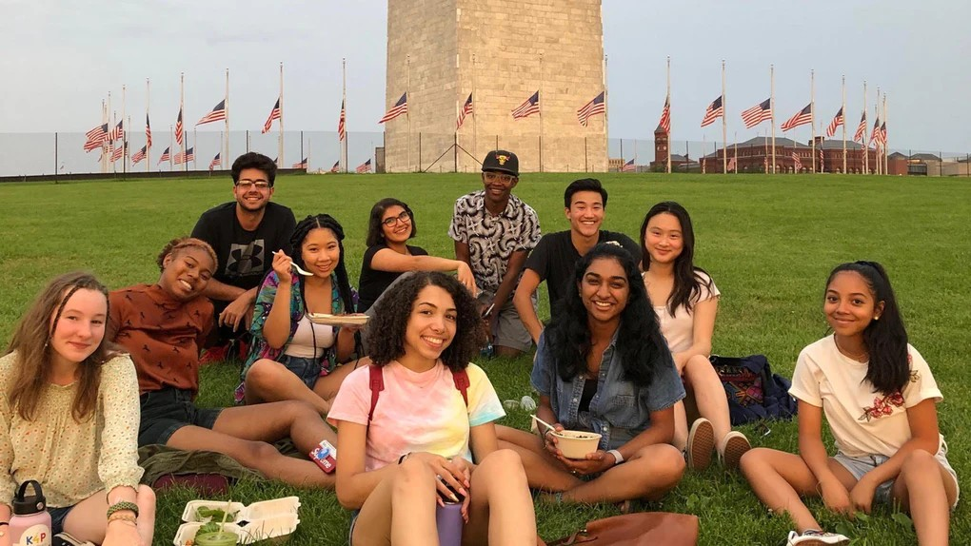
Brandon Klugman/Vote16USA

How Old Do You Have To Be To Vote? These Teen Activists Are Changing The Game

BY MADHURI SATHISH F E B 7, 2 0 2 0

Amira Tripp Folsom believes in change. The 18-year-old activist from Portland, Oregon, is passionate about discussing issues that affect teens across the country — like climate change, systemic racism, and school policing — and what she thinks should be done about them. "We should have a say in the things that happen to us," Tripp Folsom tells Elite Daily. That's why she's pushing so hard to lower the voting age to 16. "There are a lot of really terrifying things that are happening right now in this world, like climate change and the

threat of gun violence," Tripp Folsom explains. "Young people need to be included in this conversation, because we're the ones who are going to have to deal with the aftermath."

Tripp Folsom is on the youth advisory board of Vote16USA, which has worked since 2015 to coordinate local and national campaigns to lower the national voting age to 16. The teen activists on the advisory board, like many of their fellow young people, frequently raise issues that will disproportionately affect their generation, like gun violence and climate change, as reasons they should be able to vote. "[Young people] should have a say in who represents them," Tripp Folsom declares, "and also, we should be raising informed voters."

WHEN [YOUNG PEOPLE] DON’T VOTE, POLITICIANS AND ADMINISTRATIVE LEADERS DON’T SEE THOSE PEOPLE AS STAKEHOLDERS.

According to the U.S. Census Bureau, some 8.3 million American residents were between the ages of 16 and 17 as of 2018, and they are increasingly politically engaged. A 2018 survey conducted by PBS NewsHour Extra found gun control and climate change were among the issues that weighed most heavily on students' minds. A 2019 poll by Amnesty International found similar results, with environmental issues, racial inequality, and violence topping the list of what teens are concerned about. This isn't surprising; guns are a leading cause of death for children and teens in the United States, and concerns about deadly school shootings and how to address them continue to rise. At the same time, young people are overwhelmingly concerned about climate change — which makes sense, because the kids and teens of today are the first generation that will experience the full brunt of climate change in their lifetimes.

See More
Ad by Adobe
Creative Cloud

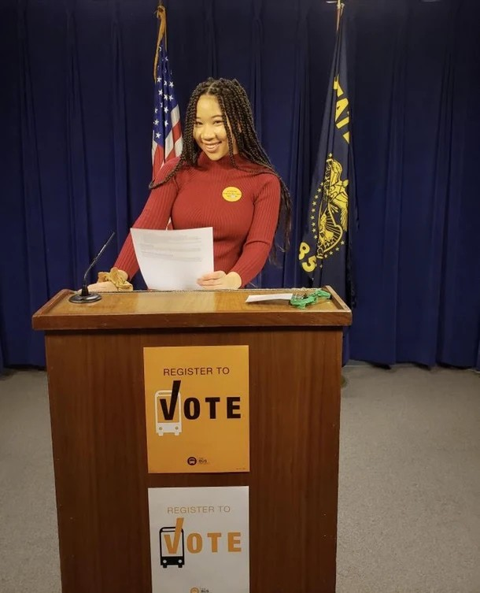

leaders don’t see those people as stakeholders," says Kei Kawashima-Ginsberg, the director of Tufts University's Center for Information and Research on Civic Learning and Engagement
Samantha Gladu

But not having a voice can mean the issues important to young people don't get the attention they deserve. "When [young people] don’t vote, politicians and administrative

(CIRCLE). "So the policies become exclusionary of the perspectives and the knowledge of the young people."

The minimum age to vote in federal elections has changed before.

The 26th Amendment to the Constitution offi ㋾ŏ怀怀 i cially lowered the voting age from 21 to 18 years old back in 1971, in the midst of the Vietnam War, and it was in large part thanks to young activists. Throughout the 1960s, thousands of activists, many of them students, participated in civil rights and anti-war movements. Many of the young activists at the time pointed at the series of wars — World War II, the Korean War, and the Vietnam War — to which 18-year-olds were sent to fight without ever having the right to vote on these decisions and the leaders who made them. Ultimately, it took roughly three decades for 18-year-olds to win the vote.
Now, nearly 50 years later, youth activists around the country are fighting to lower the voting age again.

ADVERTISING

Replay

Ads by Teads

I WOULD SAY THAT A KID WHO GOES TO SCHOOL HAS A HIGHER LIKELIHOOD OF BEING SHOT THAN A SOLDIER WHO GOES INTO THE ARMY RIGHT NOW.

Not everyone agrees with activists' efforts, though. A May 2019 poll from The Hill and HarrisX found that 84% of 1,002 registered voters surveyed opposed giving 16-year-olds the right to vote. David Davenport, a research fellow at Stanford University's Hoover Institution, tells Elite Daily that he doesn't think lowering the voting age to 16 is a good idea, even if young people are increasingly engaged in politics and activism. Davenport argues that lowering the voting age doesn't have the same urgency as it did in the '70s. "There was a sense [then] that if you were old enough to fight and die for your country, you should be old enough to have a voice in choosing its leadership," he says. He doesn't think that's the case with today's movement.

"This movement started when high school students were protesting guns on campus, which is fine, but a willingness to show up for a protest does not indicate the sort of long-term maturity and experience needed to vote," Davenport says.

But the young people who are advocating for a lower voting age disagree. "I would say that a kid who goes to school has a higher likelihood of being shot than a soldier who goes into the army right now," counters Zack Wathen, 21. "If you gave young people more of a vote, it wouldn’t be that way." According to PolitiFact, more students died in school shootings in 2018

than did military personnel in combat zones, although the overall likelihood of being killed in a combat zone is still higher than being killed in a school.

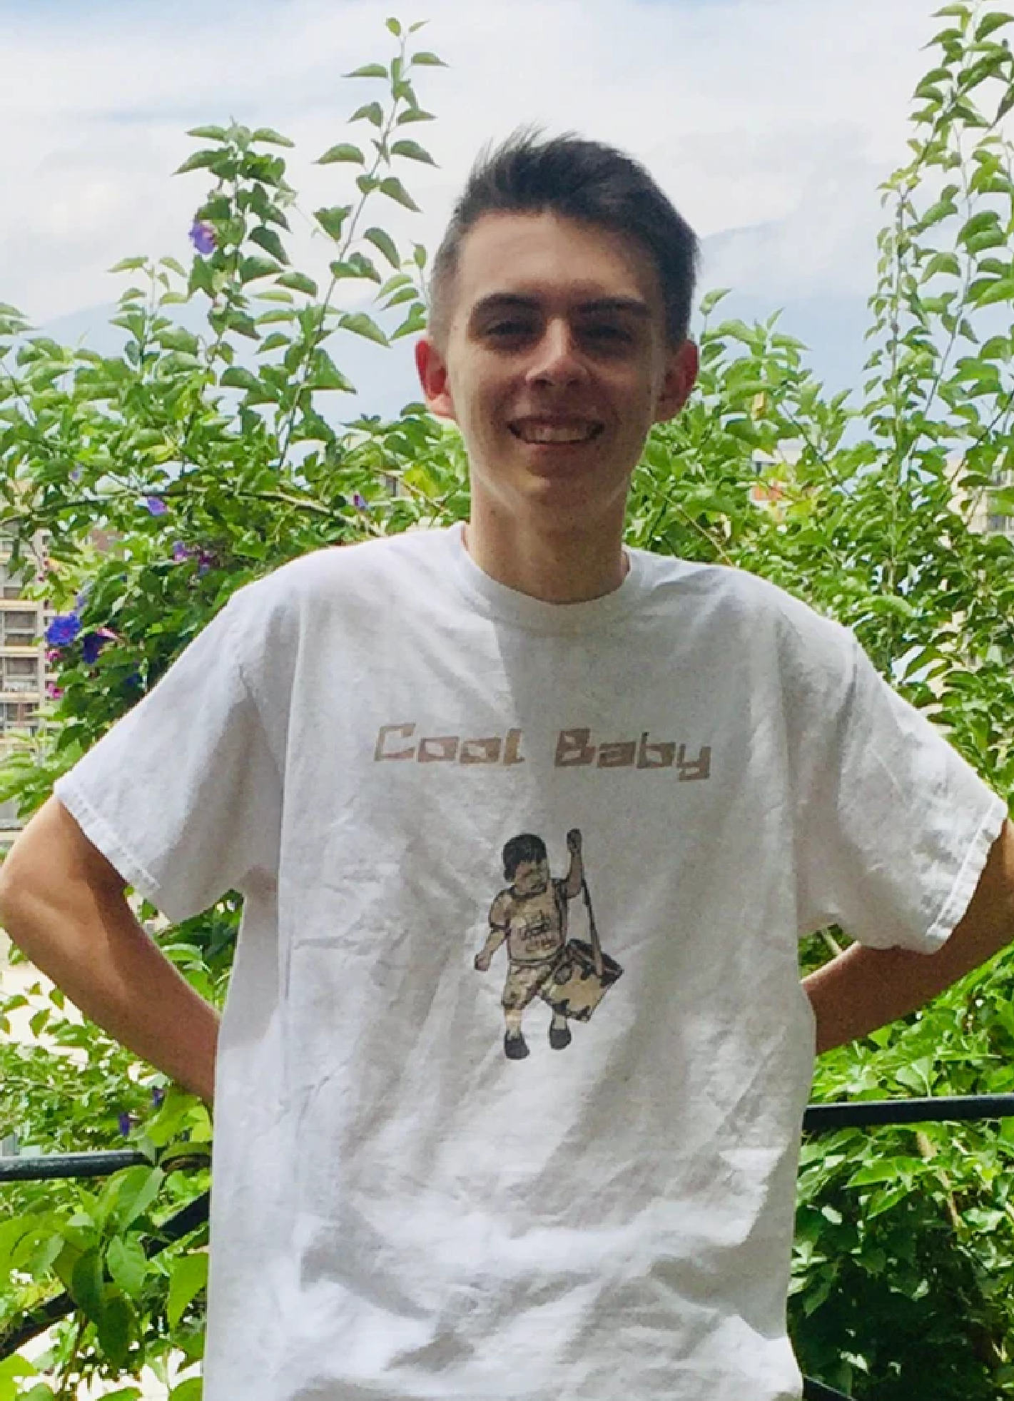
Courtesy of Zack Wathen

But teens have already shown that yes, they will show up to vote.

In 2013, Wathen's hometown of Takoma Park, Maryland, became the first city in the United States to lower the voting age to 16 in local and school board elections, though not for state or federal ones. As a result, Wathen was one of the first people in the country to vote at 16. According to Vote16USA, the turnout rate for 16- and 17-year-olds in Takoma Park was greater than any other voter bloc during the first election after they were given the right to vote. Data shared with Elite Daily by the Takoma Park city clerk's offi ㋾Ñ Qce indicates that 47.8% of Takoma Park's registered 16- and 17-year-old voters turned out to vote in the city elections in November 2017, in contrast to the roughly 22% of all registered voters in Takoma Park who voted that year.

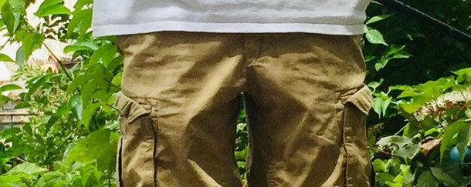THE IDEA OF NOT VOTING CERTAINLY NEVER CROSSED MY MIND.

According to Wathen, teen voters in Takoma Park regularly weigh in on local issues, including everything from retail development to the conservation of green spaces. He says the young voters in Takoma Park share similar concerns with voters around the country; it's just that they get to be heard. "The people that are civically engaged in Takoma Park — what they’re worried about [are] the same things that most young people in the country are worried about, like health care, education, climate change, and guns especially, and so it’s not anything extremely unique," Wathen says. "But by lowering the voting age, it made the legislative system more consistent with the civic system that goes on there anyway. You’ve got a lot of involvement with 16-year-olds anyway, a lot of involvement with 17-year-olds as it was." So much involvement, in fact, that Wathen — now a political science major at the University of Maryland — is considering running for local offi ce.

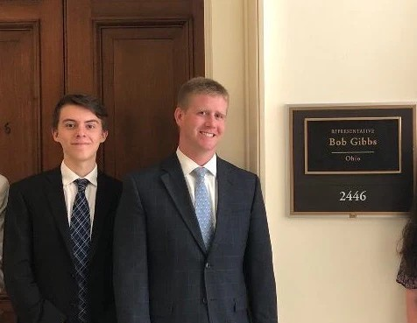

through it."
Courtesy of Zack Wathen

Wathen and his peers are an example of what a lowered voting age can achieve. "That’s the point of democracy," says Timothy Male, a former city council member who spearheaded the effort to lower the vote in Takoma Park. "That’s an open door, and people are walking

Save on our best phones.
S P O N S O R E D BY VERIZON

SEE MORE

Data from CIRCLE and the Pew Research Center also appears to support the idea that normalizing civic involvement as a teen helps keep people engaged. According to CIRCLE research, many young people cite conflicting work schedules or being out of town as their primary reasons for not voting. "Only some students go to college, and it’s a really missed opportunity to develop an identity of voters or civic actors earlier, when many, many more people are in that structured educational setting," Kawashima-Ginsberg tells Elite Daily.

"One of the best predictors of voting in the future is having voted in the past, and so young people haven’t had as many opportunities to vote," Bradley Jones, research associate at the Pew Research Center, also notes. He adds that young people are "having perhaps less impact than they could, given their numbers."

IF YOU FIND SOMETHING THAT YOU REALLY CARE ABOUT, THERE’S PROBABLY A PLACE FOR YOU.

Wathen has seen this at work. Having voted at 16, he was already familiar with how the voting process worked, but his friends at college weren't as comfortable. Some of them ended up not voting, even after they turned 18, because they didn't know how to exercise their right to vote. "Because I was able to vote at 16, I already knew how to vote when I was 18," he says. "The idea of not voting certainly never crossed my mind."

Tripp Folsom can also attest to the power of engagement. As a young black woman, the issue of voter suppression — particularly of black voters — was a key factor in her decision to fight for a lower voting age. "I didn’t really realize the importance of voting for a long time until I learned about voter suppression and how it’s still reflected today," Tripp Folsom explains. "People in power have historically done everything that they can to keep black people from voting."

"As a member of the youth advisory board, I feel like I should also be keeping in mind our history and the intersectionality of democracy when I’m doing this work," Tripp Folsom adds.
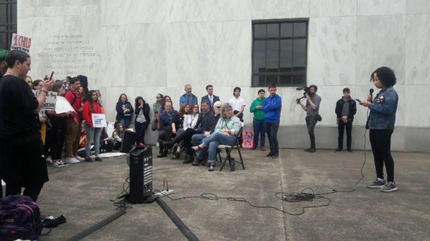

Samantha Gladu

But lowering the voting age is not an easy process.

Takoma Park was able to do it because Maryland's state constitution gives local municipalities the right to change these kinds of laws at a local level. Changing the national voting age, however, would require a new constitutional amendment, which would entail either a constitutional convention or achieving a two-thirds majority vote in the House and

Senate. Only a handful of 2020 Democratic candidates are open to the idea, and only former tech executive Andrew Yang has included lowering the voting age in his campaign's offi cial policy proposals. It's a high bar, but young people like Tripp Folsom are optimistic that the voting age could be lowered again — if young people get involved and stay engaged.

"If you’re comfortable, a lot of student groups, nonprofits, and organizations that do work with activism are looking for people to join them," Tripp Folsom says. "If you find something that you really care about, there’s probably a place for you. And if there’s not, you can always start something."

IMAGINE HOW MUCH MORE PRODUCTIVE WE COULD BE IF WE HAD THE RIGHT TO VOTE.

So far, House Speaker Nancy Pelosi has expressed tentative support for lowering the voting age, and in March 2019, Massachusetts Rep. Ayanna Pressley spearheaded an amendment to the Democrats' voting rights bill that would have lowered the voting age nationwide, although it ultimately failed. In a statement to Elite Daily, Pressley pledged to continue fighting for young people in 2020. “I have stood witness to deep and meaningful

mobilization by 16- and 17-year-olds who stand at the forefront of some of the most existential crises facing our communities," Pressley said. "Now is the time for us to demonstrate 2020 courage that matches the challenges of the modern-day 16- and 17- year-old."

As Pressley and her fellow lawmakers continue advocating for young people in Congress, youth activists like Tripp Folsom are determined to continue fighting for the roughly 22% of Americans under age 18 to have a voice in the issues that matter to them.

"Student activism has a lot of power," Tripp Folsom says. "Imagine how much more productive we could be if we had the right to vote, and the ability to really show up — and be represented and reflected — in our own government."
Sponsored Content

How many people globally live with significant disabilities?
Tommy Hilfiger is committed to inclusivity ⁴⁰
through the innovative Tommy Adaptive line.
80 120

160
0 million
0
200

Share T&Cs Powered by Speakable

More like this

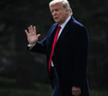
These Tweets About The Impeachment Vote In the Senate Are Full Of Emotions

By MADHURI SATHISH

These Tweets About Nancy Pelosi's Reactions At The 2020 State Of The Union Are Something Else
By MADHURI SATHISH

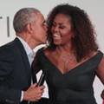
Michelle Obama's Comment About Being An Empty Nester Sweetly Referenced Barack

By LARA WALSH

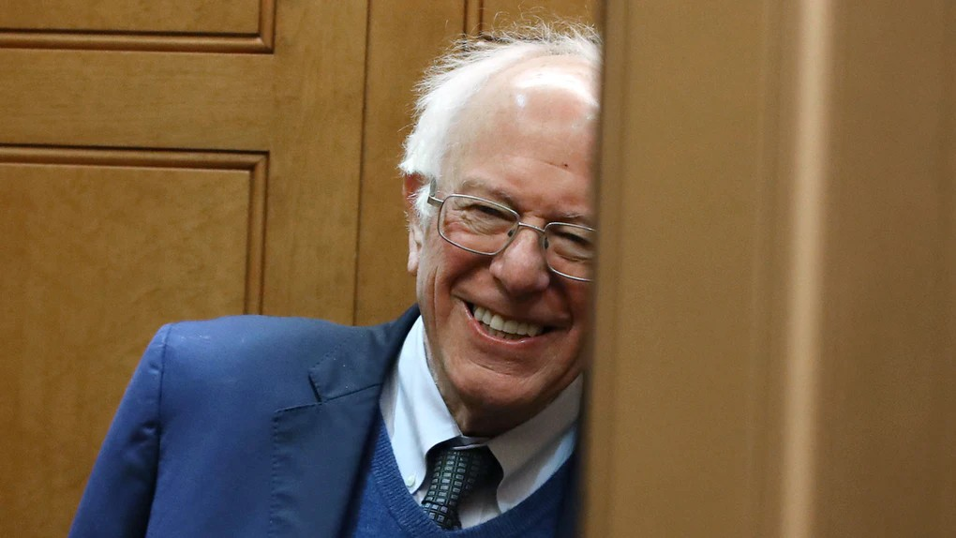
Mark Wilson/Getty Images News/Getty Images

These Memes About Bernie Sanders Asking For Support Are Going Viral

BY MADHURI SATHISH F E B 7, 2 0 2 0

On Dec. 30, 2019, Vermont Sen. Bernie Sanders tweeted out a short video beseeching voters to make contributions to his 2020 presidential campaign. As is the case in many of Sanders' fundraising calls, the Democratic presidential candidate reminded viewers his campaign does not rely on a Super PAC to get funding. But this fundraising effort was different, because Sanders' end-of-year fundraising video became a viral meme. These memes about Bernie Sanders "once again asking" for anything other than financial support have now made their way around the internet, and social media users can't get enough of them.

This latest meme originated from Sanders earnestly saying, "I am once again asking for your financial support" in the Dec. 30 video, as he walked along in the snow wearing a heavy winter coat. When social media users saw Sanders' latest plea, they quickly went to work turning it into a meme, and they "once again asked" for everything from emotional support to cat food. The meme template isn't all that complicated: you simply use a screenshot from Bernie's fundraising video and replace the caption "for your financial support" with a variety of demands you would probably never hear from Sanders. This is the original video that inspired all of the memes:

As you ponder what you can once again ask your followers for, you can take a look at some of these Sanders memes below:

Some social media users decided to use this meme to make some musical demands.

Other users had more specific requests.

Given that the meme is all about Sanders, the error-ridden nature of the Iowa caucus results certainly did not escape social media users' attention.

This is not the first time Sanders has inspired a viral meme. In fact, even as the "once again asking" meme continues to gain traction, another Sanders meme came to life at the beginning of February. On Feb. 2, Sanders' campaign manager, Faiz Shakir, tweeted a photo

of Sanders writing a thank you message to his field staff on a whiteboard. Within just a couple of days, social media users had turned the image into a meme of Sanders writing all sorts of messages, like this one:

According to New York Magazine, much of Sanders' support and popularity comes from young voters, so it's not too surprising the Vermont senator would frequently find himself the subject of amusing memes. Ever since Sanders launched his first presidential bid in 2015, he has appealed to young, leftist voters who are eager to see a progressive in offi ㋾ŋalce. As Refinery29 pointed out, his fundraising concerts with bands like Vampire Weekend and Bon Iver, coupled with his repeated emphasis on the youth voice, cements his popularity with millennial and Generation Z voters. Now, even as Sanders continues to roam the internet in meme form, he is celebrating his strong performance in the Iowa caucuses while campaigning in New Hampshire, where voters will participate in the country's first primary on Tuesday, Feb. 11.

