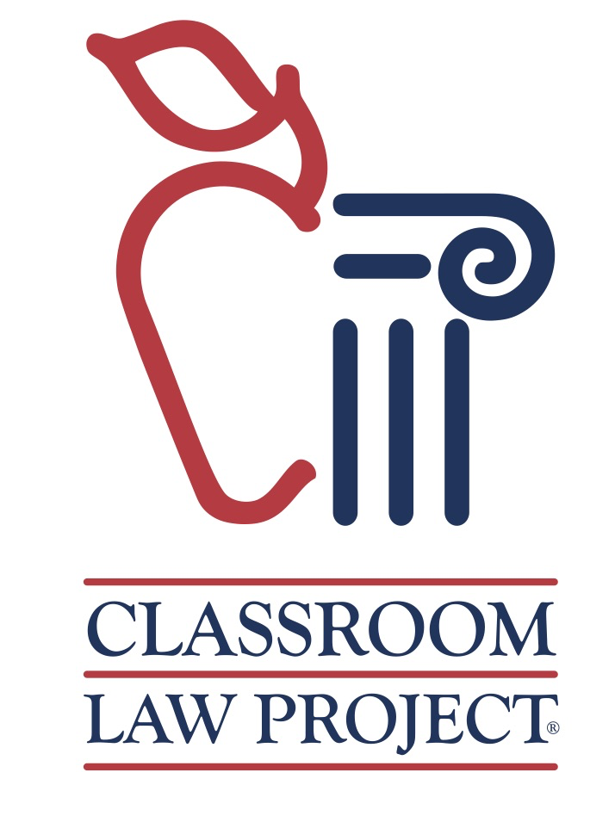
Classroom Law Project’s
Extraterrestrials and the Bill of Rights!
Lesson Plan
Grades 4 - 12

Activity Steps:

- Announce that we were going to start with [whatever you had planned for that day], but there is some breaking news that needs to be addressed first!

- Handout article, let students read

- Ask what happened - what information do we have?

- Let students know that the ETs have reviewed our laws and perceive us to have too many rights. They have chosen YOU to resolve this problem.

- Students should break into small groups - each group gets an envelope with strips cut of the different rights.

- Let students know that there are the same 16 perceived rights (rights we assume we have) in each envelope.

- They are to eliminate 3 they believe we could live without (put those back in the envelope).

- Still too many rights, say the extraterrestrials. Eliminate 3 more.

(embellish situation!)

- Nope, this doesn’t work either. Eliminate 3 more.

- Now, eliminate 4 to get to the last 3 they think we MUST have in the end.

- Have 1 student from each group come to board and write top 3 up.

- Look at similarities and differences in group choices. Have a conversation around WHY these were the final choices.

- Then let class know that they ALL have to come up with a top 3 - do it together as a consensus-building activity.

Debrief:

- What strategies did you use to come to a solution?
- What was difficult?
- What was not?
- Whole group, how did you decide?
- Did you feel your voice was heard? - If not, why?
- Did you use any guiding principles to make decisions? (ex. Life is sacred)

- The founders used guiding principles to decide on which rights to put in the Constitution, where are they (Bill of Rights!) - and why do you think those are the ones they chose?

Notes:

- We recommend not to explain what the 16 rights are and let the students in each group come to a decision on what they think each one means. This can lend a lot of richness to the conversation about how we all interpret certain rights differently, even when they are explicitly in the Constitution.
- You can easily adjust this to fit any grade level, so while you might adjust the wording on the list of rights for younger students or English Language Learners, we recommend keeping them as close to the original as possible when challenging students to start with inquiry and ask questions about what they think different words and rights mean.

