Judicial Review & the Oregon Supreme Court

What is the Oregon Supreme Court and How Does it Work?

Part 2

In this section:

  - Judicial Review & Court Vocabulary
  - Background on the Oregon Supreme Court & Judicial System
  - What is Judicial Review?
  - How the Courts work - Graphic Organizer

Note to Teachers:

This section contains most of the background information you can use to scaffold learning for your students into a Moot Court activity and the culminating experience of watching live Oregon Supreme Court Hearings. You are free to modify the information into a format you prefer. However, we created it to be as digestible as possible while still engaging the knowledge needed for the entire experience.

Oregon Supreme Court Oral Arguments
2.1 - Vocabulary

Judicial Review and the Court System
Vocabulary

Amicus curiae - Latin for "friend of the court." It is advice formally offered to the court in a brief filed by an entity interested in, but not a party to, the case.

Answer - The formal written statement by a defendant in a civil case that responds to a complaint, articulating the grounds for defense.

Appeal - A request made after a trial by a party that has lost on one or more issues that a higher court review the decision to determine if it was correct. To make such a request is "to appeal" or "to take an appeal." One who appeals is called the "appellant;" the other party is the "appellee."

Appellant - The party who appeals a district court's decision, usually seeking reversal of that decision.

Appellate courts - The part of the judicial system that is responsible for hearing and reviewing appeals from legal cases that have already been heard in a trial-level or other lower court.

Brief - A written statement submitted in a trial or appellate proceeding that explains one side's legal and factual arguments.

Burden of proof - The duty to prove disputed facts. In civil cases, a plaintiff generally has the burden of proving his or her case. In criminal cases, the government has the burden of proving the defendant's guilt. (See standard of proof.)

Case law - The law as established in previous court decisions. A synonym for legal precedent. Akin to common law, which springs from tradition and judicial decisions.

Clerk of court - The court officer who oversees administrative functions, especially managing the flow of cases through the court. The clerk's office is often called a court's central nervous system.

Common law - The legal system that originated in England and is now in use in the United States, which relies on the articulation of legal principles in a historical succession of judicial decisions. Common law principles can be changed by legislation.

Complaint - A written statement that begins a civil lawsuit, in which the plaintiff details the claims against the defendant.

Counsel - Legal advice; a term also used to refer to the lawyers in a case.
Court - Government entity authorized to resolve legal disputes. Judges sometimes use "court" to refer to themselves in the third person, as in "the court has read the briefs."
Court reporter - A person who makes a word-for-word record of what is said in court, generally by using a stenographic machine, shorthand or audio recording, and then produces a transcript of the proceedings upon request.
Damages - Money that a defendant pays a plaintiff in a civil case if the plaintiff has won. Damages may be compensatory (for loss or injury) or punitive (to punish and deter future misconduct).

Defendant - In a civil case, the person or organization against whom the plaintiff brings suit; in a criminal case, the person accused of the crime.

Docket - A log containing the complete history of each case in the form of brief chronological entries summarizing the court proceedings.

Due process - In criminal law, the constitutional guarantee that a defendant will receive a fair and impartial trial. In civil law, the legal rights of someone who confronts an adverse action threatening liberty or property.

Habeas corpus - Latin, meaning "you have the body." A writ of habeas corpus generally is a judicial order forcing law enforcement authorities to produce a prisoner they are holding, and to justify the prisoner's continued confinement. Federal judges receive petitions for a writ of habeas corpus from state prison inmates who say their state prosecutions violated federally protected rights in some way.

Judge - An official of the Judicial branch with authority to decide lawsuits brought before courts. Used generically, the term judge may also refer to all judicial officers, including Supreme Court justices.

Judicial Review - The power of the courts (specifically appellate courts) to determine if a law is constitutional.

Jurisdiction - The legal authority of a court to hear and decide a certain type of case. It also is used as a synonym for venue, meaning the geographic area over which the court has territorial jurisdiction to decide cases.

Lawsuit - A legal action started by a plaintiff against a defendant based on a complaint that the defendant failed to perform a legal duty which resulted in harm to the plaintiff.

Litigation - A case, controversy, or lawsuit. Participants (plaintiffs and defendants) in lawsuits are called litigants.

Opinion: A judge's written explanation of a decision of the court or of a majority of judges. A dissenting opinion disagrees with the majority opinion because of the reasoning and/or the principles of law on which the decision is based. A concurring opinion agrees with the decision of the court but offers further comment.

Oral argument - An opportunity for lawyers to summarize their position before the court and also to answer the judges' questions.

Plaintiff - A person or business that files a formal complaint with the court.

Precedent - A court decision in an earlier case with facts and legal issues similar to a dispute currently before a court. Judges will generally "follow precedent" - meaning that they use the principles established in earlier cases to decide new cases that have similar facts and raise similar legal issues. A judge will disregard precedent if a party can show that the earlier case was wrongly decided, or that it differed in some significant way from the current case.

Remand - Send back.

Reverse - The act of a court setting aside the decision of a lower court. A reversal is often accompanied by a remand to the lower court for further proceedings.

Oregon Supreme Court Oral Arguments
2.2 - Oregon Judicial System Background

The Oregon Judicial System & the Oregon Supreme Court

I. The Rule of Law

The Oregon court system fulfills a tremendously important purpose in our democratic society. We usually think of the court system in terms of its obvious functions:
- to try those who are suspected of committing criminal acts, or
- to settle disputes between parties who cannot reach an agreement themselves.

However, the courts fulfill many other vital functions, including:
- the protection of individual rights,
- the assurance that no one will be above the law, and
- the preservation of the balance of power among the three branches of government.

The court’s decisions are based upon the constitutions and the laws of the United States and the State of Oregon and include city and county ordinances.

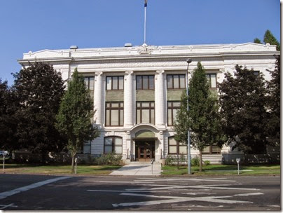
The Oregon courts hear disputes brought by private citizens, corporations, business organizations, and the state and local governments. There are two broad categories of disputes adjudicated by the courts: criminal and civil disputes.

A criminal case involves a dispute where an individual has broken a law of the state created by the Legislature or local government. If the individual violated a federal law that case will be heard in federal district court. In general, crimes are described as either felonies or misdemeanors and they are classified according to the terms of punishment prescribed by the Legislature for a specific crime. A felony is a crime for which the punishment is imprisonment for more than one year. Misdemeanors are lesser crimes for which the penalty is imprisonment for less than one year. When an individual is charged with a criminal offense, they are referred to as the defendant in the case. The district attorney who represents the state is called the prosecutor.
Oregon Supreme Court

Civil disputes include all matters that are not criminal. They often involve disputes between private citizens and business organizations over matters relating to contracts, personal injury, and property disputes. The party who files the suit is called the plaintiff and the responding party is called the defendant. The adjudicatory process begins when the plaintiff files a complaint with the county clerk in the circuit court that has jurisdiction over the matter. The complaint generally states the accusations against the defendant and informs the defendant that they must appear in court.

Criminal law is enforced by the government,
while civil law is enforced by private citizens through civil action.

2. Oregon Judges

All judges in Oregon are elected to their positions and each serves a six-year term. This includes judges who serve on the Oregon Supreme Court. While Oregon judges have to run for election similar to state legislators and county officials, they have an entirely different set of responsibilities owed to the public.

Judges are tasked with promoting justice by making fair and impartial decisions that do not rely on public opinion. They rely exclusively on the law to inform their decisions, and it is the judge’s responsibility to act as a steward of the law to make sure it is applied to each case correctly. The most important duty of a judge is to identify the relevant law that applies to the facts of a specific case and to make sure the law is applied to the facts correctly. There are a variety of sources of law that may apply in any given case and most people are familiar with the two main types: statutory law created by the Legislature and common law created by judges.

Like the organization of Oregon’s court system, both statutory and common law follow a hierarchy where all laws must be consistent with the law at a higher level. For instance, a local ordinance must be consistent with a state statute that must not contradict the United States Constitution.

Statutory law is written law created by the Legislature that aims to clarify the functioning of government or define rules for civil order. Most criminal cases involve statutory law because the defendant broke a law that the state Legislature put in place to make certain acts a punishable offense.

Common law, on the other hand is generally used to settle disputes between individuals in civil cases. Common law is created through the decisions of judges in state appellate courts. These decisions become binding on the lower courts within the state. The tradition of common law extends all the way back to 12th Century England when King Henry the II established central courts to help consolidate the laws of England and move away from system of solving disputes based upon local custom.

3. Jury Trial

A jury trial is the cornerstone of the United States legal system. The right of citizens to have a dispute decided by a fair and impartial decision maker is protected by the 6th Amendment of the Constitution and represents an essential aspect of the administration of justice in the United States.

A citizen’s right to trial by jury in Oregon is secured by the State’s constitution for both criminal trials (Article 1, section 11) and civil trials (Article 1, section 17). In every criminal case, the defendant is entitled to a jury trial unless they waive this right. In civil cases however, the right to a jury is only automatic for cases involving $750 or more in controversy. If the amount in controversy is less than $750, defendants will receive a bench trial where a judge alone acts as the “finder of fact” as well as deciding issues of law.

Jury trials are composed of either six or twelve jurors depending upon the nature of the crime alleged, or the amount of money involved in the case. Civil suits involving $10,000 or less are only tried by six jurors. In Oregon, all citizens over the age of 18 are eligible for jury duty so long as they have not served on jury duty within the last 24 months or been convicted of a felony.

The jury trial is exclusively administered by the circuit courts. It is essentially a judicial examination of the dispute between the parties where the judge provides the jury with instructions on the relevant law that relates to the case, and the jury applies this law to the facts. The jury will act as a finder of fact, deciding which facts are relevant and which witnesses to believe. In a criminal trial, the relevant law will likely be found Oregon’s statutes that relate to criminal offenses.

Great deference is given towards the jury’s verdict in a case. Article VII, Section 3 of the Oregon Constitution prohibits a trial judge or an appellate court from reexamining any fact found by the jury unless the court can affirmatively say there is no evidence to support the verdict.

Jury Decisions in Oregon:

Type of Case | # of jurors present at trial | # of jurors required to agree in order to reach a verdict
Criminal Felony | 12 | 12
Murder | 12 | 11
Death Penalty | 12 | 12
Criminal Misdemeanor | 6 | 6
Civil case between $750 & $10,000 | 6 | 5
Civil case greater than $10,000 | 12 | 9

“It is your sole responsibility to make all decisions about the facts in this case. You must evaluate the evidence to determine how reliable or how believable that evidence is. When you make your decision about the facts, you must then apply the legal rules to those facts and reach your verdict.”

Jury instructions from a civil case in Multnomah County, Robert Hill v. LaGrand Industrial Supply

4. Circuit Courts: deal with the FACTS of a case

The circuit courts are the real workhorse of Oregon’s court system. Circuit courts are courts of general jurisdiction. That means they hear every kind of criminal and civil case with the exception of tax cases that have their own exclusive tax court. Circuit courts also perform the important function of holding the jury trial to resolve factual matters in disputes.

In order for any judicial system to be successful, it must be accessible to the citizens who rely on it. Everything from minor traffic violations to class A felonies to civil cases involving important contract disputes are adjudicated by the circuit courts. Unlike the Oregon Supreme Court and Court of Appeals where there is just one of each court for the entire state, each one of Oregon’s 36 counties has a circuit court. There are 173 circuit court judges in 27 judicial districts within the state. The citizens who live in the judicial districts that the judges serve elect the judges to their positions. Some judicial districts cover more than one county. For example, District No. 24 includes both Grant and Harney Counties in eastern Oregon. The number of judges in each district is based upon population in that district as well as size of the district’s case load. Multnomah County, in District No. 4, is the largest judicial district and has 38 circuit court judges.

5. Oregon Court of Appeals: deals with the LAW in a case

The Court of Appeals hears all civil and criminal cases appealed from the circuit courts. This court serves as the first level of appeal after a trial. The adjudicatory process in an appeal is very different from the trial procedure used in the circuit court and places a different level of responsibility on the attorneys who represent the two parties and the judges who ultimately decide the case. Ten judges serve on the Court of Appeals.

Appellate Procedure

When a party makes an appeal, they do not get a whole new trial with a jury. This is the primary difference between an appeal and a case initially decided in circuit court. Each party is only allowed to submit a written brief and present an oral argument of the merits of their case to the judges who will be making the decision. The written brief is a summary of the how the law relates to the facts of the case.

The party who made the appeal is called the appellant and they will be asking the court to reverse the lower court’s decision. The party that did not appeal is called the appellee and they will argue the reasons why the lower court’s decision should be affirmed. The two opposing parties are also given the opportunity to present an oral argument to the judges who will be deciding the case. This is another opportunity for each party to present the merits of their case, but mostly it is a chance for the judges to ask the respective attorneys questions about the law as it applies to the case.

Because appeals almost exclusively involve questions of law, judges and not a jury decide them. In certain situations however, the judges in an appeal might send a case back to the circuit court because the dispute centers around an important fact that the jury must decide. The judges’ main role in an appeal is to make sure the lower circuit court was correct in applying the law that determined the outcome of the case.

To help manage the heavy appeals caseload, the court of appeals is divided into three panels with three judges each. Each panel evaluates the trial record from the circuit court and the written briefs from the opposing parties, and hears oral arguments presented by both parties. In some cases the panel will agree to affirm the lower court’s decision without writing a formal opinion. In other cases, one member of the panel may draft an opinion explaining the panel’s reasoning.
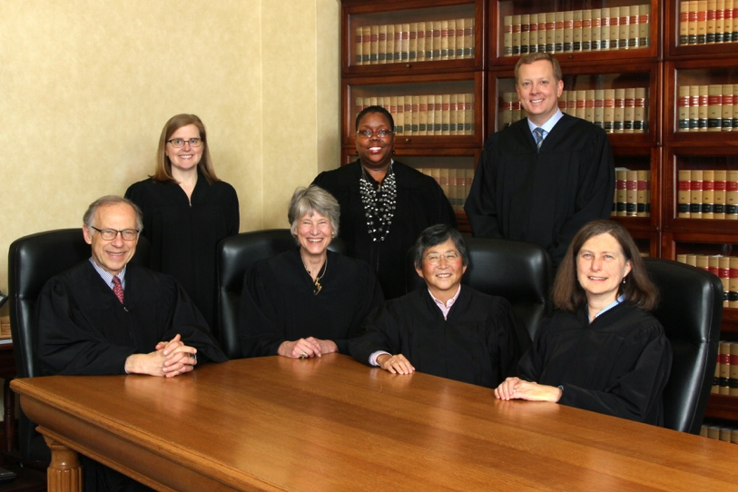

6. The Oregon Supreme Court: interprets the law and the Oregon Constitution

The Oregon Supreme Court is the highest court in the Oregon state court system. Any decision by this court is binding upon all of the other lower courts in the state. The United States Supreme Court is the only court that can reverse a decision by the Oregon Supreme Court. Seven justices serve on the Oregon Supreme Court and each serves a six-year term.
Standing from left to right: Justice Rebecca A. Duncan, Justice Adrienne Nelson, and Justice Christopher L. Garrett.
Seated from left to right: Justice Thomas A. Balmer, Chief Justice Martha L. Walters, Justice Lynn Nakamoto, and Justice Meagan A. Flynn

The Oregon Supreme Court is primarily an appeals court. They have discretionary review of cases from the Court of Appeals. If a party thinks the Court of Appeals has made a mistake in interpreting the law, they may petition the Oregon Supreme Court to review that decision. The Supreme Court may choose to accept or deny that petition.

The Oregon Supreme Court has direct review of certain kinds of cases. This means that the case goes directly to the Supreme Court without review by the Court of Appeals. Death penalty cases and decisions from the Oregon Tax Court are two examples of cases where the Supreme Court has direct review.

Judicial Pathways in Oregon:

Supreme Court

Court of Appeals

Tax  Court |  | Circuit  Court

Citizens and the State of Oregon

Number of cases filed in Oregon courts in 2016:

Supreme Court . . . . . . . . . . . . . . . . . . . . 813
Court of Appeals . . . . . . . . . . . . . . . . . . 2,812
Circuit Court . . . . . . . . . . . . . . . . . . . .716,712

Oregon Supreme Court Oral Arguments
2.3 - What is Judicial Review?

Judicial Review

The United States Constitution does not specifically mention Judicial Review, but in explaining Article 3 powers of the judiciary, Alexander Hamilton wrote in Federalist 78:
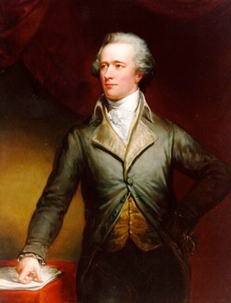
“The interpretation of the laws is the proper and peculiar province of the courts. A constitution is in fact, and must be, regarded by the judges as a fundamental law. It therefore belongs to them to ascertain its meaning as well as the meaning of any particular act proceeding from the legislative body.”

Alexander Hamilton
In short, the judiciary’s ability to check and balance the powers of the Executive and Legislative branches lie in its authority to interpret laws based on the constitution. That is what Judicial Review is.
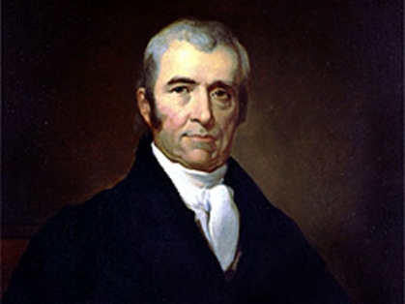
Chief Justice John Marshall put it another way when he led the Supreme Court to use judicial review for the first time to judge the constitutionality of a law in the case Marbury v. Madison:

“It is emphatically the province and duty of the judicial department to say what the law is.”
John Marshall

Questions to Consider:

- Why do you think the Courts should have the power of judicial review (rather than the other two branches)?
- What dangers might there be in the power to declare a law constitutional or not?
- How might Judicial Review protect citizens’ rights?

- Do you think Oregon’s state supreme court justices remain independent with their power of Judicial Review if they are up for election every 6 years? Why or why not?

Oregon Supreme Court Oral Arguments
2.4 - Judicial Review

The Oregon Court System:
A Graphic Organizer

Trial Courts

Who decides?

What do they decide?

Process for decisions:

Appeals Court

Who decides?

What do they decide?

Process for decisions:

Oregon Supreme Court

Who decides?

What do they decide?

Process for decisions:

Oregon Supreme Court Oral Arguments
2.4 - Judicial Review

The Oregon Court System:
A Graphic Organizer - KEY

Process for decisions:

Each side submits a brief stating their side of the matter. Other groups may also submit briefs. The judges review the briefs and hold oral arguments to question the attorneys for each side. Then the judges decide if the law was followed.

Trial Courts

Who decides?

A jury of citizens

What do they decide?

The facts of the case

Appeals Court

Who decides?

A panel of 3 Appellate judges

What do they decide?
Whether the lower court used the law correctly in its decision

Process for decisions:

Juries hear witnesses, testimony, and see exhibits, then they decide together what the facts are in the case

Oregon Supreme Court

Who decides?

All of the Justices

What do they decide?

The constitutionality of laws in a case

Process for decisions:
Each side submits a brief stating their side of the matter. Other groups may also submit briefs. The justices review the briefs and hold oral arguments to question the attorneys for each side. Then the judges decide if the law was followed constitutionally & issue opinions

