Classroom Law Project
Presents

Election 2020
Why Voting Matters

Unit 4

Why Should Americans Vote?

Unit 4
Why Should Americans Vote?

Essential Questions:
- Why does voter turnout matter?
- How important is voting to democracy?

Objectives
Students will
- Develop an understanding of their own political efficacy
- Assess the history of voter turnout in the United States
- Consider the effect of vote-by-mail in Oregon turnout
- Develop a plan to encourage more voting in their community

Unit 4 Standards:

OR 2018 Grade 8 Social Studies Standards
8.2
8.7
8.8
8.9
8.10
8.29
8.30
8.32
8.33
8.34
8.35

Grade 8 CCSS Literacy in History/Social Studies
6-8.RH.2
6-8.RH.3
6-8.RH.5
6-8.RH.8
6-8.WHST.1
6-8.WHST.2
6-8.WHST.9

OR 2018 High School Social Studies Standards
HS.10
HS.11
HS.13
HS.54
HS.61
HS.67
HS.71
HS.73
HS.74
HS.76

Grades 9/10 CCSS Literacy in History & Social Studies
9-10.RH.1
9-10.RH.2
9-10.RH.4
9-10.RH.5
9-10.RH.8
9-10.RH.9
9-10.WHST.1
9-10.WHST.4
9-10.WHST.9

Grades 11/12 CCSS Literacy in History & Social Studies
11-12.RH.1
11-12.RH.2
11-12.RH.3
11-12.RH.8
11-12.RH.9
11-12.WHST.1
11-12.WHST.2
11-12.WHST.9

Unit Vocabulary

- Political socialization
- Political efficacy
- Voter turnout
- Vote-by-mail
- Compulsory voting
- Automatic Voter Registration
- Midterm elections
- Voter registration

Materials and Handouts

4.1 Political Socialization: What makes voters WANT to vote?
Handouts:
  - Political Socialization – What influences people’s vote?
  - Article: What motivates people to vote?
  - Analysis: What would motivate me to vote

4.2 Voter Turnout: Why don’t more people vote?
Handouts:
  - Voter Turnout graphs
  - Backgrounder: Every Vote Counts
  - Article: US trails most developed countries in voter turnout
  - Article: Letting people vote at home increases voter turnout
  - Article: How Oregon Increased Voter Turnout More than any other State
  - FAQs about Voting in Oregon
  - Low Voter Turnout Role Play Activity
  - Persuasion: How can you convince people to turnout to vote?

4.1

Political Socialization: What makes voters WANT to vote?

Handouts:
  - Political Socialization – What influences people’s vote?
  - Article: Four Researched ways to get people to vote
  - Analysis: What would motivate me to vote

Opener: Do a class poll or a pair and share about what aspects of a person’s life might influence them as they form their political opinions. See how many items the students can brainstorm. They can compare this list to what this lesson teaches about influencing factors on voters.

Political Socialization & Efficacy – These are big words so it helps to break them down for students.

In essence, Political Socialization is the process of how people form their political opinions. The way this happens can be very influential to a person’s sense of Political Efficacy. Political Efficacy is people’s motivation to participate based on whether they believe their vote will make a difference and if they have faith that government will respond and be reliable. Voters with high efficacy are very driven to participate. Low efficacy often means they don’t show up.

Lesson Options:

Use the information about political socialization to challenge the students to consider what might influence their own personal motivation to vote. Another option is to have them survey a few eligible voters they know to see what motivates those voters to vote. An issue importance scale is included that students can use for themselves or to conduct a survey (“what would motivate me to vote”).

The Pew Research on trust in government gives students an opportunity to read and analyze graphs and data-based information. The article included in this lesson is a brief summary of some reasons why people DON’T end up voting or having a high sense of efficacy.

Students can gather this information and combine it with the next lesson to formulate a plan for persuading or influencing eligible voters to turn out in 2018.

What Motivates People to Vote?

Political Socialization is the process of how people form their political opinions.

Political Efficacy is people’s motivation to participate based on whether they believe their vote will make a difference and if they have faith that government will respond and be reliable.

People are most often influenced by their personal values and beliefs. These are the most common motivating factors in whether a person believes their vote will matter and whether they decide to vote at all.

Influencing Issues:

Family
Education Level
Mass Media
Peers
Race / Ethnicity
Religion

Income
Age
Political Leaders Celebrities
Gender
Occupation

What others can you add to this list?

Science News for Students

By Bethany Brookshire

November 7, 2016

4 research-backed ways to get people to vote
Scientists are finding ways to increase voter turnout

Millions of Americans will be lining up to vote on November 8. Millions will also stay home. But scientists have insight into how to convince people to vote.

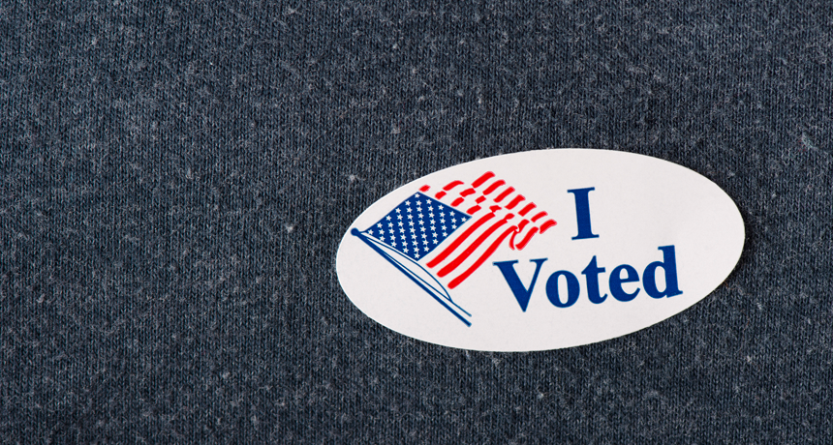
ICEMANJ/ISTOCKPHOTO

Every two years, on the first Tuesday (after a Monday) in November, Americans should head to the polls to take part in a national election. Some important elections may take part in the off-years as well. But not everyone who is eligible to vote will do so. In fact, millions of people won’t. And that’s a problem because people who don’t vote lose out on a prime chance to register their views.

Also, voting isn’t just important. It is a privilege and a right that many people throughout the world lack.

One person’s vote probably won’t change course of an election. But a few thousand votes — or even a few hundred — certainly can. Consider, for instance, the famous election between George W. Bush and Al Gore in 2000. Once the polling was over, Florida had to recount its votes. In the end, Bush won by 537 votes. That difference decided who became president of the United States.

Even in polling for local offices — such as a school board — the result of a vote can change everything from what schools neighborhood children will attend to whether their textbooks will cover evolution.

There are many reasons why people don’t vote. And to counter the anger, apathy, fatigue and other factors that deter many folks from voting, organizations big and small mount campaigns urging people to go to the polls. Facebook users may plead with their friends. Politicians may hire phone banks to call thousands of people in states where a race appears to be very competitive. Celebrities may beg over YouTube.

Does any of this really work?

Political scientists have studied ways to change people’s voting behavior. These four methods seem to stand out in terms of being most effective.

1) Educate early and well Messages that people receive early in life have a strong impact on whether people vote, notes Donald Green. He’s a political scientist at Columbia University in New York City. Parents and teachers should therefore let kids know “voting is important,” he argues. “It’s what makes you a functioning adult.” Teachers might help deliver this message in classes where students learn about how their country and government functions. That happened to me in high school when my own teacher one day begged me and my classmates to vote.

People with college degrees are also more likely to vote. Perhaps society should make it easier for people to afford college. “A person who gets a college education ends up in a different life circumstance,” explains Barry Burden. He’s a political scientist at the University of Wisconsin–Madison. College graduates tend to associate more with people who vote — and then they vote, too. They also stand to earn more (paying more taxes), data have shown. So a more educated population should be a win-win for society.

2) Peer pressure A healthy dose of name and shame can have a big effect on Election Day. Green and his colleagues demonstrated this in a study published in 2008 in American Political Science Review. They applied a little social pressure to voters.

Right before Michigan’s 2006 Republican primary, the researchers selected a group of 180,000 potential voters. They mailed about 20,000 voters a letter asking them to do their “civic duty” and vote. They mailed another 20,000 a different letter. It asked them to do their civic duty, but added that they were being studied — and that their votes were a matter of public record. (In some states, such as Michigan, voting records are publicly available after an election.)

A third group got the same messages as the second group. But they also got a note that showed them their previous voting record, and the previous voting records of the people in their household. A fourth group got the same information as the third group, as well as being shown the publicly available voting records of their neighbors. The last 99,000 people or so were a control — they got no mailings at all.

When many Americans vote on November 8, they will go into small, curtained stalls to keep their choices private.
phgaillard2001/Flickr (CC-BY-SA 2.0)

After all the votes were counted, the scientists saw a 1.8 percentage point increase in turnout by people who had been reminded to vote over those who did not get such a mailing. For the group told their votes were a matter of public record, there was a 2.5 percentage point increase. But the biggest increase were among those shown voting records. Turnout increased by 4.9 percentage points among people shown their previous voting records. And if voters were also shown their neighbors voting records, turnout at the polls rose a whopping 8.1 percentage points.

Although shaming may get out the vote, Green cautions that it likely also burns bridges. “I think it produces backlash,” he says. In the 2008 study, many of the people who received the letter that showed the voting records of their neighbors called the number on the mailing and asked to be left alone.

Peer pressure doesn’t always have to be mean, though. Asking friends directly to pledge to vote — and then making sure they do — might be effective, Green says. The most effective thing to do, he says, may be to say to a close friend or coworker, “let’s walk to the polls together.”

3) Healthy competition “People are going to participate when they think they are going to make a difference,” says Eyal Winter. An economist, he works at the University of Leicester in England and the Hebrew University of Jerusalem in Israel. He notes that there is higher voter turnout when an election is close and there’s no telling who might win. Winter compares elections to football or baseball games. When two close rivals face off, their competitions will draw much bigger crowds than when one team is sure to roll right over another.

To find out whether a close election might make more people vote than a race where one politician is far behind another, Winter and his colleague looked at U.S. elections for state governors from 1990 to 2005. When surveys before the election showed that results were likely to be very close, voter turnout increased. Why? People now felt their vote might make a bigger difference.

More voters also turned out for the side with the slight majority in the poll. “It’s nicer to support your team when you’re expected to win,” Winter explains. He and his colleague Esteban Klor — a political scientist at the Hebrew University of Jerusalem — published their findings in 2006 on the Social Science Research Network.

4) The personal touch Hundreds of studies have been done on what gets people to vote. Some of the studies might be partisan — focusing on people who support a particular party. Others might focus on both major parties or even on people in general. Such research has probed everything from the how much money to spend on voicemail messages to crafting the ideal subject line for an email.

Many of these ideas are described in Get out the Vote: How to increase voter turnout. This book was written by Green and his colleague Alan Gerber of Yale University in New Haven, Conn. The 2015 version of the book includes chapters on social media, mailing letters to people’s houses and putting signs along highways. Letters and signs, computerized phone calls and Facebook posts all seem to help a little. But the most effective methods employ face-to-face and one-on-one discussions of the candidates, Green says. For politicians this means walking door to door (or having volunteers do it).

But maybe someone just wants to get a sister or friend to vote. In that case, Green says the most effective message might be to convey your own enthusiasm for the candidates, the issues and how much you’d like to see that person vote.

Appealing directly to friends and family might help them get to the polls on Election Day. But keep in mind that everyone has their own opinions on the candidates. Even if you get your friends and family members to vote, they might not vote the way you’d like them to.

Name: Date:

What Would Motivate Me to Vote

Rate the following values and areas of your life that most influence your political opinions and ideas by checking the box that most applies (you can fill in some of your own at the bottom).

Issue/Value | 5  Really Important | 4  Sort of Important | 3  Neutral | 2  Very little Importance | 1  Not important at all
My Family’s Opinions

My Age

My Education Level

My Job

My Religious Beliefs

My Race / Ethnicity

My Gender

My Family’s Income Level

What my favorite celebrities think

Who the current president is

How likely are you to vote as soon as you are eligible and why?

4.2
Voter Turnout: Why don’t more people vote?

Handouts:
  - Voter Turnout graphs
  - Backgrounder: Every Vote Counts
  - Article: US trails most developed countries in voter turnout
  - Article: Letting people vote at home increases voter turnout
  - Article: How Oregon Increased Voter Turnout More than any other State
  - FAQs about Voting in Oregon
  - Low Voter Turnout Role Play Activity
  - Persuasion: How can you convince people to turnout to vote?

Lesson Overview:

Voter turnout is a constant

Opener: This lesson is an interesting one to start with some graph analysis. Have students look at some of the voter trend graphs provided and see if they can figure out what caused the upturns and downturns in voter turnout.

Lesson Options:

- The graphs provided here can be used in multiple ways – as whole class discussion prompts, or as points of data for analysis and text-based writing.

- The articles provided discuss the impact of voter turnout and particularly how vote by mail and automatic voter registration in Oregon has increased voter turnout

- The Low Voter Turnout Role Play is an engaging activity where students take on the roles of eligible voters of various types and interview each other about why people don’t turnout and why they should turnout.

The activity is built so you can cut out each role and hand it out to one or more students. Have the students read their role and understand the perspective. Then begin a round-robin style of activity where they go to different members of the class and one interviews the other and then they switch, noting their answers and comments. Coming back together, what did they learn from each other? What did they find most convincing? What do they feel is the best argument for motivating voters to turnout?

- The persuasive activity teaches students about the 3 main rhetorical vehicles for persuasion. It asks students to develop arguments in all three areas to convince someone to turn out to vote.

Voter Turnout Graphs

Questions to consider:
- What data do each of these graphs provide?
- What do you learn about who has turned out to vote in the last elections?
- What differences do you see between general election years and midterm election years?
- How have turnout rates changed?

Backgrounder

Every Vote Counts

Following are a few examples of very close elections in which each vote made a difference. Most examples of “winning by one vote” occur in local races, which emphasizes the importance of being more aware, involved, and informed about what is happening in your own community.

1839 Massachusetts gubernatorial election: Marcus “Landslide” Morton was elected governor of Massachusetts by one vote. Of the 102,066 votes cast, he received 51,034. Had his count been 51,033, the election would have been thrown to the Legislature, where he probably would not have won. “Landslide” also made the record books in 1842 when he won the same office again by one vote, this time in the Legislature.

1884 U.S. presidential election:
The race between Grover Cleveland and James G. Blaine came down to New York. Cleveland defeated Blaine by a margin of less than 1% of the vote, won New York's 36 electors and the presidential seat. This was the first time in six elections that a Democrat had defeated a Republican.

1948 Texas Democratic senatorial primary: Lyndon B. Johnson won his senatorial campaign by only 87 votes, despite suspicion about 200 “mystery” votes from one precinct. He later went on to become president!

1974 New Hampshire US Senate election: The race was between Democrat John Durkin and Republican Louis Wyman. Wyman was an experienced politician and many expected him to win by a huge margin. On Election Day, however, he won by only 355 votes. Then, after the first recount, it turns out Durkin had won by ten votes. Yet another recount was done and it turned out Wyman won by only two votes. The two candidates started a heated legal battle over the results, and eventually decided to have a totally new election. The new election was held on September 16, 1975. A record-breaking turnout gave the election to Durkin by a 27,000-vote margin.

1992 Democratic Primary for Oregon House of Representatives, District 13:
Oregon Governor Kate Brown had her own close call. When she ran in her first primary election for the Democratic nomination for Oregon House of Representatives in 1992, she won by just seven votes.

2004 Washington gubernatorial election:
One of the closest political races in United States election history, Republican Dino Rossi was declared the winner in the initial automated count and again in the subsequent automated recount. It wasn't until after the third count, done by hand, that Christine Gregoire, a Democrat, took the lead by a margin of 129 votes.

2008 Minnesota Senate race:
Al Franken defeated incumbent U.S. Senator Norm Colemen by a very narrow 312-vote margin in the race for the U.S. Senate. Mr. Franken was not declared the winner until after a series of recounts that dragged on for nearly half a year.

Pew Research Center

May 21, 2018

By Drew DeSilver

U.S. trails most developed countries in voter turnout

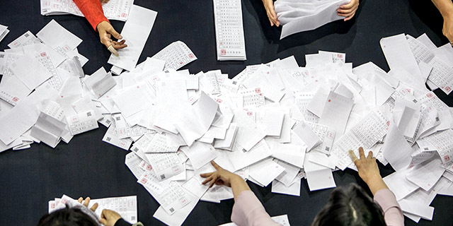
Tellers in Seoul, South Korea, count ballots from the May 2017 presidential election, which had a turnout of nearly 78% of the voting-age population. (Jean Chung/Getty Images)

Nearly 56% of the U.S. voting-age population cast ballots in the 2016 presidential election, representing a slight uptick compared with 2012 but less than in the record year of 2008. While most Americans – 70% in a recent Pew Research Center survey – say high turnout in presidential elections is very important, what constitutes “high turnout” depends very much on which country you’re looking at and which measuring stick you use.

The Census Bureau estimated that there were 245.5 million Americans ages 18 and older in November 2016, about 157.6 million of whom reported being registered to vote. (While political scientists typically define turnout as votes cast divided by the number of eligible voters, in practice turnout calculations usually are based on the estimated voting-age population, or VAP.) Just over 137.5 million people told the census they voted in 2016, somewhat higher than the actual number of votes tallied – nearly 136.8 million, according to figures compiled by the Office of the Clerk of the U.S. House of Representatives, though that figure includes more than 170,000 blank, spoiled or otherwise null ballots. That sort of overstatement has long been noted by researchers; the comparisons and charts in this analysis use the House Clerk’s figure, along with data from the International Institute for Democracy and Electoral Assistance (IDEA) and individual nations’ statistical and elections authorities.

The 55.7% VAP turnout in 2016 puts the U.S. behind most of its peers in the Organization for Economic Cooperation and Development (OECD), most of whose members are highly developed, democratic states. Looking at the most recent nationwide election in each OECD nation, the U.S. placed 26th out of 32 (current VAP estimates weren’t available for three countries).

The highest turnout rates among OECD nations were in Belgium (87.2%), Sweden (82.6%) and Denmark (80.3%). Switzerland consistently has the lowest turnout in the OECD: In 2015, less than 39% of the Swiss voting-age population cast ballots for the federal legislature.

One factor behind Belgium’s high turnout rates – between 83% and 95% of VAP in every election for the past four decades – may be that it is one of the 24 nations around the world (and six in the OECD) with some form of compulsory voting, according to IDEA. (One canton in Switzerland, also an OECD member nation, has compulsory voting.)

While compulsory-voting laws aren’t always strictly enforced, their presence or absence can have dramatic impacts on turnout. In Chile, for example, turnout plunged after the country moved from compulsory to voluntary voting in 2012 and began automatically enrolling eligible citizens. Even though essentially all voting-age citizens were registered for Chile’s 2013 elections, turnout in the presidential race plunged to 42%, versus 87% in 2010 when the compulsory-voting law was still in place. (Turnout rebounded slightly in last year’s presidential election, to 49% of registered voters.)

Chile’s situation points to yet another complicating factor when comparing turnout rates across countries: the distinction between who’s eligible to vote and who’s actually registered to do so. In many countries, the government takes the lead in getting people’s names on the rolls – whether by registering them automatically once they become eligible (as in, for example, Sweden or Germany) or by aggressively seeking out and registering eligible voters (as in the UK and Australia). As a result, turnout looks pretty similar regardless of whether you’re looking at voting-age population or registered voters.

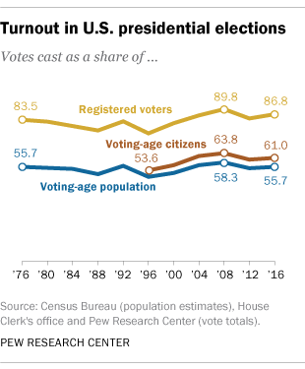

In the U.S., by contrast, registration is mainly an individual responsibility. And registered voters represent a much smaller share of potential voters in the U.S. than just about any other OECD country. Only about 64% of the U.S. voting-age population (and 70% of voting-age citizens) was registered in 2016, according to the Census Bureau report, compared with 91% in Canada (2015) and the UK (2017), 96% in Sweden (2014), and 99% in Slovakia (2016).

As a consequence, turnout comparisons based only on registered voters may not be very meaningful. For instance, U.S. turnout in 2016 was 86.8% of registered voters, fourth-highest among OECD countries (and highest among those without compulsory voting). But registered voters in the U.S. are much more of a self-selected group, already more likely to vote because they took the trouble to register themselves.

There are even more ways to calculate turnout. Michael McDonald, a political scientist at the University of Florida who runs the United States Election Project, estimates turnout as a share of the “voting-eligible population” by subtracting noncitizens and ineligible felons from the voting-age population and adding eligible overseas voters. Using those calculations, U.S. turnout improves somewhat, to 59.3% of the 2016 voting-eligible population. However, McDonald doesn’t calculate comparable estimates for other countries.
No matter how they’re measured, U.S. turnout rates have been fairly consistent over the past several decades, despite some election-to-election variation. Since 1976, voting-age turnout has remained within an 8.5-percentage-point range – from just under 50% in 1996, when Bill Clinton was re-elected, to just over 58% in 2008, when Barack Obama won the White House. However, turnout varies considerably among different racial, ethnic and age groups.

In several other OECD countries, turnout has drifted lower in recent decades. Greece, which has a compulsory-voting law on the books (though it’s not enforced), saw turnout in parliamentary elections fall from 89% in 2000 to 62% in September 2015. In Norway’s parliamentary elections last year, 70.6% of the voting-age population cast ballots – the lowest turnout rate in at least four decades. And in Slovenia, after a burst of enthusiasm following the country’s independence from Yugoslavia in 1992 (when 85% of the voting-age population cast ballots), turnout fell rapidly – sinking to 54% in 2014, a drop of 31 percentage points in just over two decades of democracy.

On the other hand, turnout in recent elections has bumped up in several OECD countries. In Hungary’s parliamentary elections this past April, nearly 72% of the voting-age population voted, up from 63.3% in 2014. In the Netherlands, turnout rose from 71% in 2012 to 77.3% in March 2017. And turnout inched above 69% in September 2017’s German parliamentary election – the highest level since 2005.

The Washington Post
By Gilad Edelman and Paul Glastris
January 26, 2018

Letting people vote at home increases voter turnout. Here’s proof.

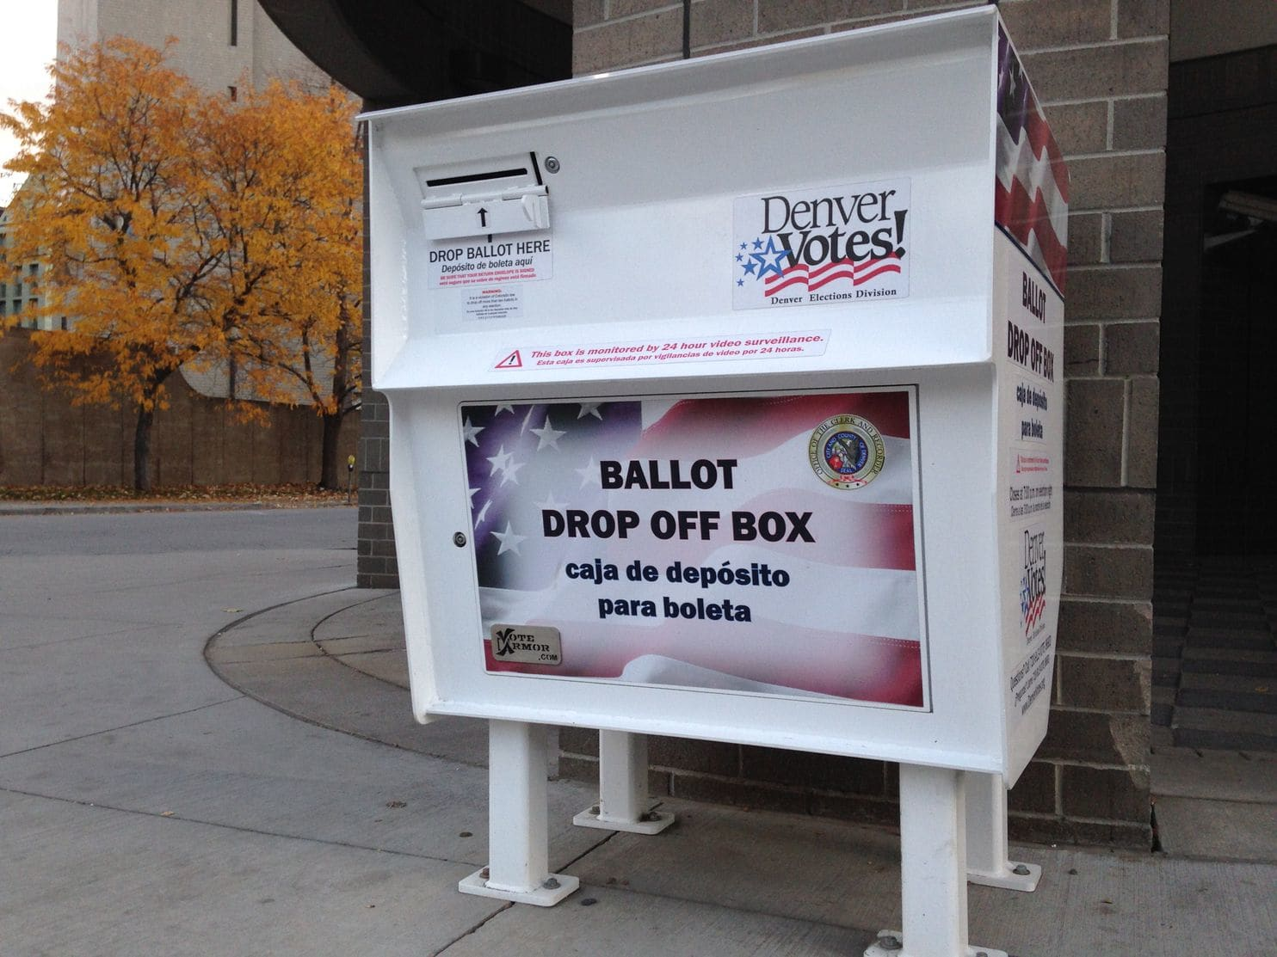
A ballot drop-off box in Denver during Colorado’s 2014 election, the first one there where people could vote at home. (Ivan Couronne/AFP/Getty Images)

It's no secret that American democracy is in a bad way. In the last midterm elections, only about 37 percent of eligible adults voted — the worst showing since World War II. Trump fever may push that number up this November, or it may not. The Alabama Senate election in December, in which Democrat Doug Jones won a surprise victory, was heralded for its unusually high turnout for a special election — yet even that was only 40 percent of registered voters and less than 30 percent of eligible adults, showing how low our expectations have fallen. The problem is especially acute for Democrats, because participation is typically lower among minorities, the poor and the young. But it ultimately hurts both parties, because hyper-low turnout in primaries empowers the most extreme candidates at the expense of the party establishments — as the GOP learned in Alabama with Roy Moore.

Over the past few years, Washington Monthly, where we work, has published a series of articles arguing that the simplest and most effective way to address these problems is to adopt universal vote by mail, also known as "vote at home." The idea is simple: Instead of going to a designated polling place, every registered voter automatically receives a ballot in the mail. They have a window of time, typically two weeks, to fill it out and either mail it back or drop it off at a secure site.

By making voting dramatically more convenient and changing it from opt-in to opt-out behavior, vote at home promises to boost turnout, especially among the people who today vote the least, and to broadly expand participation in lower-profile, non-presidential elections. Yet only a handful of states have begun to use it. Republican political leaders fear that it would benefit Democrats; meanwhile, some Democrats aren't convinced that vote at home would help them. Some even worry that it could help the other side. They point to the 2014 election in Colorado, the state's first using a vote-at-home system, in which Democrat Mark Udall lost his Senate seat.

But there's never been concrete data to test either side's interpretation. So last summer, we commissioned a study by the political research firm Pantheon Analytics, using data from Colorado's 2014 election for more than 2.8 million registered voters. The study found that vote at home increased overall turnout by 3.3 percent, and by even more among young and low-propensity voters. The implication is clear: Anyone who cares about improving turnout should make expanding vote at home a top priority.

The challenge in trying to evaluate the impact of vote at home on turnout is that there's never a control group. Turnout rates in the states where everyone can vote at home — Oregon, Washington and Colorado — have increased since the system was adopted, and they're now among the highest in the country. But because elections are complicated, and each state's demographics are unique, it's hard to prove that vote at home is the cause.

So Pantheon Analytics did the next best thing. The firm looked at voter files — the records of individual voters kept by state elections officials — in Colorado in 2014 and compared them with the predictions of a respected voter turnout model created by the Democratic-leaning consulting firm Clarity Campaign Labs. Turnout models use publicly available voter file information — age, sex, voting history — combined with consumer data to generate a probability score for each registered voter.

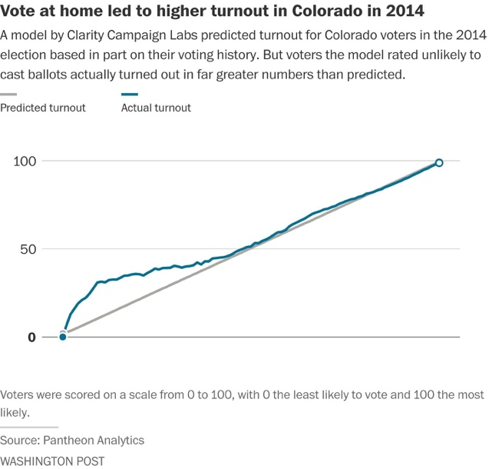
With the benefit of hindsight, we know that the Clarity model was fairly accurate nationwide in 2014. But because it was based on past elections, it couldn't account for changes to a state's electoral system. So if the 2014 results in Colorado, which was implementing vote at home for the first time, deviated from the predictions, it would be reasonable to infer that vote at home was the reason — especially if voting was up among people with low predicted turnout.

That's exactly what happened. Nationally, the Clarity model slightly overpredicted turnout. But in Colorado, it was the opposite: Turnout was 3.3 percentage points higher than the model forecasted. Even more significant, that increase was mostly driven by a huge boost among people with the lowest turnout probability scores. Registered voters assigned a 10 percent chance of voting, for instance, turned out at a 31 percent rate.
Who were these overperforming voters? Overwhelmingly, they were young. The 18-to-24-year-old bracket, forecast to turn out at 26.6 percent, actually turned out at 38.7 percent. And 25-to-34-year-olds outperformed their prediction by 7.4 percentage points.

Those results should have Democrats salivating. While there are many reasons they struggle to win elections — candidates and campaigns matter too, of course — Democrats' biggest hurdle is turnout. If young people voted as regularly as seniors, Democrats would win a whole lot more elections. (In Alabama last month, Jones won voters under age 30 by 22 percentage points.) A boost like Colorado's could have major implications if replicated nationwide.

At the same time, the results broken down by partisanship are more ambiguous. When analyzed by party affiliation, vote at home seems to have benefited Republicans slightly more: Registered Republicans outperformed the model by 3.7 points , compared with 2.8 points for registered Democrats. But voters with no party affiliation outnumber both registered Democrats and Republicans in Colorado, and they outperformed the model by 3.1 points.

An analysis according to a Clarity predictive partisanship model yielded similarly inconclusive results. The model scores people from 0 to 100, where 0 is "definitely voting Republican" and 100 is "definitely voting Democrat." People pegged as near-certain Republican voters beat turnout predictions by 2.3 points, while near-certain Democrats outperformed by 1.8 points. Again, that's an apparent (but tiny) advantage for Republicans.
But the biggest turnout boosts were toward the middle of the spectrum. Voters with a partisanship score between 60 and 70 — likely Democratic leaners — outperformed the model by 7.9 points. Those in the 40 to 50 range did so by 6.1 points. This group would be classified as weak Republican leaners, potentially still persuadable for a savvy Democratic campaign. Younger people are probably overrepresented in that middle zone, because they have less survey data and voting history to use to assign them a partisanship score.

Vote at home clearly seems to have pushed young people and infrequent voters into the electorate — exactly what our ailing system needs. Democrats should be fighting tooth and nail to get it implemented wherever possible. But the partisanship results are hazy enough that Republicans shouldn't be too scared: It looks like these low-frequency voters tend to be less partisan and therefore more up for grabs.

Besides, boosting turnout in lower-profile elections would be good for the long-term health of both parties. Low turnout may help Republican candidates prevail in general elections, but it also empowers the right-wing fringe, leading to a party that, once in power, is incapable of governing — as the GOP's inability to prevent a shutdown, despite unified control of the federal government, recently illustrated.

Meanwhile, vote at home offers tangible benefits for voters of any party affiliation. Because it relies on old-fashioned pen and paper, it can't be hacked. While ballots are counted by machine, those machines don't need to be connected to the Internet, and a paper trail is there for a recount. Since 2000, tens of millions of mailed-out ballots have been cast in Oregon, Washington and Colorado, without a hint of serious fraud or other mischief. (As a check against possible fraud, election officials match signatures on the ballots against those on voters' registration cards.) And counties stand to save millions of dollars per election rather than paying for poll workers and voting machines or renting voting locations, money that can be used to provide other essential services. Perhaps we would lose something intangible by doing away with brick-and-mortar polling locations and "I voted" stickers — an element of performative civic participation. But that would be a small price to pay for increasing actual civic participation.

So, unless you adore waiting in lines on Election Day, what's not to like? Adopting a vote at home system nationwide could go a long way toward reviving our democracy. But to make that happen, more states have to follow the example of Colorado, Oregon and Washington.

The Nation Magazine
July 27, 2017
By Sean McElwee, Brian Schaffner, and Jesse Rhodes

How Oregon Increased Voter Turnout

More Than Any Other State

New evidence shows how automatic voter registration increased not only voter participation but also voter diversity.

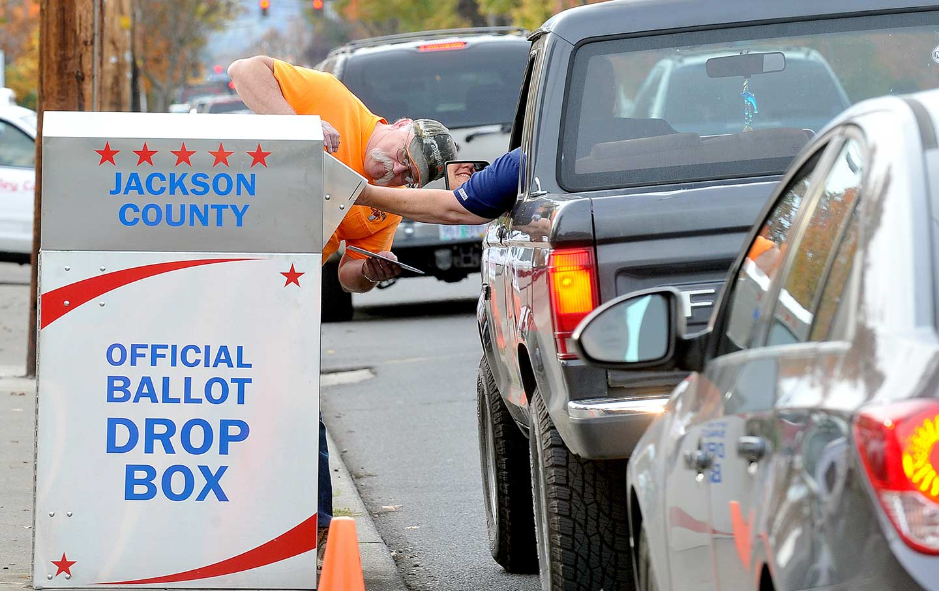
Voters drop off ballots by foot and by car in Medford, Oregon, on November 7, 2016. (The Medford Mail Tribune via AP / Denise Baratta )

The United States has a voter-turnout problem. For decades, participation in presidential elections has ranged from about 50 to 65 percent of eligible voters, and in midterm elections has averaged between 25 and 45 percent. Turnout in state and local elections is typically much lower, sometimes in the single digits. Voter turnout in the United States trails that of most other developed democracies.

Low voter turnout is not merely a problem of numbers. It has the effect of skewing politics and policy making toward the preferences of groups most likely to turn out to vote: whites, older Americans, the affluent, and those with more education. Conversely, people of color, low-income people, and young people are substantially underrepresented in the electoral process and in policy making. Instead of giving everyone an equal voice in the political process, our democracy gives some people voice and power, while others are shut out—including many who have historically faced, and continue to face, active suppression of their right to vote.

For this reason, activists, policy-makers, and social scientists have worked for decades to increase turnout in elections. Reforms that target registration tend to be most effective. For instance, same-day registration boosts participation and facilitates stronger class diversity among the electorate. But even then, it is a persistent challenge to maintain and expand overall participation, particularly among people who vote less consistently.

Recently, policy-makers have begun examining automatic voter registration (AVR). It has generated a lot of excitement, and rightly so. New research from Demos examines the effects of Oregon’s recent adoption of AVR on the level and composition of turnout in the 2016 federal election. Using unique individual-level data, we provide new evidence that AVR increased the racial diversity of Oregon’s electorate. Our findings suggest that AVR is effective in raising voter turnout, especially among individuals who are voting for the first time or are less-frequent voters. These patterns point to a positive relationship between AVR and increased voter participation, and demonstrates that AVR is a successful reform to reduce political inequities stemming from the historic underrepresentation of young people, people of color, and low-income people in the electorate.

OREGON’S AVR PROGRAM

In almost every state, persons who wished to vote in the 2016 election had to take affirmative steps to register themselves. This system of self-registration puts the burden on the individual to obtain and maintain registration status.

The exceptions were North Dakota (which does not legally mandate registration in order to vote) and Oregon, which in January 2016 became the first state in the country to implement automatic voter registration. This reform increased access to voting by using information already provided to the government in order to add eligible individuals onto the voter rolls. Under the new Oregon program, eligible voters who have a qualifying interaction with the DMV are notified by mail that they will be added to the voter rolls, unless they decline registration or opt out within 21 days by returning a postcard to the state’s election authorities.

For purposes of primary voting, this notification postcard also allows individuals to choose a political party. If no response is given, these individuals become automatically registered as “non-affiliated” voters, which makes them ineligible to vote in primaries because Oregon has a closed primary system. Automatic address updates and notifications also take place through this system.

AVR HELPED INCREASE TURNOUT AND PROMOTE A MORE INCLUSIVE ELECTORATE

In 2016, 288,516 people registered to vote for the first time in Oregon. Of individuals registering for the first time, 186,050—or 66 percent—were registered via the AVR program. An additional 35,000 Oregon residents whose registration had lapsed were reregistered through AVR. Given these figures, it is not unreasonable to conclude that without AVR, 220,000 fewer citizens likely would have had the opportunity to vote in the 2016 elections.

Did people registered by AVR turn out to vote? Of the individuals who were registered for the first time through Oregon’s new program, a significant portion—67,902, or 36 percent—voted in 2016. In our view, AVR has been successful in mobilizing many new Oregonians to participate in the election who may not have voted without this program being in place.

Critics will find difficulty arguing against the Oregon AVR’s healthy turnout impacts. Turnout in Oregon increased more between 2012 and 2016 than in any other state. Overall voter turnout in the state reached 68 percent in the 2016 presidential election, up from 64 percent during the 2012 non-AVR election period.

Nationally, voter turnout increased by only 1.6 points. This stands out for two reasons. First, Oregon already held perennial status as one of the top voter-participation states in the country. Second, in a non-swing state that didn’t feature a competitive Senate race, the 2016 presidential candidates invested zero television or radio advertisement dollars during the critical final two-and-a-half weeks leading up to Election Day. We estimate that AVR accounted for at least 38 percent of individuals who registered in 2016 and voted.

AVR also helped increase the diversity of Oregon’s electorate. Oregon’s citizen voting-age population is 84 percent white, but its voting electorate is 94 percent white. By comparison, 89 percent of the new AVR voters (individuals who were registered using AVR and had no record of voting going back to 2008) were white.

Fourteen percent of those who were registered automatically were people of color, roughly equal to the share of the Oregon’s minority population (16 percent). While 3 percent of non-AVR voters were Latino, 7 percent of new AVR voters and 9 percent of AVR registrants were. Less than 2 percent of the non-AVR voters were Asian, compared to 4 percent of AVR registrants and 3 percent of AVR voters.

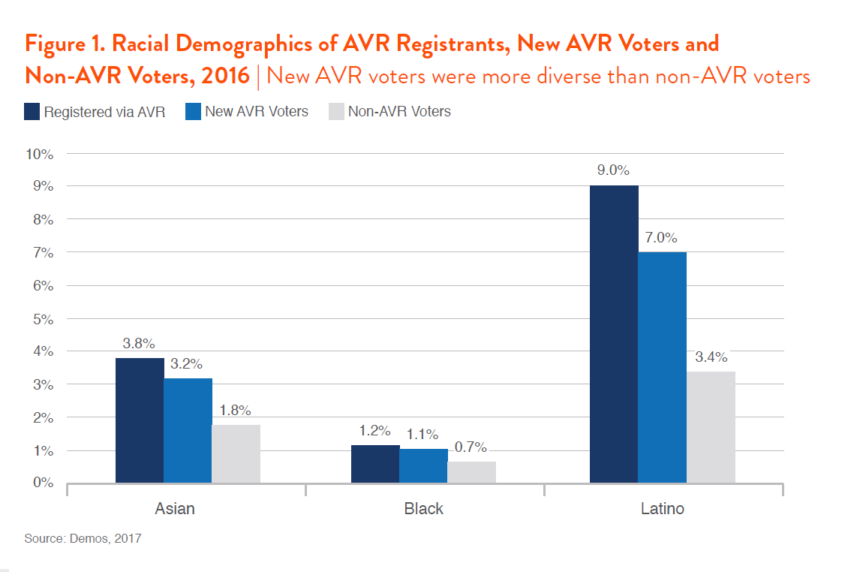

AVR also brought in more young and low-income voters. Only 13 percent of non-AVR voters were between the ages of 18 and 29, compared to 37 percent of new AVR voters. And 39 percent of new AVR voters lived in Census Blocks with a median income below $45,000 compared to 34 percent of non-AVR voters. Twenty-six percent of new AVR voters lived in neighborhoods with a median income over $60,000, compared with 31 percent of non-AVR voters.

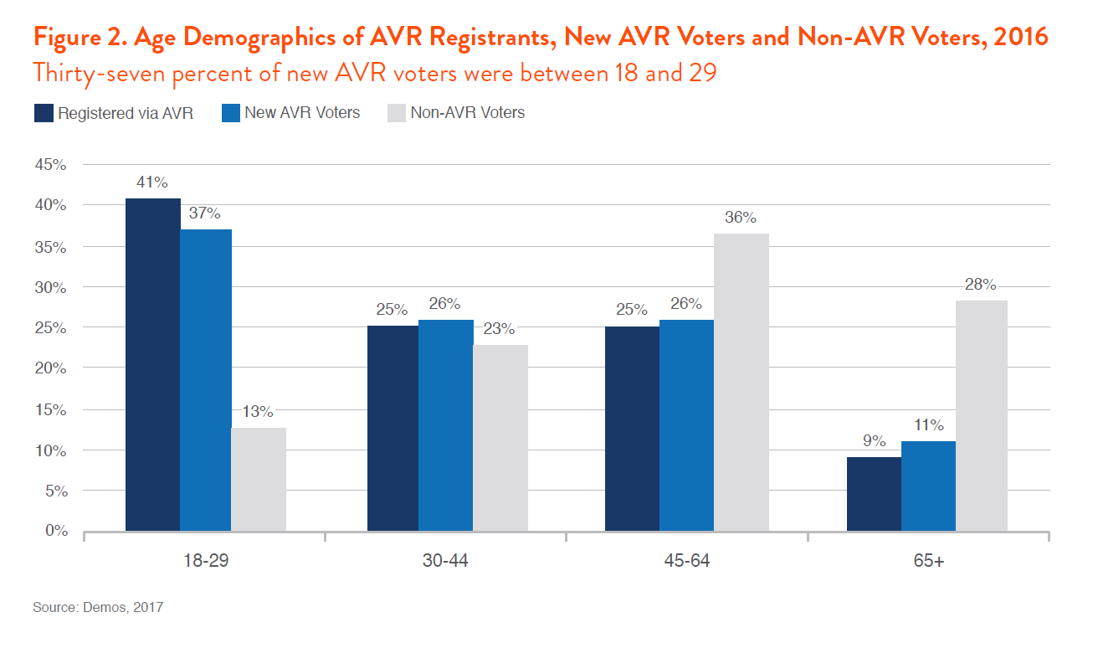
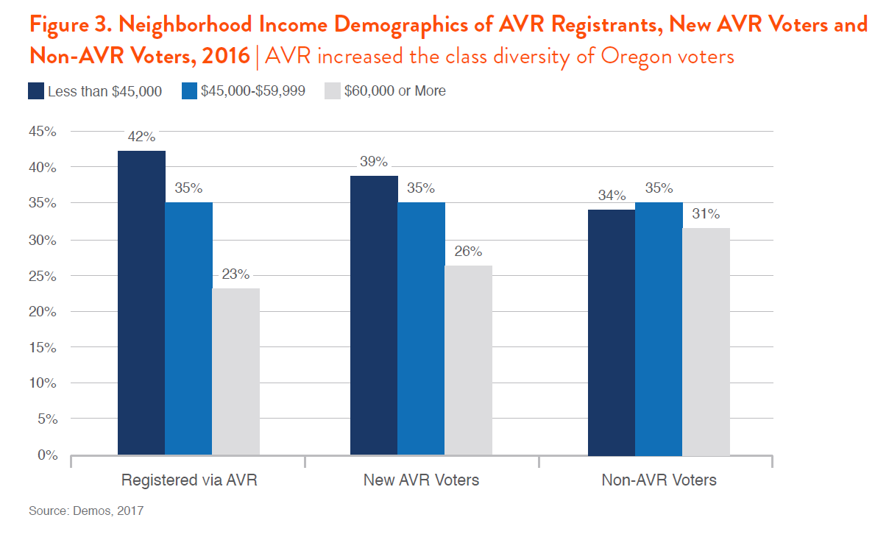

A KEY REFORM FOR DEMOCRATIC INCLUSION

The Oregon program has important implications for both the extent and composition of voter turnout. The causes of low voter turnout in the United States are clear: The requirement that individuals register in order to become eligible to vote is a major obstacle to equal participation in American elections. Many nations with higher turnout rates automatically enroll their citizens to vote.

Some academics and policy-makers scoff that if people want to vote, they will register ahead of time. However, many states have registration deadlines as far out as 30 days before an election. This unduly punishes individuals who may want to register but can’t because of practical life realities—such as losing time from work, caregiving responsibilities, or transportation access, among other reasons—which render these deadlines prohibitive. Research suggests that deadlines closer to the election increase turnout, and extensive research confirms that same-day registration also bolsters participation.

Automatic voter registration could empower workers with multiple jobs, low-income people, people of color, and young people to fully participate in our democracy. Our evidence suggests that automatic registration increases turnout and the diversity of the electorate. It’s time for more states to embrace this important idea for a more robust and inclusive democracy.

FAQs about Voting in Oregon

- What are the requirements to register to vote in Oregon?
- It’s the day before Election Day and I am ready to register. Can I?
- When should I update my voter registration?
- Must I select a political party when I register?
- How do I actually register?
- Where do I find the forms?
- Can I vote when I go away to college?
- I know people with felony records. Can they vote?
- What are voter registration laws like in other states?
- My one little vote doesn’t count for much. Why should I bother?
---

1. What are the requirements to register to vote in Oregon?
A. There are three requirements:
- You must be 16 in order to register to vote once you turn 18.
- You must be a US citizen. Oregon does not require proof of citizenship like some states.
- You must be a resident of Oregon. This requires that you show a driver’s license or ID issued by the Department of Motor Vehicles, or provide the last 4 digits of your social security number, or provide a utility bill, paycheck stub, bank statement or government document.

2. It’s the day before Election Day and I am ready to register. Can I?
A. Well, yes, you can register but you won’t be able to vote the next day. In Oregon, you must register at least 21 days before Election Day. This year’s deadline to register October 18, 2016.

3. When should I update my voter registration?
A. The most common time to update is if you change your home or mailing address. You should also update if you change your name or want to change or select a political party.

4. Must I select a political party when I register?
A. No. When you register you will be given many party choices including “not a member of a party.” Your selection will determine what ballot you get for the primary elections.

5. How do I actually register?
A. There are two ways: one where you do nothing because it happens automatically, and another where you actually sign up.
- You may already be registered and not even realize it! Oregon revolutionized voter registration nationwide when it passed a new law in 2015. Oregonians become automatically registered to vote when they apply for or renew an Oregon Driver’s License, Learner’s Permit or State I.D.
- People can register using a paper form or online.

6. Where do I find the forms?
A. Voter registration forms may be found in many places. Here are a few:
- DMV offices (paper),
- any county elections office (paper),
- Oregon Secretary of State, Elections Division (paper and online, oregonvotes.gov) and
- League of Women Voter’s online resource: Vote411.org (paper).

7. Can I vote when I go away to college?
A. Absolutely! Two things you should keep in mind: (1) when two addresses are involved (home and school), you can be registered to vote at only one of them and that address determines which ballot you will get; and (2) Oregon is a vote by mail state and the ballots are mailed about three weeks before Election Day. Therefore, you have choices. If you are already registered at home and want to vote using that ballot, you can go home to vote or have your parents or guardian mail your ballot to you, or you can officially request (oregonvotes.gov) that the ballot be delivered at school. Or, you can change your address so you get the school-area ballot. If you are going to college in a different state and want to become an official resident there, then you should register in the new state according to its laws. When you register in a new state, be sure to answer the part about previous registration so it can notify Oregon (and Oregon will cancel your registration). Bottom line, go to oregonvotes.gov and it will walk you through whatever steps are needed.

8. I know people with felony records. Can they vote?
A. Yes. Oregon is one of 12 states that restores voting privileges after incarceration. Generally, a person cannot vote if currently serving a jail or prison sentence for a felony conviction, except in Maine and Vermont where people in prison are allowed to vote.

9. What are voter registration laws like in other states?
A. Thirty-three states have voter ID laws where voters must show ID when they go to their local polling place to cast their ballot on Election Day. This has created problems for voters who lack an ID and have difficulty assembling the necessary documentation (see Handout 3 Why Voter ID Laws are Controversial: The Case of Viviette Applewhite?). This is not a factor in Oregon because we vote by mail. To learn about the requirements in other states, refer to the Voter ID backgrounder and chart.

10. My one little vote doesn’t count for much. Why should I bother?
A. The Oregon Bus Project estimates that the Millennial Generation will represent one-third of all eligible voters in the U.S. Ever wonder why health care gets so much air time? Because the elderly vote – and the elderly care dearly about health care. Want education (environment, jobs, you fill in the blank) to get more attention? Then vote. The power of the Millennial voice – your voice – in influencing and potentially controlling the decisions is just waiting for 18-30 year olds to act. As for one little vote not counting for much, wrong. Oregon’s Governor Kate Brown won her first election as by just seven votes (see Every Vote Counts! backgrounder). Your vote matters.

LOW VOTER TURNOUT
INTERVIEW ROLE PLAY

Practice your interview skills. When researching the issue of low voter turnout, interviewing stakeholders in the community is an important part of the process. Assume the role of one of the stakeholders and be interviewed by others. Questions to ask:

- Why does voting matter in your perspective?
- How would you get more people to vote?
- What is the most convincing argument you have to motivate people to vote?

After a few minutes, swap roles. Interviewers become stakeholders (in a role not interviewed) and stakeholders become interviewers (interviewing for a different role).

ROLES
Cut into individual roles and distribute.

1. County Elections Official

2. Member of the State Legislature (Oregon Representative or Senator)

3. League of Woman Voters Member

4. Secretary of State’s Office

5. Lobbyist

6. Democratic Party Member

7. Republican Party Member

8. Bus Project Volunteer

9. Political Campaign Worker

10. County Commissioner

11. Typical 25 year old

12. Judicial Candidate

1. County Elections Official

My job is to uphold a reputation for transparent, accurate, accessible and accountable elections. County Elections offices conduct all local, city, county, state and federal elections for the citizens of our county. Conducting elections involves registering voters; maintaining the voter data base; maintaining address and district data; checking signatures on city, local and state candidate/initiative petitions; accepting candidate/measure filings; producing voters' pamphlets; issuing and mailing ballots; establishing drop site locations; accepting and processing returned ballots; counting ballots; and releasing results.

Using Multnomah County as an example, there are about 748,00 residents in Multnomah County and about 80% of them are 18 and older – or about 598,400. Yet only 402,285 or 67% of them are registered to vote. We are open to serve the public 8 a.m. - 5 p.m., Monday - Friday and 7 a.m. - 8 p.m. on Election Day. Here are the voter turnout statistics for age groups Multnomah County’s recent May elections.

Ages 18-24 Eligible 31,815 Accepted 4795 15.07%

Ages 25-39 Eligible 12,062 Accepted 300771 24.94%

Ages 40-54 Eligible 10,663 Accepted 402991 37.79%

Ages 55+ Eligible 14,321 Accepted 858298 59.93%

402285 total eligible 161,000 total ballots counted 40.02% turnout

Statewide, with 2,021,263 registered to vote, only 787,847 (38.98%) voted in the the May 2012 Primary.
In 2008, we had 2,153,914 registered and 1,845,251 or 85.67% turnout (the highest turnout since 86.51% in 1960).
In 2010 we had 2,068,798 registered or 1,487,210 or 71.89% voting.
The estimated number of eligible voters is 2.8 million (as of Dec. 2008).

2. Member of the State Legislature (Oregon Representative or Senator)

As an elected official, I am concerned that many people still do not vote. Some are afraid to vote on issues they do not understand. We greatly appreciate the support of the League of Women Voters to provide information for voters. Citizens need to embrace their civic responsibility and become informed about candidates and the ballot measures. As a legislator with staff and many colleagues with whom to consult during the session, I understand the work involved in trying to consider all the issues surrounding ballot measures. When citizens vote on ballot measures, they assume the role of a legislator, too.

I try to visit schools in my district urging students who are 17 and older to register to vote and keep their voter registration information up to date so they can receive a ballot. I cringe when I think about the money we spend to mail ballots that are not returned.

3. League of Woman Voters Member

I am excited to be a member of the League. We are a non-partisan organization with a mission to provide assistance in getting voters registered to vote, voter education improving elections and improving government.

The League strives to ensure that government at every level works as effectively and fairly as possible. This involves continual attention to issues of transparency, a strong and diverse judiciary, appropriate government oversight, and funding. The League of Women Voters is a citizens’ organization that has fought since 1920 to improve our government and engage all citizens in the decisions that impact their lives. We operate at national, state and local levels through more than 800 state and local Leagues, in all 50 states as well in DC, Puerto Rico, the Virgin Islands and Hong Kong.

Formed from the movement that secured the right to vote for women, the centerpiece of the League’s efforts remain to expand participation and give a voice to all Americans. We are well known for hosting candidate debates and forums. We undertake this and other important election work because we believe deeply that the public should hear different views on the issues facing our communities and our nation. An honest and respectful sharing of ideas is vital to the functioning of American democracy.

Being nonpartisan does not mean we lack opinions, or the willingness to express them. Our opinions are formed after research, study and consensus. We are passionate advocates – both women and men – who work to influence policy on specific issues by speaking out and putting pressure on our elected leaders.

On the national level we are closely watching state efforts to restrict voting through ID requirements. These restrictions ultimately discourage voters from participating. There is another layer of bureaucracy being created which will only pass more costs on to the voters. The level of provable fraud is so miniscule given the restrictions that are being placed on people in over 20 states.

In Oregon we are famous for our Voters’ Guide summarizing the candidates and ballot measures.

We have worked hard nationwide to increase high school voter registrations. We are committed to providing key voter information at Vote411.org to help voters across the country.

4. Secretary of State’s Office

We have the responsibility to oversee all of the elections in the State. We work with all of the county elections offices. We are responsible for publishing the State Voter’s Guide, which, as you may recall, comes in two volumes some years depending on the number of ballot measures we have.

5. Lobbyist

My job is to persuade folks to vote for the position of my clients. I work hard to prepare materials including media ads to get our position out. Much of my job is spent building relationships with people and providing additional information on a given position. Some of my time is spent as a political strategist. There are times when it is helpful to our cause if people are confused and do not vote on a given issue. We are not always about more people voting – especially if they disagree with our position.

6. Democratic Party Member

We are working day and night using social media, etc. to get information out to young voters and recruiting them to volunteer to help work on our fall campaigns. We have found that peer encouragement can help get more first-time voters to the polls. We know government can stimulate more jobs, correct the unfairness with immigration issues and we now have the green light to keep moving on solving problems with implementing the new health care laws. Get out the Vote efforts are our main focus.

7. Republican Party Member

Not all young people are Democrats. We are working hard to help young voters understand that balancing the budget and being fiscally conservative is in their best interest.

The Republican Party believes in the value of voluntary giving and community support over taxation and forced redistribution. Small government is a better government for the people. The Republican Party, like our nation's founders, believes that government must be limited so that it never becomes powerful enough to infringe on the rights of individuals.

You know what to do with your money better than government. The Republican Party supports low taxes because individuals know best how to make their own economic and charitable choices. Free markets keep people free. The Republican Party is supportive of logical business regulations that encourage entrepreneurs to start more businesses so more individuals can enjoy the satisfaction and fruits of self-made success.

8. Bus Project Volunteer

Not right, not left, but forward – that’s what we say at the Bus. We really do have a bus. We use it to travel the state and help register people to vote. We have also created a great lesson – fun, too! – on voting that we have volunteers who are willing to come to high school classrooms to present. The lesson shows that of the eligible voters, frequently only ¼ of the population is actually participating as voters. We sponsor a number of fun events like Candidates Gone Wild to help young voters connect with the candidates and understand the issues. Getting young people engaged is key to our efforts. We sponsored a weeklong Rebooting Democracy conference at a number of venues urging folks to get involved in Democracy.

We’re working hard to build a democracy that is accessible to every one of its citizens, supports equality amongst its people and is bold enough to think ahead and build a tomorrow that is better than today. To do that, we help elect forward-thinking candidates across party lines, support future-minded policy and do democracy’s greatest, hardest work: having meaningful one-on-one conversations with thousands upon thousands of voters. We have ideas to modernize the current voter registration system so everyone gets a ballot in Oregon. We are directly addressing the problem of low voter turnout by getting folks on the bus!

9. Political Campaign Worker

I am 70 years old and have voted every in every election since I was 21. I pride myself in being informed on the issues. I read several papers daily and stay connected online with political issues. Since I am retired, I make sure to pick a candidate who will need my help in getting elected. Sometimes I work on elections in my legislative district and other times I work for candidates who will not necessarily represent me. I understand the political process needs to help people feel more informed and comfortable with voting. Too often folks are turned off by all the political ads but that does not mean they should not vote. I invite my neighbors to house parties for candidates as a way to bridge the politics gap.

10. County Commissioner

All politics is local. The Commissioners conduct all legislative activities of the County. As such, they adopt policies; sit as the budget committee; review and amend the executive budget; hold hearings; and adopt the County budget. They act as liaisons to departments, advisory boards and commissions; make changes in administrative departments; fill vacancies in elective offices; and, adopt labor agreements. Topics range from corrections to mental health, juvenile services, criminal prosecution, public housing, air pollution, parks and land-use planning. We deal with issues that voters confront daily. We determine how to spend tax dollars on local services. It is key for voters to participate in selecting people who will make decisions that will directly affect their lives.

11. Typical 25 year old

I do not vote, never have and never will. I am not interested in all the fighting that goes on with elections. It seems now that people with money will buy the election with all the billions they can spend on advertising. How is the average person to know who, if anyone, is telling the truth? Where is that guy Walter Cronkite today? Government, especially Congress is more focused on fighting than on getting anything done. Yes, I understand that I pay taxes and so I should at least want to pay attention to what the politicians are doing with my money. But it is all so boring and complicated. I work at the Humane Society and help out in my neighborhood so I am not a complete do-nothing – but politics and voting are not for me.

12. Judicial Candidate

It is not easy to run for the office of Judge. A judges are not supposed to be politicians; they are supposed to be smart, good listeners, and fair. All of the judges in Oregon must run for office. There are strict rules about raising money for judicial races. I am not to know who contributes and must have someone else do the fundraising for me. Most lawyers do not have a statewide public recognition. So for those of us who run for the Court of Appeals or Supreme Court, we need to advertise, go to community meetings around the state, get statewide endorsements while staying within the restrictions of not answering questions about how we would decide an issue. We are not to be politicians. We cannot publicly identify as members of a political party.

Running for a judge position is straightforward when you do not have an opponent. But I have an opponent with support from a large lawyer association. I want people to vote, but I really want them to know who I am and why I am the best person for the position. It is not easy to educate folks about the role and skills needed to be a fair judge.
Name: Date:

Persuading Eligible Voters to Vote

There are 3 major modes of persuasion. They are taken from the Greek and help us to understand the different ways we can possibly convince others of our point of view:

Ethos: an appeal that uses the credibility or character of the person who is doing the persuading. Or using an expert witness or knowledgeable person’s words to help convince someone.

Logos: an appeal to the listener’s logical thinking. Convince your audience using reasoned arguments, evidence, and literal examples that will make sense to the person’s thinking.

Pathos: an emotional appeal that persuades your audience because you move them to feel a certain way about the topic. You may try to gain sympathy or anger or even excitement to convince someone of your opinion.

1. What arguments can you make in each of these three areas to persuade an eligible voter to turn up to vote this November?

Your Ethos Argument:

Your Logos Argument:

Your Pathos Argument:

2. Write a letter to an eligible voter (you may know them or it may be to a general person who can vote) and incorporate your above three types of persuasion to try to convince them to vote in November, and why their vote matters.

