****

**Classroom Law Project**

**Presents**

**Election 2020**

**Why Voting Matters**

**Unit 3**

**Voter Rights**

**Unit 3**

**Voter Rights**

**Essential Questions:**

* **What does the Constitution say about Voter Rights?**
* **How have voting rights changed over the years?**
* **Whose voting rights are being limited in 2020?**

**Objectives:**

Students will be able to

* Discuss what parts of the US Constitution deal with voter rights
* Identify the major moments in the history of voting rights in America
* Explain the current challenges to voting rights
* Design a solution for fair voter access

**Unit 3 Standards:**

**OR 2018 Grade 8 Social Studies Standards**

8.2

8.5

8.7

8.8

8.10

8.29

8.30

8.32

8.33

8.34

8.35

**Grade 8 CCSS Literacy in History/Social Studies**

6-8.RH.1

6-8.RH.2

6-8.RH.3

6-8.RH.5

6-8.RH.8

6-8.WHST.1

6-8.WHST.2

6-8.WHST.9

**OR 2018 High School Social Studies Standards**

HS.1

HS.4

HS.10

HS.11

HS.13

HS.54

HS.61

HS.67

HS.71

HS.73

HS.74

HS.76

**Grades 9/10 CCSS Literacy in History & Social Studies**

9-10.RH.1

9-10.RH.2

9-10.RH.4

9-10.RH.5

9-10.RH.8

9-10.RH.9

9-10.WHST.1

9-10.WHST.4

9-10.WHST.9

**Grades 11/12 CCSS Literacy in History & Social Studies**

11-12.RH.1

11-12.RH.2

11-12.RH.3

11-12.RH.8

11-12.RH.9

11-12.WHST.1

11-12.WHST.2

11-12.WHST.9

**Unit Vocabulary**

* Suffrage
* Gerrymandering
* Voter I.D.
* The Voting Rights Act of 1965
* The 14th Amendment
* The 19th Amendment
* The 26th Amendment

**Materials and Handouts**

**3.1 What is the history of Voting Rights in the U.S.?**

**Handouts:**

* + Voting Rights in the U.S. Constitution and Legislation
  + Who REALLY Gets to Vote: a Timeline
  + Article about voting rights for ex-felons
  + Article about lowering the voting age to 16
  + **Article on voter restrictions in 2020**
  + Analysis: Voting Rights Priorities

**3.2 What is gerrymandering and how does it affect voter rights?**

**Handouts:**

* + What is gerrymandering
  + Article: What Pennsylvania’s new congressional map means
  + Article: Drive Against Gerrymandering Finds New Life in Ballot Measures
  + A Solution Tree analysis of gerrymandering

**3.1**

**What is the History of Voting Rights in the U.S.?**

**Handouts:**

* + Excerpts from the US Constitution & Legislation regarding voting rights
  + Who REALLY Gets to Vote: a Timeline
  + Article about voting rights for ex-felons
  + Article about lowering the voting age to 16
  + Article: Voting Laws Roundup prior to 2020
  + Analysis: Voting Rights Priorities

**Lesson Overview:**

Interestingly, there is no explicit right to vote in the Constitution. But through the years, various groups have been added to the list of “eligible voters.” In this lesson, not only do students have the opportunity to look again at the US Constitution, but they will be able to see other laws that have been passed through history that have affected the right to vote for various groups. A constant refrain as students consider these issues should be the theme of this year: **Why Voting Matters**, and this lesson will focus on how that is affected by *who* gets to vote. Have our laws gone far enough to ensure everyone can vote? Your students may have some thoughts on this as they go through this unit.

**Suggested Opener:** Pros and cons to expanding voting eligibility are often a challenge to consider. What would be good about more people being able to vote? What might be bad about that? This would also be a good place to insert a current event about the coming election and some challenges people may be having with voting.

You might also brainstorm with your class “who is allowed to vote?” Once they come up with all of their ideas about who can vote, try a second list of who SHOULD be allowed to vote in addition to their first list. This lesson will answer the first question, and students will get the opportunity to consider the second question in more detail.

**Lesson Options:**

1. Jigsaw or read through together the **U.S. Constitution & Legislation** **excerpts** about voting rights and **Who Really Gets to Vote timeline** of voting access in the United States. Pair and Share discussions might be prompted by the question of what appears in these readings to motivate changes in law about who gets to vote? The answers require students to consider the time and the issues around each historical even they read.
2. Consider with your class what they already knew from this timeline and what surprised them about what they learned from this history. A modified K-W-L exercise would fit here well as a way for students to reflect and analyze the information.
3. The articles provided address a variety of voting challenges in modern America. They can be used as evidence for writing an analysis or an argumentative paper.
4. A worksheet for a Proposal for Voting Rights is included if you would like to challenge your students to compose a law that encompasses all the protections for voting they believe are important.

**Supplemental Lesson Ideas:**

1. Investigate more fully felons’ right to vote. Find out what Oregon’s law is regarding convicted felons’ right to vote. Discuss these questions:
   * Should a person who pays his or her debt to society should be allowed to vote?
   * Does the kind of crime a person was convicted of affect your opinion?
2. Research voting in other countries and ask students to consider issues such as Australia’s mandatory voting rule or how other countries hold elections on weekends or holidays.

**Voting Rights in the U.S. Constitution & Legislation**

**1787 - The U.S. Constitution is ratified**The Constitution, as originally written, did not define a citizen. Any citizen of a state was deemed a citizen of the nation. At the time, most states only granted the right to vote to white male property owners. By 1850, most landowner requirements were eliminated.

**1865 - Amendment XIII**In the aftermath of the Civil War, three amendments were ratified that expressly addressed the role of blacks in America: the Thirteenth, Fourteenth and Fifteenth Amendments. The Thirteenth Amendment was the first step towards full suffrage for black adult males, because it abolished slavery in the U.S.

**1868 - Amendment XIV**The Fourteenth Amendment to the Constitution defines the U.S. citizen, and thus clarifies who may vote: "All persons born or naturalized in the United States and subject to the jurisdiction thereof, are citizens of the United States and of the State wherein they reside." Children of immigrants, even illegal immigrants, are citizens and may vote when they come of age. However, this amendment does not expressly grant suffrage to non-whites and women. It does set the legal age for voting at 21. This amendment also allows a state to remove the right to vote for "participation in rebellion, or other crime." As a result, most states still ban incarcerated felons from voting, and several states extend that ban to ex-felons.

**1870 - Amendment XV**The Fifteenth Amendment forbids the federal government and the states from using a citizen's race, color or previous status as a slave as a disqualification for voting. By this amendment, suffrage is granted for black adult males, but not females. Many in the women's suffrage movement condemned the Fourteenth and Fifteenth Amendments as unfair to women.

**1920 - Amendment XIX**By the turn of the century, women were voting in many western states, but most states still banned them from the voting booth. In 1920, after several failed attempts, the Nineteenth Amendment was ratified. This amendment prohibits states or the federal government from restricting suffrage based on gender.

**1961 - Amendment XXIII**This amendment finally granted District of Columbia voters the ability to participate in presidential elections.

**1964 - Amendment XXIV**In the century that followed the Civil War, racial tension persisted. Five southern states still had a poll tax, which was eliminated by this amendment. The Supreme Court declared that even a $1.50 poll tax was an unfair burden.

**1965 - The Voting Rights Act**After blacks were granted the right to vote in 1871, literacy requirements, physical violence, property destruction, hiding the polls and economic pressures still kept many blacks from voting, particularly in the South. In some states, a voter could vote in primary elections only if his grandfather had been able to vote in primaries; other states only allowed whites to vote in the primaries. The Voting Rights Act was enacted in direct response to the Civil Rights movement. The act bans literacy tests and provides federal enforcement of voter registration and voting rights.

**1971 - Amendment XXVI**During the Vietnam War, many Americans felt it was unfair to send citizens to fight a war without the right to vote. This amendment sets the voting age at 18 across the nation for all elections.

**1975 - Voting Rights Act Reauthorization**By 1972, most adult citizens of the U.S. had the right to vote based on provisions in the Constitution. Congress amended the Voting Rights Act in 1975 to include language assistance for minority voters, who often could not vote if ballots and instructions were only available in English.

**1990 - Americans with Disabilities Act**The ADA addressed the need for physical access to the ballot box for all Americans

# *\*excerpted from CNN’s Student News One Sheet: The Right to Vote*

Who Really Gets to Vote? ☑

# Voting Timeline 1776-2001

**1776 -** White men with property can vote. Free black men can vote in New Jersey, Pennsylvania and Connecticut. (In Maryland between 1776-1783 free black men could vote, after 1810 no black men at all were allowed to vote.)  
  
**1789 -** Establishment of US democracy. White men with property can vote. Poor people, Women, Native Americans, and African- Americans cannot vote.  
  
**1790 –** 1790 Naturalization Act. The right to vote is tied directly to citizenship status; it is only for whites who have lived in the country for 2 years. In 1798 the law is changed so immigrant whites have to live in the US for 14 years before they can become citizens. This changed to 5 years after 1902.  
  
**1820 -** The property laws are taken off the books and whites can vote even if they do not own property. But they must pay a poll tax or be able to read and, in some places, they must pass religious tests before they can vote.  
  
**1848 -** The Treaty of Guadalupe-Hidalgo ends the Mexican-American War. The treaty guarantees citizenship to Mexicans living in the newly acquired territories of Arizona, California, New Mexico, Texas and Nevada. However, Mexican-Americans are not allowed to vote despite having US citizenship. Property laws, language and literacy requirements are the favored way of keeping people from voting. There are also the Night Riders who use intimidation and violence.  
  
**1866 -** The Civil War ends in 1865. Civil Rights Act of 1866 grants citizenship to native-born Americans but excludes Native Americans.  
  
**1870 -** The 15th Amendment establishes the right of African-American males to vote. In the South especially, poll taxes, reading requirements, physical violence, property destruction, hiding the polls, and economic pressures keep most African-Americans from voting. The Ku Klux Klan is a major part of the violence and intimidation used to keep African-Americans from voting.  
 **1882 -** The Chinese Exclusion Act bars people of Chinese ancestry from becoming citizens. They cannot vote.  
  
**1887 -** The Dawes Act gives citizenship only to Native Americans who give up their tribal affiliations.  
  
**1920 –** 19th Amendment allows women to vote nationwide. (Prior to 1920, women in the Wyoming and Utah territory and Colorado had full voting rights. )

**1921 -** The Sons of America are organized to fight for equality and the rights of Mexican Americans as citizens, including the right to vote. It will be **1975** before the right to vote is available to all Mexican-Americans.

**1922 -** In the case of *Takao v. United States* the US Supreme Court upholds the 1790 Naturalization Act that barred Asian-Americans from becoming citizens. This enforces the policy of no voting rights for Asian immigrants.

**1923 -** A court ruling decides that Asian Indians are eligible for citizenship. Technically, as citizens, they can now vote. However, almost all immigrants who are people of color continue to be denied the right to vote.  
  
**1924 -** The service of Native Americans during World War I helps to bring about the 1924 Indian Citizenship Act. The Act grants Native Americans citizenship, but many western states refuse to allow them to vote. Some of the tactics used to discourage voting includes physical violence, destruction of property, economic pressures, poll taxes, hiding the polls and reading requirements.  
  
**1943 -** The Chinese Exclusion Act is repealed, making immigrants of Chinese ancestry eligible for citizenship.  
  
**1946 -** Filipinos are now allowed to become citizens.  
  
**1952 -** The McCarran-Walter Act repeals racial restrictions of 1790 Naturalization Law. First generation Japanese can now become citizens.  
  
**1965 -** In a direct response to the Civil Rights movement led by Dr. Martin Luther King Jr. and others, The Voting Rights Act of 1965 is enacted. It bans literacy tests in the Deep South and provides federal enforcement of black voter registration and voting rights. This Act affects Virginia, Alabama, Georgia, Louisiana, Mississippi, North Carolina, and South Carolina. It also applies in Alaska.  
  
**1970 -** The 1970 Voting Rights Act bans literacy tests in 20 states including New York, Illinois, California and Texas.  
  
**1971 -** The 26th Amendment gives voting rights to 18 year olds in response to protests about men under 21 drafted for the Vietnam War but not able to vote.  
  
**1975 -** The Voting Rights Act is amended to include language assistance to minority voters. Language requirements have been used routinely to keep the vote from US born citizens who speak other languages. Now the Voting Rights Act has some real impact and enforcement in the Southwest.  
  
**1990 -** The Americans with Disabilities Act requires access to the polls and to the ballot.  
  
**2000 –** Vote fraud scandals in Florida and elsewhere. Thousands of eligible voters are prevented from voting. Over one million ballots are never counted.

**2001** – Help America Vote Act (HAVA) is passed and requires states to upgrade to electronic voting.

*Business Insider*

*Jan. 3, 2018*

*By Elena Holodny*

**Millions of American adults are not allowed to vote — and they could change history**

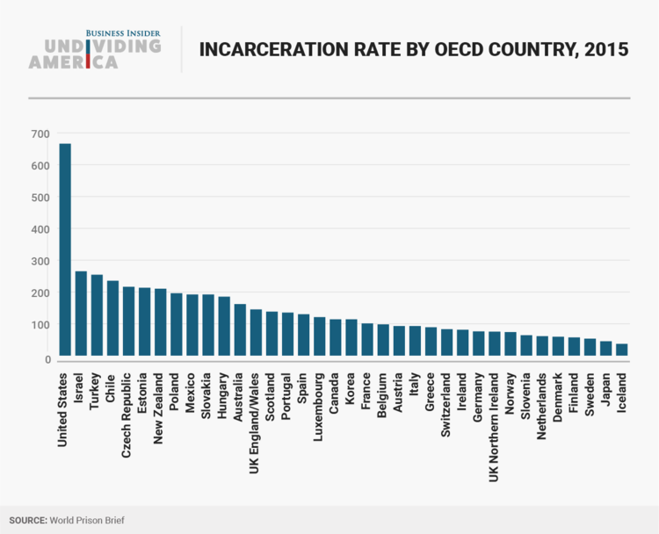A voter filling out a ballot for last year's US presidential primary election in a voting booth in Stark, New Hampshire. An estimated 6.1 million American adults were not allowed to vote in the 2016 election because they had a felony on their record.

Most had already served their sentences and returned to their communities. The majority of US states take away felons' voting rights, occasionally for life.

This disenfranchisement affects an estimated one in 40 adult Americans, or 2.5% of the total US voting-age population, according to The Sentencing Project, a group that advocates criminal-justice reform.

That number is greater than the entire population of Missouri, and it's the [largest](https://books.google.com/books?id=55_JDgAAQBAJ&pg=PA38&lpg=PA38&dq=largest+single+group+barred+from+voting&source=bl&ots=Xrq8fKMEeu&sig=J_XbAPeXvq_gSx_z3nhU8iTlJIg&hl=en&sa=X&ved=0ahUKEwjx86q_oO3UAhXGVz4KHQuvBAIQ6AEILzAC#v=onepage&q=largest%20single%20group%20barred%20from%20voting&f=false) single group of American citizens who are barred by law from participating in elections.

So many people are barred from the polls that some worry their absence could change election results. One study even suggested that allowing felons to vote in Florida could have tipped the 2000 presidential election to Democrat Al Gore.

About half of US states have loosened restrictions in recent years. But how this might affect the country's fractured politics is more complicated. Would ex-felons turn out to vote? And if they would, can we predict who'd benefit?

**The US is a huge outlier when it comes to incarceration**

The US has the one of the highest incarceration rates in the world, with about 670 inmates per 100,000 residents, according to figures from the International Center for Prison Studies. Some estimates put the figure higher.

That rate is about five times the average of other developed economies in the Organization for Economic Cooperation and Development. The next-closest OECD state is Israel, which has an incarceration rate of about 250 inmates per 100,000.

The number of Americans incarcerated has increased over the past 25 years.

The rate for US residents ages 18 and up rose from about 310 per 100,000 in 1980 to about 870 per 100,000 in 2015, a spike correlated with the "war on drugs"-era tough-on-crime policies. The rate peaked in the mid-2000s at about 1,000 per 100,000.

Which brings us to the first divide: the disenfranchisement of those with a conviction

Few major economies around the world allow inmates to vote. Politicians and voters generally argue that if a person does not follow the law, then that person should not get to choose lawmakers.

In the US, the Fourteenth Amendment grants states the authority to deny voting rights to those with criminal convictions, and then states can come up with their own rules for restoring those voting rights if they choose.

Maine and Vermont are the only two states that allow people in prison to vote. But it's what happens after a person has served time for a felony that is more controversial.

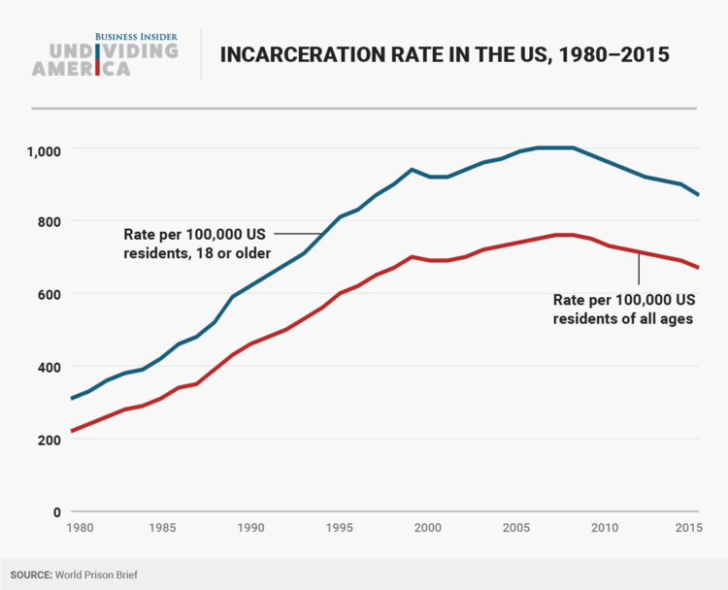Over three-quarters (77%) of disenfranchised voters are not actually in prison. Some are under probation or parole supervision, while others have completed their sentences, according to The Sentencing Project.

Twelve states — Alabama, Arizona, Delaware, Florida, Iowa, Kentucky, Mississippi, Nebraska, Nevada, Tennessee, Virginia, and Wyoming — restrict voting rights even after a person has completed a prison sentence and is no longer on probation or parole.

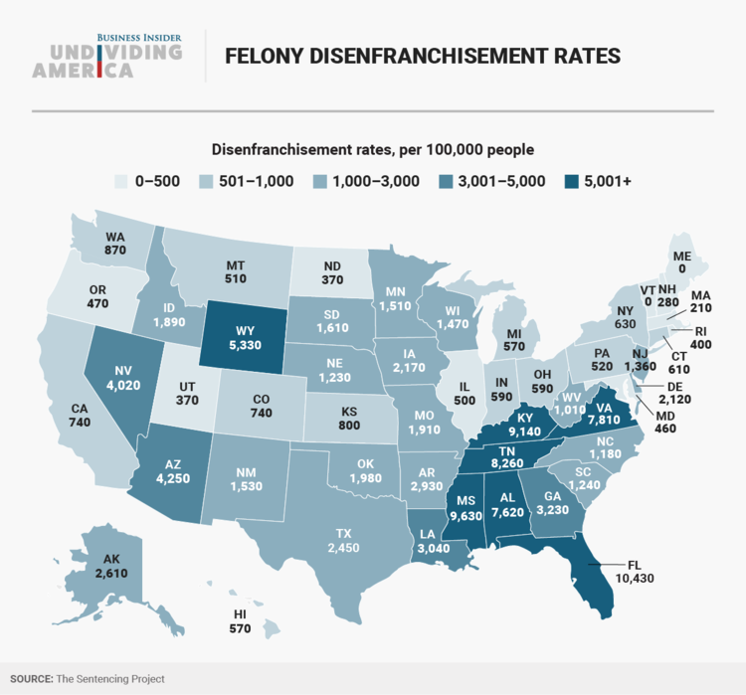

The affected people in those states make up over 50% of the entire disenfranchised population in the US.

**Which brings us to the second divide: race**

None of the laws barring ex-felons from voting explicitly mention race. The US, however, disproportionately arrests and convicts people of color. The effect is a huge disenfranchised voting bloc.

Black Americans of voting age are more than four times as likely to lose their voting rights as the rest of the adult population, with one of every 13 black adults disenfranchised nationally, according to The Sentencing Project.

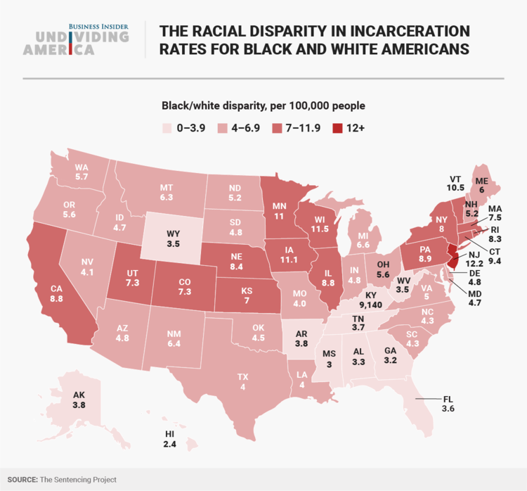

An estimated 2.2 million black citizens are barred from voting in total.

The rates of African-American felony disenfranchisement vary significantly by state, with startling numbers in a few: more than one in five African-Americans is barred from voting in Florida (21%), Kentucky (26%), Tennessee (21%), and Virginia (22%).

"This is largely the result of the historic growth in incarceration in recent decades and disproportionate enforcement of the failed 'war on drugs' in black and Latino communities, which has drastically increased the class of persons subject to disenfranchisement," The Sentencing Project said.

"Felony disenfranchisement statutes have weakened the political power of black and Latino communities," it added.

The racial compositions of prisons versus the adoption of disenfranchisement laws

African-American imprisonment rates have "consistently exceeded" those of whites since the Civil War era, according to US Department of Commerce data from the 19th century, cited in a study by Angela Behrens, Christopher Uggen, and Jeff Manza.

Looking at data from the 1850s to 2002, the trio found that states with greater nonwhite populations have historically been more likely to bar convicted felons from voting than states with proportionally fewer nonwhites.

"The expansion of citizenship to racial minorities, and the subsequent extension of suffrage to all citizens, threatened to undermine the political power of the white majority," Behrens, Uggen, and Manza wrote. "By restricting the voting rights of a disproportionately nonwhite population, felon disenfranchisement laws offered one method for states to avert [the changes]."

"The sharp increase in African American imprisonment goes hand-in-hand with changes in voting laws," they continued. "Felons disenfranchisement provisions offered a tangible response to the threat of new African-American voters that would help preserve existing racial hierarchies."

Notably, the percentage of nonwhite prison inmates nearly doubled from 1850 to 1870 in several Southern states, the authors also found. For example, about 2% of the Alabama prison population was nonwhite in 1850, but 74% of it was nonwhite in 1870 even though the total nonwhite population rose by just 3%, according to Department of Commerce figures from the 1800s.

**What does this mean for elections?**

It's difficult to predict how felon and ex-felon disenfranchisement affects election results for several reasons, including, for example, that it's hard to estimate how many ex-felons would turn out to vote if their voting rights were restored.

Ex-felons would most likely vote at lower rates than the general public, according to researchers. One study estimated that about 35% of disenfranchised ex-felons would have voted in presidential elections and 24% in Senate elections in nonelection years, while another found that fewer than 15% of recently enfranchised ex-felons actually voted in Iowa, Maine, and Rhode Island. The overall turnout for the [2012 presidential election](http://www.electproject.org/national-1789-present) was 58.6%.

As for political parties, some argue that allowing ex-felons to vote would benefit Democrats. A 2002 study by Uggen and Manza found that "Democratic candidates would have received about 7 out of every 10 votes cast by the felons and ex-felons in 14 of the last 15 US Senate election years."

Taking it a step further, when they examined how these figures would have affected elections, they found that seven Senate races out of more than 400 might have been flipped from 1970 to 1998.

Of course, individual and group voting preferences are shaped by a bunch of social, economic, structural, and political factors. So there could be some underlying, unknown variables that would affect the predictions of how a large bloc of voters across different states might vote.

For example, not all states are required to inform ex-felons about their voting rights. And that's significant because one study by Marc Meredith and Michael Morse found that the notification "can increase ex-felon participation."

**Which brings us to Florida ...**

Florida, a key swing state in recent elections, alone accounts for 27% of the US population disenfranchised by felony, according to figures from The Sentencing Project. And the nearly 1.5 million people disenfranchised in the state after completing their sentences account for 48% of the national total.

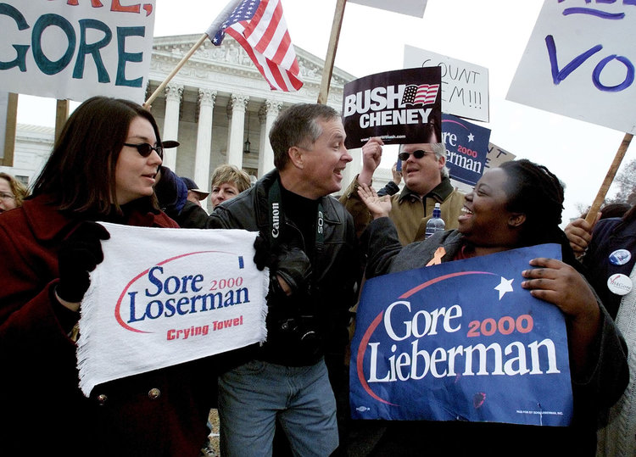

Take the hotly contested 2000 election, which saw George W. Bush win Florida by just 537 votes out of nearly 6 million.

Supporters of Al Gore and George W. Bush facing off in front of the US Supreme Court amid the landmark postelection legal battle Bush v. Gore in 2000.

Given the slim margin of victory, the outcome could have been different if felons and ex-felons were allowed to vote. Others, however, argue that Florida's large population of white felons would have leaned toward Bush anyway.

Uggen and Manza argued that the election "would almost certainly" have been reversed if "voting rights were extended to any category of disenfranchised felons."

On the flip side, Northwestern's Traci Burch, simulating outcomes for Florida 2000 under scenarios consistent with turnout rates of Georgia and North Carolina in 2000 and Florida in 2008, found that the ex-felon population in Florida would have leaned toward Bush.

**So what's next?**

The administration of Virginia Democratic Gov. Terry McAuliffe recently restored the voting rights for over 168,000 people. And about 42,000 had registered to vote for the governor's race in Virginia on November 7, 2017.

Looking at the broader picture, twenty-four states have changed felony-disenfranchisement provisions since 1997 to expand voter eligibility. According to data from The Sentencing Project, an estimated 840,000 citizens regained the right to vote from 1997 to 2016.

In some states, the restoration of voting-rights practices shifts based on who's in charge. In Florida in 2007, for example, the clemency board voted to automatically restore voting rights for many with nonviolent felony convictions, but the decision was reversed in 2011.

Whether these policies will change depends on which parties and politicians are elected to the run the states. And those with the most at stake sometimes can't take part in that decision.

*NBC News*

*June 24, 2018*

*By Devyn Rafols-Nunez*

**Push to lower the voting age gains traction across the states**

**“We know about the issues, and we deserve a voice,” says one 16-year-old.ers fight to lower voting** age to 16

JUN.24.201801:38

WASHINGTON — Jenny Gonzalez, 16, a student at Woodrow Wilson High School here, insists she and her peers are ready to vote.

"We know about the issues, and we deserve a voice," she said.

Jenny is one of dozens of invigorated teens who are part of Vote16USA, a nationwide campaign created by Generation Citizen, a national civic engagement organization, and led by youths fighting to lower the voting age with the help of Charles Allen, a Democrat on the D.C. Council.

Allen in April reintroduced the Youth Vote Amendment Act of 2018. For the first time, it would give 16- and 17-year-olds the right to vote in local races, as well as in presidential elections — all as soon as 2020.

Alik Schier, 16, said teens are one of the country's most energized voting blocs. "We want to have a say," Alik said. "So many issues that affect eligible voters now affect us."

While the movement faces resistance and procedural obstacles, it has gained traction after recent school shootings, like the killings of 17 people at Marjory Stoneman Douglas High School in Parkland, Florida.

"I think Parkland's a great example of adults' realizing that we're informed, that we know and that it was a wakeup call for adults, that there are issues and there are policies that politicians are making every day that affect our lives," Alik said.

For Jessica Parks, 16, it's about school violence and community safety.

"Outside of my school, two young males were shot and killed," she said. "They were only ninth-graders. Things like this happen every day, and we don't even have a voice or say in how to put a stop to it."

Theirs isn't the first generation to push for lowering the voting age; teens have been advocating for the change for years.

They've had some success, with a few Washington suburbs in Maryland, like Takoma Park, Greenbelt and Hyattsville, already allowing 16-year-olds to vote in local elections. More than a dozen countries, including Brazil, Scotland and Austria, meanwhile, allow voters that young in national elections.

Several other cities and states have also proposed bills on both the local and the state levels, most of them as state constitutional amendments. The issue has come up in school board elections in Berkeley, California, and in state elections in Arizona, Minnesota and, most recently, North Dakota and Michigan.

Since April, Washington teen activists have been meeting after school to map strategy, campaign in their neighborhoods and speak with parents, teachers and peers. They're also meeting with Allen and preparing for a council hearing on Wednesday.

So far, the 16-year-olds have convinced seven of the 13 council members that they deserve to vote, but they still need to persuade the rest of America.

In all other U.S. cities, voting ages can be lowered only for local elections, while elections for federal offices are managed at the state level. Washington, D.C., which preregisters the age group during school-based registration, uniquely has authority over both local and federal elections and therefore would be the first place where 16- and 17-year-olds would vote for president.

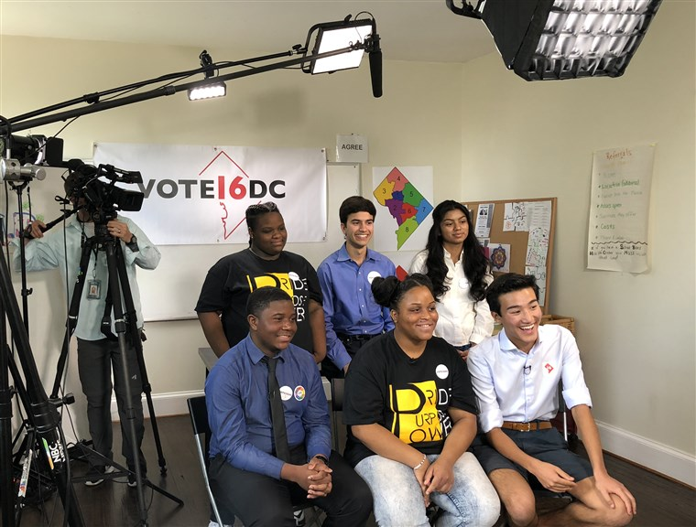

Teen voting activists during an interview in Washington on Thursday. From top left, Ceon Dubose, 16; Oliver York, 19; and Jenny Gonzalez, 16. From bottom right, Elijah Robinson, 16; Jessica Parks, 16; Alik Schier, 16. NBC News

If the measure is approved at Wednesday's hearing, it will proceed to a legislative session in September for full council action. Mayor Muriel Bowser has endorsed it.

Critics say the teens are just single-issue voters, hoping to move the needle only on issues such as legal marijuana or college loans. But Elijah Robinson, 16, said they care about violence, climate change, affordable housing — all issues that will affect future generations."

Not only that, we do things like adults," he said. "We pay taxes. We have jobs. We have to be at those jobs on time. We have to be at school on time, or there'll be penalties."1701:52

David Davenport, a research fellow in politics and law at the Hoover Institution at Stanford University, said young people may get excited about one issue, like guns on campus, but lack political knowledge to be effective voters.

"My concern is if 16-year-olds were allowed to vote on any kind of broad scale, what we'd actually be doing is bringing the least politically informed, the least politically experienced, the least mature in terms of making long-term judgments and trade-offs, directly into and potentially affecting our voter turnout and results," Davenport said.

In the Washington suburb of Takoma Park, Maryland, youth turnout has skyrocketed since 16- and 17-year-olds were given the vote in 2013, with teens voting at more than twice the rate of older registered voters every time.

"We started looking at ways to create more turnout in the city election," said Tim Male, a former member of the City Council. "Scotland at the time had started an independence referendum and let 16-year-olds vote, and it just seemed like an obvious thing that we could talk about doing."

Teens in Takoma Park are advocating for dog parks, holding mock debates after school and showing up at candidate debates. "When someone says 'I want to vote; I'm in a democracy; I want to vote; I know who the candidates are,' how do you say no to them?" Male asked.

To advocates, lowering the voting age would also lead to greater lifelong civic engagement.

"If 16- and 17-year-olds actually had the right to vote, they'd be more motivated to learn how the process works and schools would be incentivized to include experiential civics education as a core part of their curriculum," said Scott Warren, chief executive and founder of Generation Citizen.

As the teens prepare for the D.C. Council hearing on Wednesday, they're anxious about what could be a milestone. "We're all in this community together, but we still don't have a say in that," said Jenny Gonzalez, the Wilson High School student. "We hope that changes for the better."

**Voting Laws Roundup 2019**

*Brennan Center for Justice*

*Updated: July 2019*

With most legislatures closed, major positive reforms were enacted, but a handful of states made it more difficult to vote.

At this point in the year, 42 state legislatures have concluded their last regular legislative session in the leadup to a presidential election year. Looking back at this session, three new, Democratic trifectas – New York, Nevada, and Colorado – were responsible for an outsize portion of the most impactful expansive voting laws enacted so far this year.

At the same time, a late-session surge in legislation cutting back voting access was successful in creating new restrictions in five states. Most significantly, in Florida, a new restriction cuts back on the gains made by Amendment 4. This new restriction could dramatically curtail the number of people who get their voting rights back under Amendment 4 and it flies in the face of the voters’ decision last November to expand voting access. In addition, in Tennessee, lawmakers added new burdens on voter registration drives. And in Texas, lawmakers pushed through a new restriction on early voting, but it could have been even worse, if a powerful coalition had not come together to stop an even more restrictive bill that was moving toward passage.

Overall, since the start of the session, 46 states have introduced or carried over 688 bills expanding access compared to 29 states have introduced or carried over at least 87 bills restricting voting access. In addition, 33 states have introduced or carried over at least 108 bills related to election security.

**Expansive Voting Bills**

The massive burst of pro-voter bills introduced this session – 688 bills in 46 states – translated into significant reform across the country. As a group, states with new, Democratic trifectas led the way in terms of expansive laws this year – and, within that group, New York, Colorado, and Nevada enacted multiple, high-impact reforms. In addition, Delaware and Virginia enacted early in person voting. And a number of other states – under Democratic, GOP, and mixed control – enacted reforms that are either more incremental or alleviate past voter suppression.

A couple of other trends emerged as well. States enacted a number of bills providing notice and cure opportunities for absentee ballots and voter registrations. In addition, despite Florida’s decision to cut back on Amendment 4, rights restoration continues to gain momentum. See below for more details:

* **New Democratic Trifectas.**Following the 2018 election, Democrats newly obtained trifecta control of state government in six states. At the start of 2019, U.S. House Democrats made democracy reform a central part of the party’s agenda, by introducing (and then passing) a democracy reform bill as H.R.1 – the first bill in the new House. Each of the six states with new Democratic trifectas states has enacted (or is shortly expected to enact) major pro-voter reforms.  
    
    
  + **New York** passed the most significant reforms this year, enacting into law a package of voting reforms at the start of the legislative session, including: **early voting** (SB 1102), **pre-registration** for 16- and 17-year-olds (AB 774), and **portability** of registration records (AB 775), as well as a law that consolidated the dates for state and federal primaries and required ballots to be distributed to military voters farther in advance of elections (AB 779). The legislature also passed constitutional amendments to permit **same-day registration** (SB 1048) and **no-excuse absentee voting** (SB 1049), which will need to be passed again and then ratified by the voters.
  + **Colorado** enacted a law **restoring voting rights** to individuals on release from incarceration (HB 19-1266) and a law expanding **AVR** and writing that reform into the statute books (it had previously been put in place as an administrative measure by election and DMV officials) (HB 19-235). In addition, the state enacted a law improving voting access for voters with disabilities (SB 19-202) and a law with several additional reforms, including new standards for vote centers and improvements to the registration process for voters living on Indian reservations (HB 19-1278).
  + The**Illinois**legislature sent Governor Pritzker a bill that would enhance voting access for eligible voters confined in jails (SB 2090).
  + **Maine**enacted **AVR** (HB 1463).
  + **Nevada** enacted a law providing immediate **rights restoration**to people on release from incarceration (AB 431) and a law that authorizes **same day registration,**improves the provisional ballot process and extends early or absentee voting deadlines, among other reforms (AB 345).
  + **New Mexico** enacted same day voter registration (SB 672).

* **Additional Notable Reforms.** Several states passed additional expansive reforms through their legislative process. Both red and blue states took steps to expand access this year – continuing a trend we have seen throughout the decade. While GOP-controlled states passed a wide variety of pro-voter measures, the most common were reforms to enhance absentee voting and access for voters with disabilities. Reforms include:  
  + **Delaware**enacted **early in-person voting** (HB 38).
  + **Georgia**enacted into law reforms addressing a variety of problems with its voting systems (and the lawsuits that challenged them), including improvements to its “no match, no vote” policy, voter purges, absentee voting, provisional voting, voting for people with disabilities (HB 316).
  + **Virginia**enacted **no-excuse early in-person voting** (SB 1026/HB 2790).
  + **Washington**enacted a Native American voting rights act (SB 5079).

* **Notice/Cure Process.** States’ processes for determining the validity of voting materials like absentee ballots or registration applications are critically important but can result in improper disenfranchisement. For example, some states require elections officials to compare the voter’s signature on an absentee ballot with the signature they have on file and to reject the ballot if the signatures do not match. In some cases, though, states offer inadequate guidance to officials to make the comparison and inadequate recourse to voters whose ballots have been rejected.

This year, several states enacted laws that require election officials to notify and/or permit voters to cure deficiencies in absentee ballots, absentee ballot applications, or voter registration applications (or improve their existing processes), including: Arizona (SB 1054), Florida (SB 7066), Georgia (HB 316), Kansas (SB 130), and Virginia (HB 1042).

* **Rights Restoration Momentum Continues**. Last year, Florida voters enacted the paradigm-shifting Amendment 4, and New York and Louisiana also made major improvements to their rights restoration laws. This year, while Florida lawmakers cut back on Amendment 4, lawmakers in other states pushed forward.  
  + As noted above, **Colorado** and **Nevada** enacted rights restoration laws. In addition, **Arizona** enacted a law that would eliminate the obligation for people with only one felony conviction to pay certain types of legal financial obligations before having their voting rights restored (HB 2080). People are still required, however, to pay any outstanding restitution.
  + **California** (AB 646) and **New Jersey**(SB 2100) continue to consider rights restoration legislation.
  + Moreover, even though efforts in Iowa (HJR 14) and Tennessee came up short this year, the seriousness of those efforts, in states with extremely restrictive rights restoration regimes, is a further indication of the momentum behind this critical reform.

**Restrictive Voting Bills**

While some states are expanding voting access, others are cutting it back. At least seven restrictive bills in five states have been signed into law. All of the five states with new restrictions are under Republican trifecta control, and all of them had already passed restrictions making it more difficult to vote previously since we started systematically tracking anti-voter legislation in 2011.

The most noteworthy restrictions that passed this year are in Florida, where lawmakers cut back on Amendment 4, and Tennessee, which enacted new restrictions on voter registration drives. Arizona, Indiana, and Texas also signed new restrictions into law. Opponents, however, were able to stop a major additional piece of legislation in Texas.

* **Florida** enacted a law that **cuts back** on the **historic changes to the state’s felony disenfranchisement laws** that voters passed overwhelmingly in November 2018 (SB 7066). Voting rights advocates, including the Brennan Center, have filed a lawsuit challenging the law.
* **Tennessee** enacted into law wide-ranging **new restrictions on third-party voter registration** (HB 1079 and SB 971). The initial version of the bill imposed new registration and training requirements on third-party registration groups, as well as civil and criminal penalties for, among other things, submitting too many “deficient” voter registration forms. The amended version improves on this by carving out volunteers and organizations that only use volunteers from the new requirements. Voting rights groups have filed lawsuits challenging these new restrictions.
* **Arizona** enacted laws that **extend voter ID requirements to early voting** (SB 1072) and **restrict access to emergency early/absentee voting** (SB 1090). These bills appear to be a GOP reaction to the use of emergency vote centers in Maricopa County during the 2018 Senate election.
* **Indiana**enacted a law **cutting the deadline** for submitting an **absentee ballot application** for most voters from eight days to 12 days prior to the election (HB 1311) and a law **restricting state court lawsuits to extend polling place hours** (SB 560).
* **Texas**enacted a law **restricting mobile early voting** sites (HB 1888). Voters and voting rights advocates joined in a powerful coalition, however, to halt another highly restrictive bill that was moving towards passage. SB 9 would have significantly increased penalties and risk of prosecution for election code violations by voters; permitted poll watchers to inspect voter ID; and imposed new restrictions on people assisting voters with physical limitations or who cannot read the ballot, among other measures.

**Election Security Bills**

In advance of the 2020 elections, state legislatures showed renewed interest in shoring up election infrastructure and implementing election integrity measures. Ten states have signed into law 14 election security bills thus far this year, and another three states have passed bills through their legislature.

Several states have recognized the critical importance of post-election audits to verify vote totals. The urgency of adopting these audits has only increased in light of the foreign interference in the 2016 election – and the likelihood that foreign powers will attempt to interfere in next year’s election. Still, more work remains in order for states to be ready for 2020.

The following bills have been enacted into law or passed through the legislature:

* **Arkansas**enacted a law that requires post-election audits (SB 524).
* The **California**legislature passed a bill authorizing the Secretary of State to require data security training as a condition of receiving voter registration information.
* The **Delaware**legislature passed a bill that makes the paper ballot is the legal ballot of record, enhances pre-election voting machine inspection requirements, and requires post-election audits (SB 121).
* **Florida**enacted a law requiring the Secretary of State to promulgate security standards addressing chain of custody of ballots, transport of ballots, and ballot security (SB 7066). (Note that this bill also cuts back on Amendment 4, as explained above.)
* **Georgia**enacted a law that requires voting machines to produce a paper record and authorizes a risk-limiting audit pilot program (HB 316), as well as a law that requires the Secretary of State to establish security protocols to protect voter registration information (HB 392).
* **Indiana**enacted a law requiring two-factor authentication to access the computerized voter registration list as well as requiring election vendors to disclose foreign ownership (SB 558); a law authorizing a risk-limiting audit pilot program (SB 405); a law prohibiting the acquisition and, eventually, the use of direct recording electronic voting machines (“DREs”), and imposing new security measures for e-pollbooks, among other measures (SB 570); and a law mandating annual cybersecurity training for county elections officials (SB 560).
* **Iowa**enacted a law directing state and local election officials to adopt new election cybersecurity measures (HF 692).
* **Maryland**enacted a law requiring vendors to disclose foreign ownership (SB 743).
* **Nevada**enacted a law that would mandate risk-limiting audits starting in 2022 (and a pilot risk-limiting audit program for the 2020 election) and establish a cybersecurity training requirements for local elections officials (SB 123).
* **Oklahoma**enacted a law: authorizing the State Board of Elections to order post-election audits, requiring county election officials to undertake new cyber-security measures. and authorizing the State Board to declare an election emergency in response to security threats or interference (SB 261).
* The **Oregon**legislature has passed a bill authorizing risk-limiting audits (SB 944).
* **South Dakota** enacted a law that requires vote centers and counties that use e-pollbooks to have printed paper copes of the registration list.
* **Texas**enacted a law that would direct the Secretary of State to establish new cybersecurity rules for protecting elections data, among other reforms (HB 1421).

Name: Date:

**Voter Rights Priorities**

How do you think Oregon should EXPAND voting rights?

Are there any RESTRICTIONS on voting rights that you think will affect Oregonians who want to vote in 202?

What is your opinion about lowering the voting age – explain your reasoning:

**3.3**

**What is gerrymandering and how does it affect voter rights?**

**Handouts:**

* + What is Gerrymandering
  + Article: What Pennsylvania’s new congressional map means
  + Article: Drive Against Gerrymandering Finds New Life in Ballot Measures
  + How should we deal with political gerrymandering for future elections?

**Understanding Gerrymandering**

Political gerrymandering has been an issue for over 150 years in the United States. But recently there has been a new revival in the push to undo a lot of the political lines that have been drawn in the past decades. Much of this push is due to the race-based district apportionment that has happened in many states, especially following the *Shelby County* Supreme Court case which lifted some aspects of the Voting Rights Law. This lesson delves into what gerrymandering is and how it works. It also challenges students to consider what could be done about it in the future.

**Suggested Opener:** A fun opener might be to show the old Pennsylvania district map prior to the most recent 2018 court-ordered changes. See if students can find District 7 or 6. Ask them if they can figure out why the lines might have been drawn that way!

**Lesson Options:**

1. Jigsaw or read through together the explanation of gerrymandering and the articles about recent gerrymandering issues.

2. Challenge the class in either a discussion or writing assignment about what is most fair when states apportion their voting districts after a census. What kind of apportionment might create the best opportunities for voter access and motivate voters to turn out?

3. The Solution Tree analysis is a Cause and Effect exercise that asks students to consider some solutions to the political gerrymandering issue.

* With a solution tree, students start at the bottom and name as many roots to the problem (causes) as they can. around the roots, students can write what they think causes the problems of political gerrymandering.
* Next at the trunk of the tree, they name one clear problem those roots cause – this can be whatever they come up with as the pinpoint problem of the issue of gerrymandering.
* Finally, each of the branches offers an opportunity to name a solution. Solutions can be categorized along bigger branches and stems, or there can be many multiple ideas.
* A conclusion to the solution tree might be to have the students work together on a tree and then have a whole class discussion, or contribute to a whole class tree drawn for everyone to come to a final idea about what solution might be possible to help voters in 2018 and the future have the most access to fair voting.

**What is Gerrymandering?**

At the writing of the Constitution, the Framers decided to leave it up to the states to decide how they would pick their Representatives for Congress. The only requirement was that it had to be based on population. The population count is to be updated every 10 years, according to the Constitution.

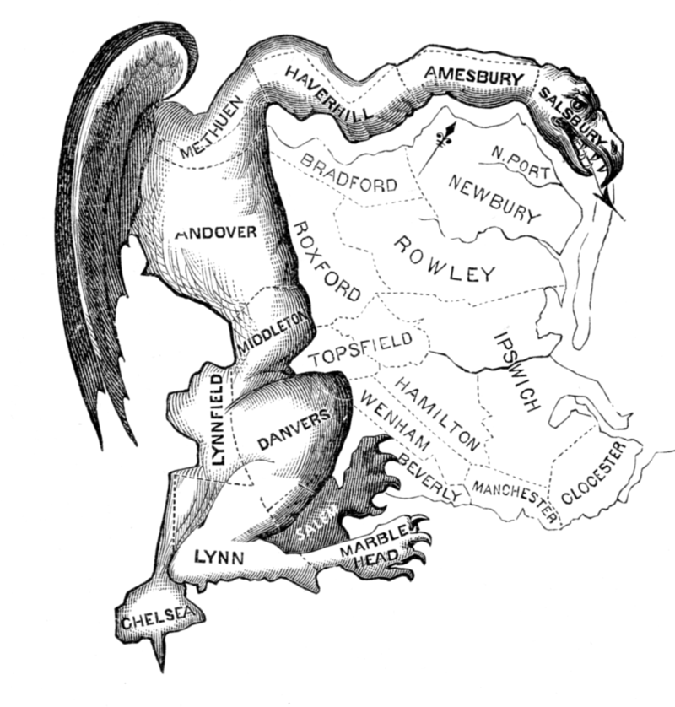

Many states took to dividing up voting districts to favor certain political parties or interest groups. In 1812, the word “Gerry-mander” was created to describe Massachusetts Governor Gerry’s contorted drawing of voting districts to favor his political party. The “mander” part of the word was taken from the fact that his newly drawn districts looked like a strange salamander

From then on, the practice of trying to draw voting district lines to favor a group has been known as “gerrymandering.”

Imagine a state as a geographical grid with a certain number of voters. Say a certain percentage of them traditionally vote Republican (often represented with the color red), and the other half vote Democratic (often represented with the color blue). After receiving its new census numbers, there are several ways a state could divide these voters up:

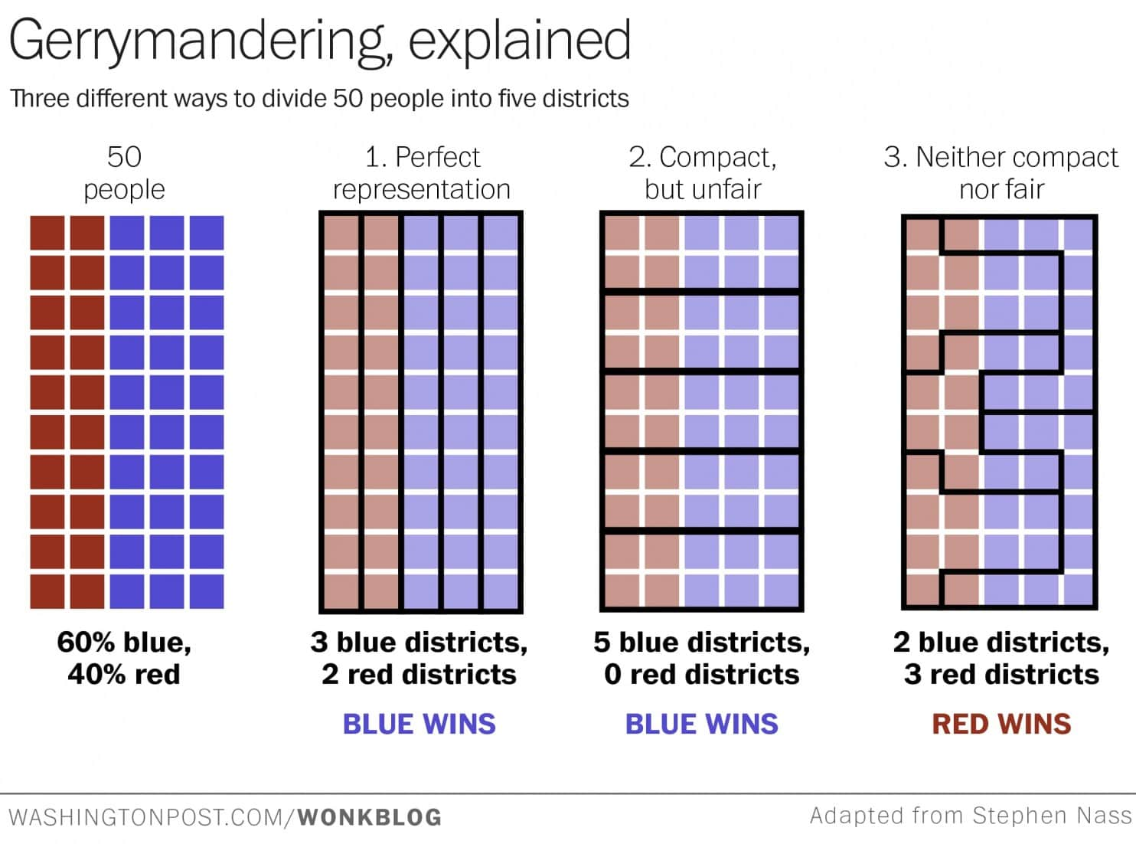

*Infographic on Political Gerrymandering from SubscriptLaw.com:*

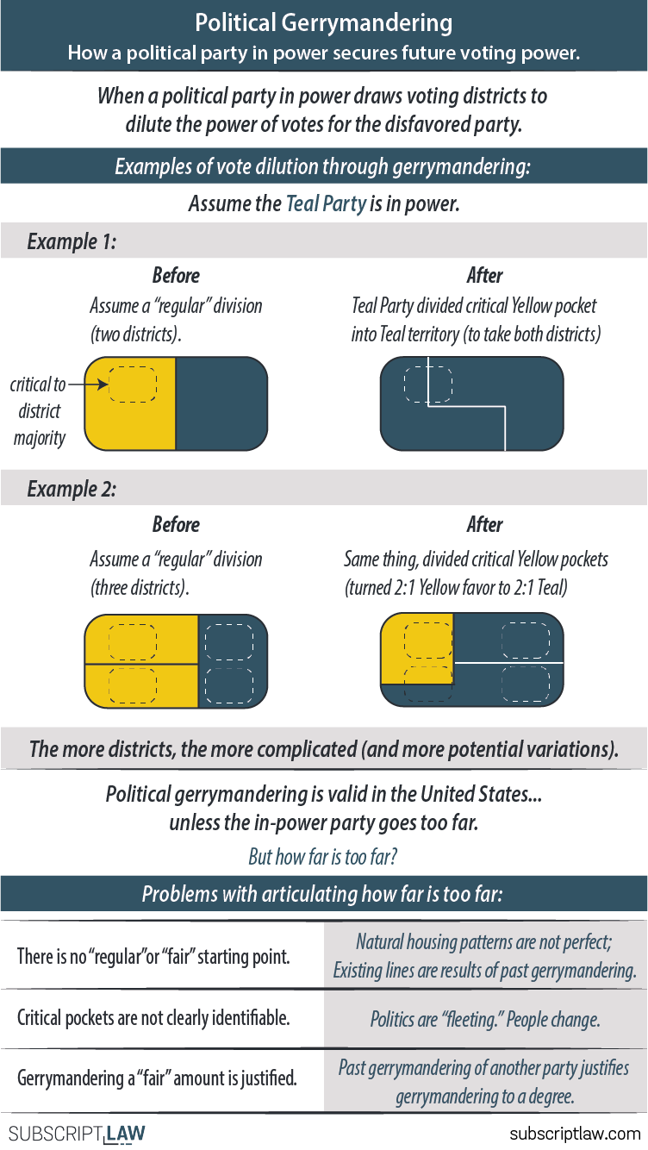

*From Vox News*

*March 19, 2018*

*By Andrew Prokop*

**What Pennsylvania’s new congressional map means**

It’s official: Pennsylvania will get a new US House of Representatives map for 2018, replacing an old map the state’s supreme court struck down as a Republican partisan gerrymander. A last-ditch effort from the state GOP to block the map failed Monday, as the US Supreme Court declined to intervene in the matter.

The new map is positively fantastic news for Democrats in their effort to take back the House this fall. “Democrats get everything they could want,” the[New York Times’s Nate Cohn tweeted](https://twitter.com/Nate_Cohn/status/965675177802649602) when he first saw the map. “With few exceptions it’s Democrats’ dream come true,” the [Cook Political Report’s Dave Wasserman tweeted](https://twitter.com/Redistrict/status/965677119480188928). “GOP not going to like this at all.”

**The net impact of the new map is:**

* It creates two new districts where Democrats are favored that didn’t exist in the previous map (and in one of those, they’re overwhelmingly favored).
* It keeps the same number of very closely divided swing districts that existed before (three).
* It changes one district that had been overwhelmingly Republican to be one where the GOP is favored but not entirely certain to win (Trump won the new district by about 9 points).
* Overall, it reduces by one the number of safe Republican districts (where Trump won by more than 15 points), and by one the number of lean Republican districts (where Trump won by 5 to 15 points).

So open seats held by retiring GOP Reps. Pat Meehan and Charlie Dent are more likely to flip, Republican incumbents like Rep. Ryan Costello and Keith Rothfus are now more embattled, and even GOP Rep. Scott Perry is no longer assured of skating to reelection.

**Pennsylvania’s old and new maps, compared**

After their landslide victories in the 2010 midterm elections, Republicans gerrymandered Pennsylvania within an inch of its life, in what [Sean Trende of RealClearPolitics suggested](https://www.realclearpolitics.com/articles/2011/12/14/in_pennsylvania_the_gerrymander_of_the_decade_112404.html) could be “the gerrymander of the decade.”

Here’s the map the GOP came up with:

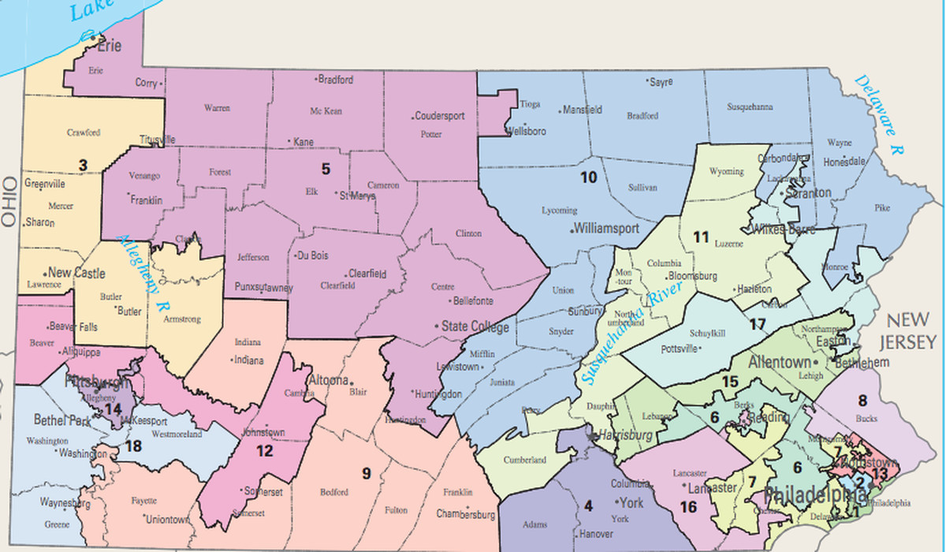*National Atlas*

Note above the oddly shaped districts surrounding Pittsburgh on the southwest of the map — the 12th and 18th — and the truly bizarre mess around Philadelphia on its east side, especially the contortionist 6th and 7th districts.

Ugly-looking districts don’t always point to gerrymandering, but in this case, they do — Republicans tried to pack Democratic-leaning areas together into very few districts while surrounding the state’s big cities with districts Republicans would win comfortably.

To get a sense of how powerful Pennsylvania’s gerrymander was, consider that in 2012, Democratic candidates won slightly more votes in US House elections and Barack Obama won the state. But the state’s 18 House seats didn’t split 9-9 between the parties — instead, Republicans won 13 seats there, and Democrats just won five. No seats changed partisan hands in the 2014 or 2016 elections, either.

But this January, the state Supreme Court — which has a Democratic majority — struck down the existing map as a partisan gerrymander that, a majority of justices wrote, violated the state constitution. The Republican state legislature and Gov. Tom Wolf (D) failed to agree on a new map, so the court instituted one itself.

The new map, below, looks cleaner, splits fewer counties, and will likely lead to many more competitive elections:

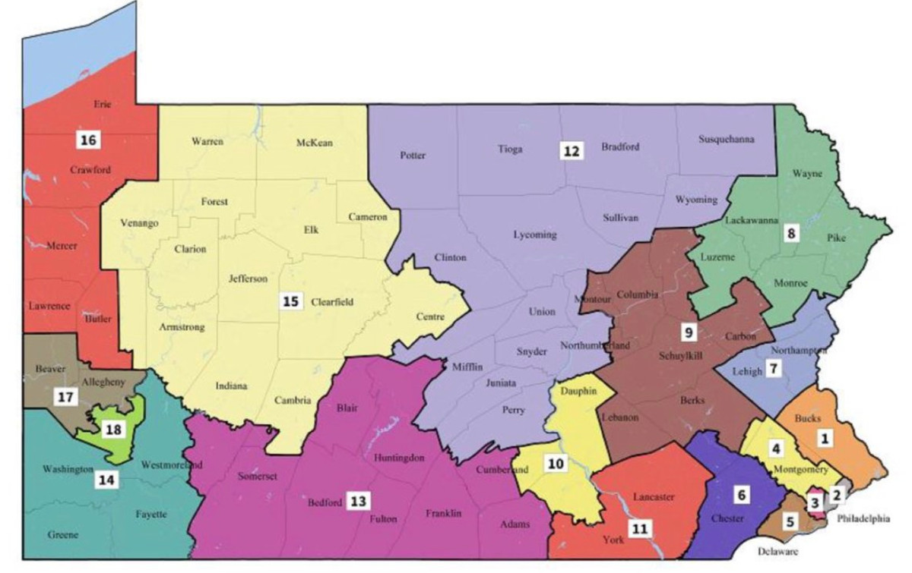

So in the southwest of the map, Pittsburgh is suddenly surrounded by one safe Republican district (the 14th) and one swing district (the new 17th), rather than the two safe Republican districts that existed before.

Around Philadelphia in the east, meanwhile, the conspicuous contortions are now gone.

The new map is much more favorable to Democrats than most election wonks expected, given the geographic patterns of where people actually live in Pennsylvania.

Indeed, as [Trende wrote in an interesting tweetstorm](https://twitter.com/SeanTrende/status/966095886966194177), “the consistent, subtle choices made make clear that this map was drawn with an eye toward shifting multiple districts leftward” — to increase competitiveness.

But it doesn’t seem to be an overwhelmingly or unfairly Democratic map, since, after all, Trump still won 10 of the 18 new districts. It’s a map designed, seemingly deliberately, to compensate for the party’s geographic disadvantages and give them a fighting shot in several districts.

**What the map means for 2018**

The New York Times’s Nate Cohn, Matthew Bloch, and Kevin Quealy put together this [extremely helpful breakdown of the new partisan numbers for each new district](https://www.nytimes.com/interactive/2018/02/19/upshot/pennsylvania-new-house-districts-gerrymandering.html?rref=collection%2Fbyline%2Fnate-cohn&action=click&contentCollection=undefined&region=stream&module=stream_unit&version=latest&contentPlacement=1&pgtype=collection), and you should really [read the whole thing](https://www.nytimes.com/interactive/2018/02/19/upshot/pennsylvania-new-house-districts-gerrymandering.html?rref=collection%2Fbyline%2Fnate-cohn&action=click&contentCollection=undefined&region=stream&module=stream_unit&version=latest&contentPlacement=1&pgtype=collection).

But my top-level takeaways from their new numbers are as follows.

First off, districts’ potential competitiveness can be measured in different ways, but if we take the obvious measurement of how much each presidential candidate won in each district in 2016, we move from:

* 11 districts Trump won by 5 points or more in the old map to 9 in the new map
* Four districts Clinton won by 5 points or more in the old map to 6 in the new map
* Three swing districts that neither presidential candidate won by more than 5 points in both maps

So even from that bird’s-eye view pegged to 2016 results, it’s clear that, on net, two districts became much more Democratic in the new map.

Now, let’s get more specific about what the changes mean for particular districts and members of Congress:

* The open district held by Rep. Pat Meehan (R), who is retiring due to [a sexual harassment scandal](https://www.vox.com/policy-and-politics/2018/1/20/16913546/meehan-settlement), is changed from a closely divided district to one Clinton won by 28 points — making for a near-certain Democratic pickup there (the Fifth District, in the new numbering)
* Rep. Ryan Costello (R) is moved from a very evenly divided district to one Clinton won by nearly 10 points (the Sixth District, under both the old and new numbering).
* Rep. Brian Fitzpatrick (R) represents a swing district that becomes just slightly more Democratic (the First District, in the new numbering).
* The area represented by retiring Rep. Charlie Dent (R) changes from a district Trump won by 8 points to a district Clinton narrowly won (the Seventh District in the new numbering).
* Rep. Keith Rothfus (R), who represented a safe Republican district, is suddenly thrown into a swing district where Conor Lamb, the impressive Democratic candidate who won last week’s special election under the old map, will run. (This is the new 17th District.)
* Then Rep. Scott Perry (R) is moved from a safe Republican district to a district Trump won by 8.9 points — a solid win, but not an overwhelming one. With a strong Democratic challenger or a big Democratic wave, this district now looks at least potentially flippable. (This is the new 10th District.)

All in all, that makes six Republican-held seats that suddenly have a more Democratic electorate — with the open seats held by Meehan and Dent, and the seats currently held by Costello and Rothfus, suddenly growing much more likely to flip. However, there’s also one notable change the other way, as Rep. Lloyd Smucker (R) moves from a lean Trump district to a solidly Republican one (the new 11th District).

In contrast, there are no comparable changes that put any of the few districts held by Democrats into play. Only one of them, Rep. Matt Cartwright (D), currently represents a district Trump won (by about 10 points), and his district’s partisan breakdown looks like it will stay about the same, [per the Times](https://www.nytimes.com/interactive/2018/02/19/upshot/pennsylvania-new-house-districts-gerrymandering.html?rref=collection%2Fbyline%2Fnate-cohn&action=click&contentCollection=undefined&region=stream&module=stream_unit&version=latest&contentPlacement=1&pgtype=collection). (This will be the new Eighth District.) Beyond that, there were four more safe Democratic seats before and after the new map.

The big picture is that this new map is enormously good news for Democrats in their effort to take back the House. Republicans currently hold the majority in the entire House of Representatives by 24 seats (which will drop to 23 if Conor Lamb’s victory last week is certified). Now, all of a sudden, their chances in several key Pennsylvania races have sharply improved — there are now five very plausible pickup opportunities in this state alone. If the party can score victories on this more favorable new turf, it will be a major help in their efforts to retake the chamber.

*New York Times*

*July 23, 2018*

*By Michael Wines*

**Drive Against Gerrymandering Finds New Life in Ballot Initiatives**

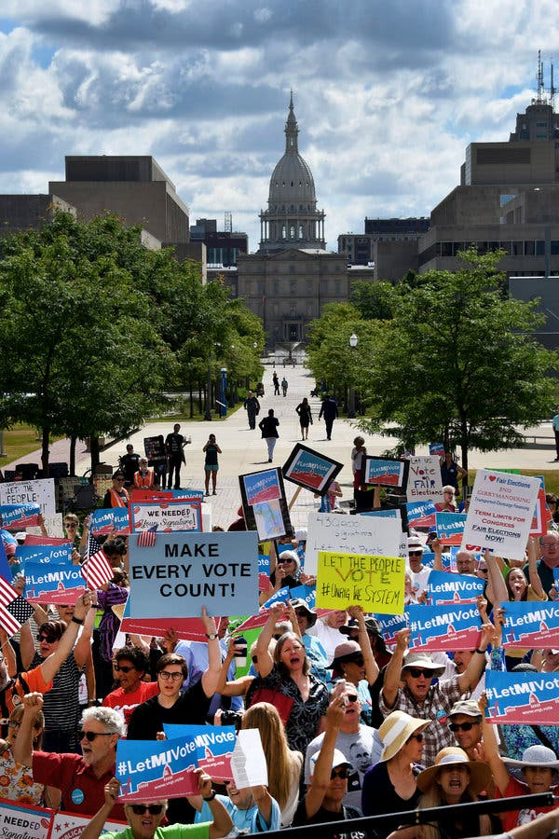The movement to take politics out of setting legislative district boundaries seemed to suffer a grievous, and perhaps even mortal, blow this spring when the Supreme Court passed up three chances to declare partisan gerrymandering unconstitutional.

*A rally in Lansing, Mich., on July 18 supporting a ballot measure that would change how the state’s legislative district maps are drawn. Credit: Dale G. Young/Detroit News, via Associated Press*

But it turns out that reports of its death are exaggerated. As federal courts dither over how to resolve the issue, activists have begun tackling it state by state at the grass roots.

In Michigan, a proposed constitutional amendment to end gerrymandering, written and promoted by a nonpartisan group called [Voters Not Politicians](https://www.votersnotpoliticians.com/), will be on the ballot in November, unless blocked by a court challenge that has so far fallen short. So many Michiganders signed petitions to bring the measure to a vote — 110,000 more than state law requires — that the group ended its signature campaign 70 days short of the six months allowed.

In Missouri, another nonpartisan group called [Clean Missouri](http://www.cleanmissouri.org/solution/) needed 180,000 signatures to get its anti-gerrymander initiative on the ballot; it collected 346,000. Final certification is expected next month.

In Utah, a group called [Better Boundaries](http://betterboundaries.org/) collected 190,000 signatures, 75,000 more than were required, to place its proposition to end gerrymanders on the November ballot.

And in Colorado, both the Democratic-run state House and the Republican-run Senate [voted unanimously in May](https://coloradopolitics.com/insights-legislation-to-shape-state-politics-for-decades-barely-got-noticed/) to place two proposals on the November ballot that would shift the duty to draw state legislative and congressional districts away from lawmakers and into the hands of independent redistricting commissions.

Those proposals join another, in Ohio, that became law in May. The state legislature there put a measure to curb partisan gerrymandering of the state’s congressional districts on the ballot for the state’s May 8 primary, after it became apparent that a citizens’ campaign for an even tougher measure was likely to succeed. [Ohioans approved the legislature’s version](https://www.washingtonpost.com/news/the-fix/wp/2018/05/09/ohio-voters-just-made-gerrymandering-more-trouble-than-its-worth/) by a three-to-one margin.

“It’s the best reform map we’ve seen in decades,” said Joshua Silver, the chief executive officer of the clean-government advocacy group [RepresentUs](http://represent.us/" \o "" \t "_blank), which has offered support to all five initiative campaigns.

It is remarkable that five states are holding ballot measures on the issue in a single year; only five had taken them up over the entire preceding decade.



*Voters in Denver cast ballots in the Colorado primary in June. The state legislature has put two proposals on the November ballot that would turn district boundary-setting over to an independent commission. Credit: Ryan David Brown for The New York Times*

Just as unusual is how little opposition the measures are meeting, at least so far. Beyond Michigan, where the state [Chamber of Commerce](https://www.michamber.com/) and the Republican attorney general are trying to block the anti-gerrymandering initiative, organized resistance to the proposals has been scant.

Mr. Silver compares the change in public opinion on gerrymandering — the practice of drawing maps to disproportionately favor one party — to the shifts on other issues like gay marriage, where voters’ views were often shown to be changing far faster than national political dogma.

In the past, only a handful of states — Idaho, Iowa and Arizona among them — embraced genuinely nonpartisan redistricting, while most states continued to treat mapmaking as the privilege of the party in power.

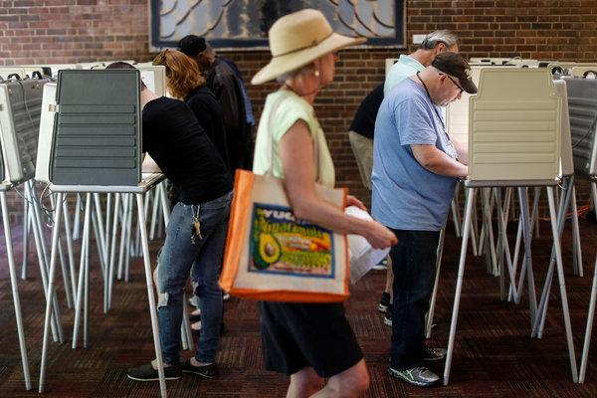Nationally, Republicans have denounced attacks on gerrymanders as assaults on their political power — understandably so, because the Republican landslide in 2010 allowed the party to [redistrict its way to long-term control](http://www.redistrictingmajorityproject.com/) of Congress, with House seats far out of proportion to its share of the vote in many states.

From 2008 to 2018, only California voted to strip state legislators of the power to draw all political boundaries. (New York voters approved nonpartisan redistricting in 2014 and Ohio voters in 2015, but only for state legislative seats, not for Congress.) Anti-gerrymander initiatives in Ohio and South Dakota were defeated in 2012 and 2016.

But advocates say that public disgust with the state of politics is increasingly overriding partisan sentiment on the issue.

“Gerrymandering resonates with people in a way it didn’t even a few years ago,” said Michael Li, senior counsel in the Democracy Program at the [Brennan Center for Justice](https://www.brennancenter.org/) at New York University. “We’re in a very distrustful moment. People think that people in power — the insider class — will do anything they can to keep it.”

Mr. Silver of RepresentUs said he agreed. “One thing that both Trump supporters and Bernie’s voters — and pretty much all voters — agree on is that the system is rigged,” he said, referring to Bernie Sanders, the liberal senator from Vermont. “In a political environment that’s confusing and frustrating to most Americans, this is an easy issue to understand.”

Only 26 states allow citizen-driven ballot initiatives, so their reach is limited. But legal experts and advocates say the campaign to end gerrymandering has other options it can pursue besides ballot initiatives.

Many states have constitutions that may offer more scope for lawsuits challenging gerrymandered maps than the federal courts do. Last winter the Pennsylvania Supreme Court became the [first court to invalidate a state’s congressional map](https://www.nytimes.com/2018/01/22/us/pennsylvania-maps-congress.html) as an unconstitutional partisan gerrymander.

And legislatures in some states, like Colorado, have begun to ponder whether the political and legal toll from partisan redistricting outweighs the advantages. Pennsylvania and Louisiana have seen the beginnings of bipartisan legislative efforts this year to hand over redistricting to apolitical commissions.

*Voters in Ohio strongly supported a measure on the primary ballot in May that limits partisan control of electoral map-making in the state. Credit: John Minchillo/Associated Press*

The current political climate is so unsettled, Mr. Li said, that legislators in some states worry about whether their party can count on having a majority — and with it, authority over redistricting — after the 2018 and 2020 elections.

“You don’t necessarily know who’s going to be in control in 2021 in many states,” he said. “That uncertainty creates an incentive to be reasonable in ways you didn’t have in the past.”

Name: Date:

**Decision Tree:**

**How do we solve Political Gerrymandering?**

**Possible Solutions:**



**Roots of the Problem:**