Classroom Law Project
Presents

Election 2020
Why Voting Matters

Unit 1

Electing a President

Unit 1
Electing a President

Essential Questions:
- How do we hire a president?
- What are the qualities of a good president?
- How will the 2020 primaries work?

Objectives:
Students will
- read and understand a primary source document – the Constitution, Article II
- analyze the constitutional tasks of president
- consider other qualifications of a president
- list the actions and experiences that would make the candidates excellent office holders

Unit 1 Standards:

OR 2018 Grade 8 Social Studies Standards:
8.2
8.5
8.9
8.10
8.29
8.32
8.34

Grade 8 CCSS Literacy in History/Social Studies:
6-8.RH.1
6-8.RH.2
6-8.RH.4
6-8.WHST.1
6-8.WHST.2
6-8.WHST.9

OR 2018 High School Social Studies Standards:
HS.4
HS.6
HS.10
HS.13
HS.71
HS.73
HS.74
HS.76

9/10 CCSS Literacy in History & Social Studies:
9-10.RH.1
9-10.RH.2
9-10.RH.4
9-10.WHST.1
9-10.WHST.9

11/12 CCSS Literacy in History & Social Studies:
11-12.RH.1
11-12.RH.2
11-12.RH.3
11-12.RH.7
11-12.RH. 9
11-12.WHST.1
11-12.WHST.4
11-12.WHST.9

Unit 1 Vocabulary:

- president
- incumbent
- constitution
- characteristics
- integrity
- executive branch
- qualifications
- candidate

Unit 1 Materials and Handouts:

1.1 How do we hire a President?
Handouts:
  - Pre-Unit Survey (half sheet handout)
  - Constitution, Article 2
  - Analyzing a Primary Document – Graphic Organizer
  - Analyzing a Primary Document - Questionnaire

1.2 What are the Qualities of a Good President?
Handouts:
  - Article: What is the Job of a President?
  - The Qualities of a Good President
  - Voter Interview Form
  - Help Wanted: a President for the United States in 2020

1.3 How will the 2020 Primaries work?
Handouts:
  - Article: The Primary Process, explained
  - Article: Importance of the US Presidential Primaries
  - SWOT Analysis of the Candidates (to be used later)
  - Issue Analysis for the Primaries
  - Calendar of the 2020 Primaries

1.1
How do we Hire a President?

Handouts:
  - Pre-Unit Survey (half sheet handout)
  - Constitution, Article 2
  - Analyzing a Primary Document – Graphic Organizer
  - Analyzing a Primary Document - Questionnaire

Overview of Lesson 1.1:

In this Lesson, students have the opportunity to consider how we “hire” a president in the United States. They will engage directly with the Constitution and do a primary document analysis to understand the basic requirements of the office. This lesson serves as a foundation to the following lessons about the role of the president, and 2020 candidates.

Suggested Opener:

Begin a class brainstorm list of job requirements to be president. Students can later compare their ideas to the Constitution’s requirements.

Investigating the Constitution:

- Divide students into groups to read through Article 2 of the Constitution

- Give each Student the “analyzing a Primary Document” handout – this can be used as an analysis guide and/or an assessment (it can be altered to meet your students’ level)

Adaptation in place of Primary Document Analysis:

- “Translate” your section of Article V: replace difficult words with kid-friendly words. Edit out parts that your group doesn’t think are needed.

- Create a chart or poster that elementary students could understand about your section of requirements for the governor.

Optional small group tasks:
- Read around in your group.
- Talk about what you read.
- Pick out most significant or interesting information in Article 2 of the Constitution.
- Identify anything that you did not understand.
- Decide on a word or phrase which best summarizes your sections.
- Which qualification or requirement or job description would you eliminate? Why? What would you add? Why?
- Make a poster illustrating the role of the President.

Name Date

Pre- Unit Survey

List three words that come to your mind about the upcoming presidential election:

Name Date

Pre- Unit Survey

List three words that come to your mind about the upcoming presidential election:

United States Constitution

Article II.

THE EXECUTIVE BRANCH

Section 1.

[1] The executive Power shall be vested in a President of the United States of America. He shall hold his Office during the Term of four Years, and, together with the Vice-President, chosen for the same Term, be elected, as follows.

[2] Each State shall appoint, in such Manner as the Legislature thereof may direct, a Number of Electors, equal to the whole Number of Senators and Representatives to which the State may be entitled in the Congress: but no Senator or Representative, or Person holding an Office of Trust or Profit under the United States, shall be appointed an Elector.

[3] [The Electors shall meet in their respective States, and vote by Ballot for two persons, of whom one at least shall not be an Inhabitant of the same State with themselves. And they shall make a List of all the Persons voted for, and of the Number of Votes for each; which List they shall sign and certify, and transmit sealed to the Seat of the Government of the United States, directed to the President of the Senate. The President of the Senate shall, in the Presence of the Senate and House of Representatives, open all the Certificates, and the Votes shall then be counted. The Person having the greatest Number of Votes shall be the President, if such Number be a Majority of the whole Number of Electors appointed; and if there be more than one who have such Majority, and have an equal Number of Votes, then the House of Representatives shall immediately choose by Ballot one of them for President; and if no Person have a Majority, then from the five highest on the List the said House shall in like Manner choose the President. But in choosing the President, the Votes shall be taken by States, the Representation from each State have one Vote; a quorum for this Purpose shall consist of a Member or Members from two thirds of the States, and a Majority of all the States shall be necessary to a Choice. In every Case, after the Choice of the President, the Person having the greatest Number of Votes of the Electors shall be the Vice President. But if there should remain two or more who have equal Votes, the Senate shall choose from them by Ballot the Vice-President.] (Note: Superseded by the Twelfth Amendment.)

[4] The Congress may determine the Time of choosing the Electors, and the Day on which they shall give their Votes; which Day shall be the same throughout the United States.

[5] No person except a natural born Citizen, or a Citizen of the United States, at the time of the Adoption of this Constitution, shall be eligible to the Office of President; neither shall any person be eligible to that Office who shall not have attained to the Age of thirty-five Years, and been fourteen Years a Resident within the United States.

[6] [In Case of the Removal of the President from Office, or of his Death, Resignation, or Inability to discharge the Powers and Duties of the said Office, the same shall devolve on the Vice President, and the Congress may by Law, provide for the Case of Removal, Death, Resignation or Inability, both of the President and Vice President, declaring what Officer shall then act as President, and such Officer shall act accordingly, until the Disability be removed, or a President shall be elected.] (Note: Changed by the Twenty-Fifth Amendment.)

[7] The President shall, at stated Times, receive for his Services, a Compensation, which shall neither be increased nor diminished during the Period for which he shall have been elected, and he shall not receive within that Period any other Emolument from the United States, or any of them.

[8] Before he enter on the Execution of his Office, he shall take the following Oath or Affirmation: —“I do solemnly swear (or affirm) that I will faithfully execute the Office of President of the United States, and will to the best of my Ability, preserve, protect and defend the Constitution of the United States.”

Section 2.

[1] The President shall be Commander in Chief of the Army and Navy of the United States, and of the Militia of the several States, when called into the actual Service of the United States; he may require the Opinion in writing, of the principal Officer in each of the executive Departments, upon any subject relating to the Duties of their respective Offices, and he shall have Power to Grant Reprieves and Pardons for Offenses against the United States, except in Cases of Impeachment.

[2] He shall have Power, by and with the Advice and Consent of the Senate, to make Treaties, provided two-thirds of the Senators present concur; and he shall nominate, and by and with the Advice and Consent of the Senate, shall appoint Ambassadors, other public Ministers and Consuls, Judges of the supreme Court, and all other Officers of the United States, whose Appointments are not herein otherwise provided for, and which shall be established by Law: but the Congress may by Law vest the Appointment of such inferior Officers, as they think proper, in the President alone, in the Courts of Law, or in the Heads of Departments.

[3] The President shall have Power to fill up all Vacancies that may happen during the Recess of the Senate, by granting Commissions which shall expire at the End of their next Session.

Section 3.

He shall from time to time give to the Congress Information of the State of the Union, and recommend to their Consideration such Measures as he shall judge necessary and expedient; he may, on extraordinary Occasions, convene both Houses, or either of them, and in Case of Disagreement between them, with Respect to the Time of Adjournment, he may adjourn them to such Time as he shall think proper; he shall receive Ambassadors and other public Ministers; he shall take Care that the Laws be faithfully executed, and shall Commission all the Officers of the United States.

Section 4.

The President, Vice President and all civil Officers of the United States, shall be removed from Office on Impeachment for, and Conviction of, Treason, Bribery, or other high Crimes and Misdemeanors.

Analyze a Primary Document

Title of Document:

Author(s):

Date:

New Words
(write down any new words you read in the document and look up their definitions)

Make Sense of the Document

What is the main idea?

List a quote from the document that support your main idea:

Why do you think this document was written?

What else is there?

Where do you think you could find out more about this document or what is in it?

What question(s) do you have for the author(s) of what you read?

Primary Document Analysis

Meet the Document

What type of document is it (check any that apply):

- Letter
- Chart
- Report
- Congressional Document
- Speech
- Newspaper
- Email
- Patent
- Advertisement
- Identification Document
- Press Release
- Court Document
- Memorandum
- Presidential Document
- Other: ________________

Observe the Parts of the Document

Author(s):

Audience:

Location it was written (if available):

Date it was written (if available):

Make Sense of the Document

What is the main point of this document?

Why was this document written?

List two quotes that demonstrate the theme of the document:

Why might this document be important to Americans?

What did you learn from this document that you didn’t know before?

What two questions might you ask the author(s) of this document if you could?

1.2

What does it Take to be a Good President?

Handouts:
  - Mind Map - the Roles of the President
  - The Qualities of a Good President
  - Voter Interview Form
  - Help Wanted: A President

Overview of Lesson 1.2:

In this lesson, students go beyond the constitutional requirements for president and contemplate the character traits and qualities of a person who should lead the state. There is an interview activity for the students to talk with an adult eligible voter to discover what they are thinking about the race for President and the primaries during Spring 2020. This will hopefully prompt the students to begin thinking about how the people around them will be voting. Also included is a fun “Help Wanted” activity for students to contemplate a job placement ad for president based on the qualities they think are most important.

Suggested Opener:

Begin a class brainstorm list of qualities or character traits of a good president. This list can be compared to the work they do in this section.

Lesson Options:

1. The graphic provided gives a general outline of the roles the president must fulfill while in office. Once students examine the mind map, they will have a better idea of what qualities might be needed for this job.

2. The Qualities of a Good President worksheet provides for a discussion of leadership qualities, may give the class some comparisons to the list you created as a class beforehand.

3. Consider having students do small group discussion before using the worksheet to analyze the qualities they believe a good governor should have.

4. You may want your students to conduct an interview of one or more eligible voters they know – their interview results can be a good opportunity for conversation about why people vote the way they do. This issue will arise again in a later unit.

5. A fun culminating activity might be the “Help Wanted” ad for students to advertise for a new governor based on the character traits they deem most important.

Supplemental Lesson Ideas:

- Ideal President poster – Another option (great for middle schoolers) is to make posters or large paper dolls of the "Ideal President" in which students label the body parts needed by the president. Examples: a good brain to think through issues; a mouth to voice one’s thoughts; a heart to care for others; hands to do the hard work; etc. One class had a great time tracing the outline of their own bodies on butcher paper then labeling (credit to Melanie Morris, West Sylvan MS, Portland).

- Qualities needed to govern compared with qualities needed to win – Begin with brief class discussion in which students share qualities necessary to win the gubernatorial election. These may include things like personal attractiveness, speaking ability, persuasiveness, organizational skills and the ability to raise money. In pairs, ask students to list winning qualities on one side of a sheet of paper. On the other side of the paper list qualities needed to carry out presidential responsibilities. Compare and discuss the two lists. To what extent are the qualities the same? How are they different? As a class, discuss how can this knowledge help voters to make an informed choice among governor candidates.

- Presidential Pie – Individually or in small groups, consider the presidency as a pie chart. Divide the pie into the pieces they consider to be most important to the job. For example, knowledge of the economy may have a large slice while space exploration may have a small slice. With whole class, compare charts.

- Qualities diagram – Create a diagram that demonstrates links between personal characteristics and presidential duties. For example, experience in the military (personal characteristic) may imply greater ability to be Commander in Chief (official duty).

CHIEF OF STATE
Responsible for representing & leading the USA

CHIEF DIPLOMAT
Responsible for the diplomacy and relationships with other countries; making agreements & treaties, and making foreign policy
CHIEF EXECUTIVE
The boss of the entire Executive Branch; manages all the Cabinet departments & agencies, decides how laws will be enforced; works with the other two branches

The Roles of the President
CHIEF LEGISLATOR
Responsible for proposing laws, influencing policy, and signing bills into law

CHIEF OF POLITICAL PARTY
Leads their political party; coordinates campaigns, supports lower offices, appoints members of the party to offices

COMMANDER IN CHIEF
Responsible for leading all the US military forces; sends troops into action; oversees the Department of Defense

CHIEF JUDICIAL APPOINTER
Nominates all federal judges and justices to the Supreme Court
CHIEF GUARDIAN OF THE ECONOMY
Responsible for leading economic policy and ideas, implementing economic laws, and guarding economic relationships with other countries

Name: _________________________________________ Date: ___________

The Qualities of a Good Leader

1. Consider some qualities of a good leader & whether you agree with them:

Qualities / Characteristics | Skills / Abilities
A Leader can  - Assume responsibility  - Take initiative  A Leader is  - Achievement-oriented  - Adaptable to situations  - Alert to social environment  - Assertive  - Competent  - Cooperative  - Courageous (risk-taker)  - Decisive (good judgment)  - Dedicated (committed)  - Dependable  - Energetic (high activity level)  - Enthusiastic  - Honest (high integrity)  - Optimistic  - Persistent  - Self-confident  - Tolerant of stress or anxiety (resilient)  - Welcoming of ideas and people  - Loyal to their organization/group | A Leader can  - Communicate well  - Listen openly to others  - Resolve conflict  A Leader is  - Broad-minded (seeks diversity)  - Clever (intelligent)  - Sees the Big Picture  - Creative and imaginative  - Diplomatic and tactful  - Outgoing and personable  - Fair-minded  - Forward-looking  - Knowledgeable about their team  - Motivational  - Persuasive  - Socially skilled  - Technically skilled  - A good speaker

2. Rank the Qualities/Characteristics of a leader into your top 5 requirements for a President:

- Rank the above Skills/Abilities of a leader into your top 5 requirements for a President

- Are there any leadership qualities listed that you think might not be applicable to being president? Why?

5. Make a comparison of your own:

A good president is more like a __________________________ than a __________________________.

Name: _________________________________________ Date: ___________

Election Interview Form

Interviewer Name: Date of Interview:

Interviewee Name (optional):

1. What is your role in the community (student, parent, business person, volunteer, teacher, etc.)

2. Do you plan to vote in the 2020 Presidential Primary or Election? (circle one): YES / NO

Why or Why not?

3. Have you decided which candidate for President you will vote for? (circle one):

YES / NO / UNDECIDED

4. When will you vote (Oregonians vote by mail – how early do you turn in or mail your ballot)?

5. What do you think the biggest issue will be for voters in the 2020 election (either in Oregon or the whole country)?

6. How was this interview conducted: _____ in person ______phone/text ______email

Name: _________________________________________ Date: ___________

Help Wanted!

Directions:
- Study the general format of classified ads online (one source might be OregonLive online)
- Review the responsibilities, experience, skills, and character traits of a good president/leader
- Write a classified ad for the position of President to be hired by the people of the United States

_________________________________________________________________________________
(title of ad)

_________________________________________________________________________________

_________________________________________________________________________________

_________________________________________________________________________________

_________________________________________________________________________________

_________________________________________________________________________________

_________________________________________________________________________________

_________________________________________________________________________________

_________________________________________________________________________________

_________________________________________________________________________________

_________________________________________________________________________________

_________________________________________________________________________________

_________________________________________________________________________________

_________________________________________________________________________________

*adapted from Using Newspapers to teach about the Election: A Lesson Plan by Colette Yeich, Social Education, Vol. 66, Issue 6, National Council for the Social Studies, 2002.
1.3
How will the 2020 Primaries Work?

Handouts:

  - Article: The Primary Process, explained
  - Article: Importance of the US Presidential Primaries
  - SWOT Analysis of the Primary Process
  - Issue Analysis for the Primaries
  - Calendar of the 2020 Primaries

Suggested Opener:

Start with a class discussion about what students the candidates for president will see as important issues for voters / and if that might be different from what the voters see as important. If they start with a list, they can refer back to it as they research candidates prior to primary season.

Thinking through the reason/process of Presidential Primaries:

As students read through the history and process of presidential primaries, they may want to consider how this part of the presidential election season might help or hinder candidates’ success, especially the location and states where early primaries are held. How will the qualities of a good president that they’ve already considered impact how well a candidate might do in the very different states who hold early primaries?

Lesson Options:

- The articles provide an opportunity for students to consider the primary process and its pros/cons.

- SWOT Analysis gives students an opportunity to analyze the primary process based on what they read in the articles or further research they do. They may also want to consider how late Oregon’s primary is and how that affects Oregon voters.

- Once the top tier of presidential candidates is more apparent (by the end of 2019), students will want to research the various candidates, compare them to the analysis they’ve already done on qualities for a good president, and perhaps prepare to watch the primary returns with their own choices ready in order to compare to exit polling.
**CLP will provide further materials for using with the primary returns, issue sheets of the top candidates, etc.

- You may want to have students do more in-depth research on the candidates’ issues positions on their own. It may be an interesting exercise to see how easy it is to find where they stand on issues that are important to the student.

- Consider concluding this lesson or the entire unit with a straw poll for students to vote for their choice for president or run a prediction game for the primary elections and see which students accurately predict the results!

The US presidential primary process, explained

By: Matthew Yglesias
Vox News
2016
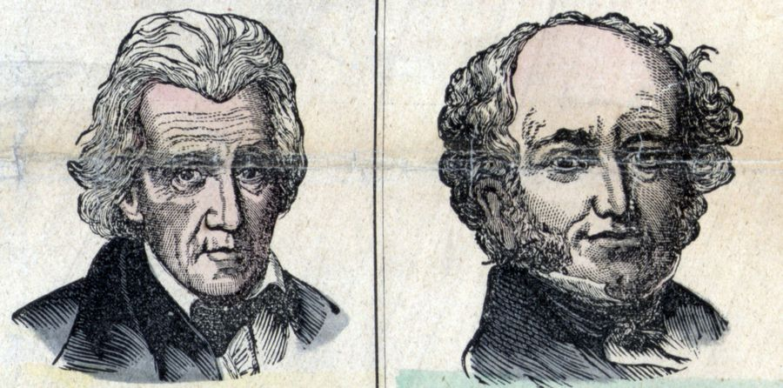

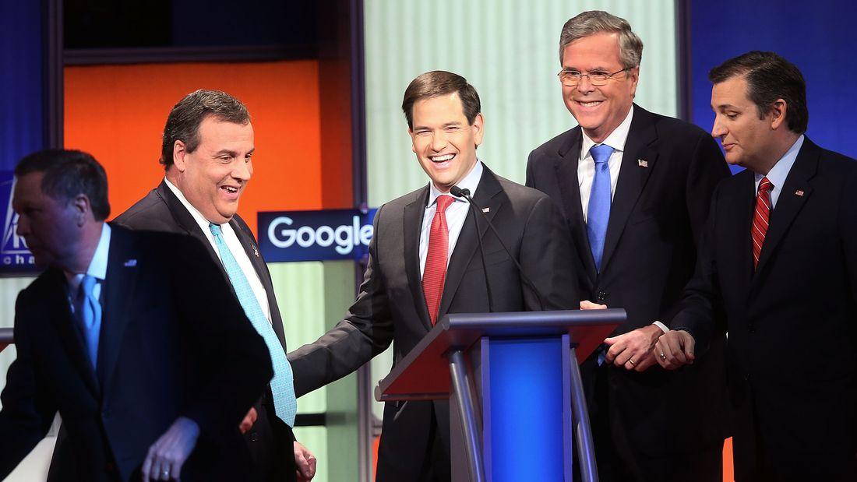
Scott Olson/Getty Images

The presidential primaries are one of the most important elements of the American constitutional order. Given that general elections give voters just two starkly opposed choices, it's largely through the primaries that nuance enters the political process. Parties define themselves by whom they select to run for president, and the ideological alignments that result end up defining the contours of political conflict.

And yet, despite primaries' central role, nothing about them is laid out in the Constitution.

In fact, the framers didn't envision American politics taking the form of two-party competition, so they gave no thought to how parties would select their candidates.

This, in turn, is part of what makes the primaries so fascinating. While the Constitution itself is incredibly difficult to change, party nominating rules and state laws are much more flexible.

Consequently, the presidential nomination process is one of the elements of the American political system that's changed the most — and often in ways that aren't anticipated by the people driving the change.
Which leads to the last thing that makes primaries so fascinating: They are genuinely unpredictable. Conceivably almost anything could happen.

Early nomination contests didn't involve primaries

Intraparty disputes over who should be nominated for the presidency are as old as the republic itself. But the modern system of determining nominees through a series of state primary elections is essentially an innovation of the 1970s. Before that, parties deployed a wide range of methods.

The Democratic-Republicans, the dominant political party of the early 19th century, used to select candidates via a vote of the party's members in Congress. That method let it control the White House for 20 years, and lasted until the rivalry between John Quincy Adams and Andrew Jackson made the party splinter into the Democrats and the Whigs in the aftermath of the 1824 election.

Presidents Andrew Jackson and Martin Van Buren. (Universal History Archive/UIG via Getty Images)

Back in 1836, in the early days of Whig versus Democrat competition, the Whig Party even tried nominating several candidates simultaneously in their bid to block Martin Van Buren from succeeding Jackson in the White House.

In most Northern states, William Henry Harrison appeared on the general election ballot, while Hugh White got the nod in most Southern ones. And Massachusetts Whigs went with Daniel Webster (who carried the state), while Willie Magnum was nominated in South Carolina.

The idea was that running multiple candidates with distinct regional appeals could successfully deny Martin Van Buren a majority in the Electoral College, throwing the choice to the US House of Representatives. The selection of the Whig on each state's ballot was left up to the local party. Had the gambit worked, one could imagine the system of multiple nominees becoming entrenched.

But it did not work. Van Buren won the election, and in subsequent contests the Whigs emulated the Democrats, picking a single nominee at a broad national convention with representatives from all states.

Conventions are still held today, but they are essentially publicity stunts. At best, they're counting exercises in which the point is simply to crown the candidate who already enjoys the support of most of the delegates.

But historical conventions were real decision-making bodies, where a cast of locally selected elites would come together to genuinely choose someone. That opened the door to outcomes like the Whigs drafting celebrity war heroes Zachary Taylor and Winfield Scott in 1848 and 1852, without the candidates needing to mount vigorous primary campaigns.

The convention system also allowed for the emergence of "dark horse" candidates like 1844 Democratic nominee James K. Polk, who was not even considered a contender at the start of the process. He emerged on the convention floor as a broadly acceptable second choice after various factions deadlocked.

Conventions generally had delegates take a series of votes to winnow the field. At the 1860 Republican convention, for example, William Seward received by far the largest number of votes on the first ballot, with Abraham Lincoln finishing a rather distant second.

Seward's problem, however, was that virtually all of the delegates who weren't for him were strongly against him on electability grounds — as governor of New York he had not only opposed slavery, but also signed laws advancing the rights of free black residents of the state, radical moves that much of the party thought went too far for the swing states of the Midwest.

Lincoln's result gave him enormous momentum. On the second ballot, he trailed Seward by just three votes. And at that point, it just took a little more cajoling for Lincoln to get over the top.

When presidential primaries started, they weren't decisive
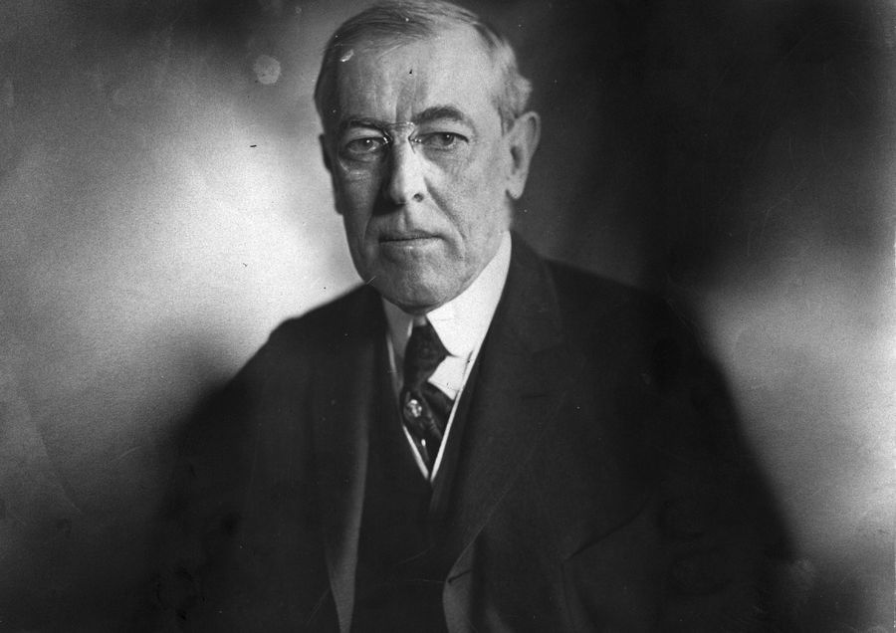
Woodrow Wilson. (Tony Essex/Hulton Archive/Getty Images)

The Progressive Era at the beginning of the 20th century saw a backlash against local party machines and their bosses dominating American politics. This backlash was especially pronounced in Western states, where reformers implemented ideas like legislating via ballot initiative at the polls.

Progressive reformers also invented the presidential primary. In 1910, Oregon became the first to use a popular election to pick its delegates for national conventions, with the delegates pledged to support specific candidates.

But these primaries lacked the efficacy and decisiveness of those we have today, in part because most states didn't have them and in part because the ultimate nomination decision was still made via a multi-ballot process at a national convention.

In 1912, ex-President Theodore Roosevelt decided to challenge his successor William Howard Taft for the GOP nomination. He crushed Taft in the primaries, carrying nine of the 12 states that held primaries, while Robert La Follette won two and Taft just one.

But that still left 36 other states, which mostly sent pro-Taft delegates to the convention, securing him the nomination. And that led Roosevelt to bolt the party and launch an independent bid for the general election.

That year's Democratic convention, meanwhile, required 24 rounds of balloting for Woodrow Wilson to prevail over the now-forgotten House Speaker Champ Clark. That meant that delegates' initial pledges to specific candidates were long irrelevant by the time the final decision to nominate Wilson was made.

Twelve years later, primary voters again found their preferences overridden when in 1924 William McAdoo swept the Democratic primaries (largely held in the South and West) with the strong support of the Ku Klux Klan. But for precisely that reason, he was totally unacceptable to the party establishment back East, whose machines relied on the loyalty of Catholic voters.

But while McAdoo didn't have enough support to win, he did have enough to block the party bosses' favorite, New York Gov. Al Smith, a Catholic.

After a brutal 99-ballot war of attrition at the Democratic convention, both McAdoo and Smith simultaneously withdrew. Then after "only" four more rounds of voting, a candidate nobody particularly liked, John W. Davis, got the nod — then got destroyed in the general election.

Primaries were beauty contests

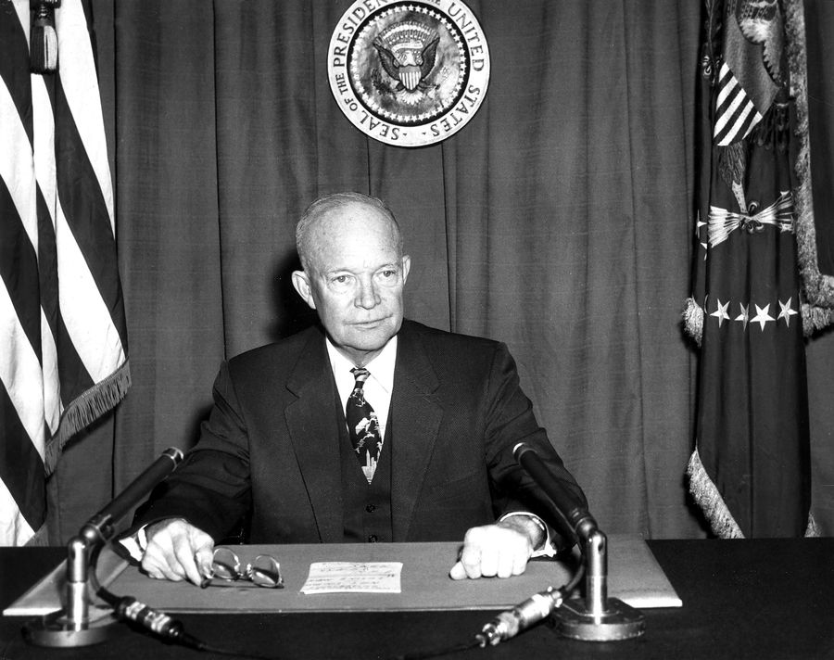
Eisenhower (ullstein bild/Getty Images)

When primaries did play a substantive role, it was instead through their function as beauty contests. Winning the 1952 New Hampshire primary let Dwight Eisenhower prove that rank-and-file Republicans, and not just party bosses, were more interested in picking a winner than in picking an orthodox conservative — thus giving the establishment permission to do what it wanted and go with Ike.

By the same token, winning the West Virginia primary in 1960 was a way for John Kennedy to demonstrate to party leaders that a Catholic could win votes in the South.

But both of these examples were making a point to persuade party leaders, not a way to override their preferences.
The fundamental inefficacy of the primaries was driven home by the bitter 1968 Democratic nomination contest that ultimately went to Vice President Hubert Humphrey, who didn't even enter any primary elections.

But the tumultuous, riot-scarred convention where it happened, followed by electoral defeat at the hands of Richard Nixon, spurred massive change.

The '70s were a crazy time for everyone

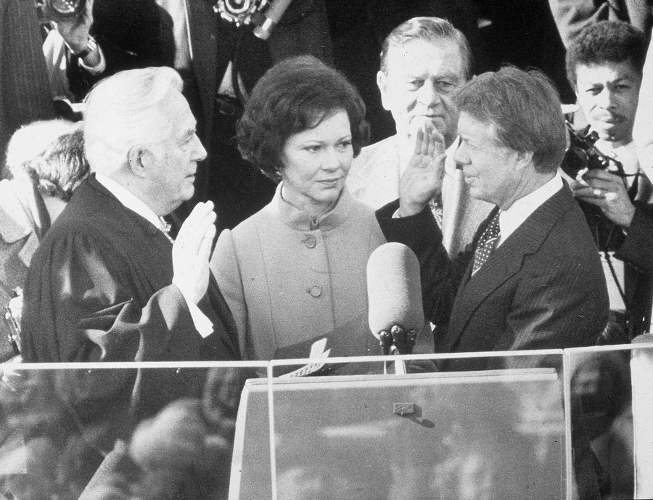

Jimmy Carter (Hulton Archive/Getty Images)

After the 1968 fiasco, the Democratic National Committee created a commission charged with proposing reforms to the nominating process. (It was chaired initially by Sen. George McGovern and then by Rep. Donald Fraser.)
Its report brought state delegate allocations into line with the distribution of population and required state parties to adopt open procedures for selecting delegates rather than allowing state party leaders to pick them in secret.
In practice, states mostly implemented this by adopting presidential primaries — which generally induced Republicans to make the same change.

The new system kicked off a chaotic era in which mavericks and factional leaders could win over the objections of party leaders.

In 1972, McGovern took advantage of his own reforms to win the Democratic nomination, even with an ideology so unacceptable to major party factions that the AFL-CIO didn't support him over Richard Nixon.

Then in 1976, Jimmy Carter won the Democratic nomination despite a total lack of ties to the party establishment in Washington, and proceeded to win the White House and then not pursue the party's agenda.

Also in 1976, incumbent President Gerald Ford faced an extremely strong primary challenge from conservative leader Ronald Reagan and was forced to drop the incumbent vice president from the ticket in order to appease conservatives.

Four years later, incumbent President Carter was challenged from the left by Ted Kennedy, his renomination secured only by the rally-round-the-flag effect induced by the Iranian hostage crisis.

At around this time, it became fashionable to observe that American political parties were in decline. University of California Irvine political scientist Martin Wattenberg achieved the apogee of this literature with his 1985 classic The Decline of Political Parties in America (since updated in five subsequent editions), citing the waning influence of party professionals, the rise of single-issue pressure groups, and an attendant fall in voter turnout. After all, a party whose leaders can't even pick its own presidential nominee in a reliable way isn't much of a party at all.

Elites still matter enormously in primaries

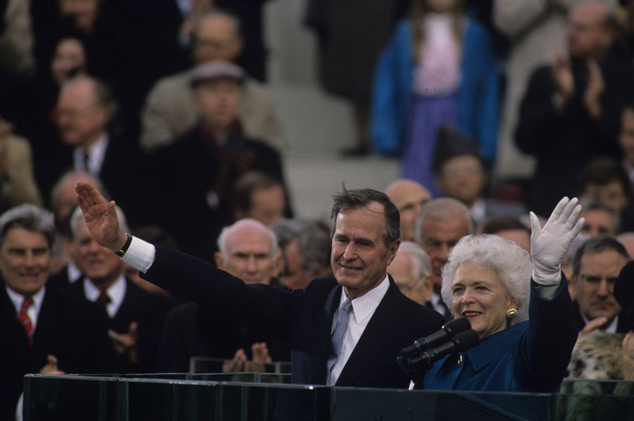
George H.W. Bush (ABC Photo Archives/ABC via Getty Images)

Just when journalists and political scientists were ready to proclaim the death of parties in favor of candidate-centered politics, the pendulum started to swing back.

Over the past 35 years, incumbent presidents have had zero problems obtaining renomination — even presidents like George H.W. Bush and Bill Clinton who alienated substantial segments of the party base with ideological heterodoxy during their first term. Reagan and Clinton both passed the baton to their vice presidents without much trouble.

Insurgent candidates who caught fire with campaigns explicitly promising to shake up the party establishment — Gary Hart in 1984, Pat Robertson in 1988, Jerry Brown in 1992, Pat Buchanan in 1996, John McCain and Bill Bradley in 2000, Howard Dean in 2004, Mike Huckabee in 2008, and Rick Santorum in 2012 — repeatedly gained headlines and even won state primaries.

But while 1970s insurgents were able to use early wins to build momentum, post-Reagan insurgents were ground down by the sheer duration and expansiveness of primary campaigns.

Tactics that worked in relatively low-population, cheap states like Iowa and New Hampshire simply couldn't scale without access to the broad networks of donors, campaign staff, and policy experts that establishment-backed candidates enjoyed.

In their 2008 book The Party Decides: Presidential Nominations Before and After Reform, Marty Cohen, David Karol, Hans Noel, and John Zaller argued that the resurgence of establishment candidates was no coincidence.

They argue that party insiders had found a way to control nominations by replacing the old smoke-filled rooms of the convention with a new series of insider bargains largely struck before convention voting begins.

It's this "invisible primary" among party elites that truly matters.

To test their idea, the book's authors tallied up endorsements from a broad set of party figures across two and a half decades of primaries. They included everyone from famous elected officials to local politicians to activists to celebrities, and calculated each endorser's importance in the party.

If one candidate was the clear winner in pre-Iowa endorsements and also won the nomination, then it could be said that the party had decided.

And that's just what they found. In eight of 10 competitive presidential primary contests between 1980 and 2004, endorsements showed that party insiders clearly backed one candidate before Iowa, and that candidate then went on to win the nomination.

Endorsements were better at predicting the outcome than polls, fundraising numbers, or media coverage.
The authors don't argue that endorsements alone specifically cause a candidate to win. Rather, endorsements are a signifier of how the invisible primary is going — and therefore of which candidate the party network is choosing to favor.

"In our theory, party insiders rally to the candidate of their choice, endowing him or her with endorsements, access to fund-raising networks, and pools of talent and volunteer labor," they write.

It's a theory that gained enormous prestige during the 2012 Republican primary cycle, which saw a series of novelty candidates rocket and then tumble in the polls, only for Republican voters to eventually settle on Mitt Romney, whom the establishment had favored the whole time.

Romney's relatively calm affect, his moderate record as governor of Massachusetts, and his Mormon faith all gave him trouble connecting with the conservative grassroots. But in the end, it didn't matter any more than it mattered for Taft or Humphrey or the forgotten Davis — the party thought he offered the best combination of commitment to conservative principles and electability, so he got the nod.

Contested primaries are a long, hard slog

Through the 1960s, nominations were typically wrapped up in the summertime — at the convention itself. Modern elections, by contrast, frequently give us primary races that wrap up within weeks of the New Hampshire primary in February, even though active campaigning may take place for a full year leading up to New Hampshire.
In 2004, for example, John Kerry rocketed out of nowhere to a big national lead after his unexpected win in Iowa in late January. And by March 2, all his opponents had dropped out.

But the long slogs of the 1970s and the brutal Obama-Clinton battle of 2008 serve as a reminder that the system as it exists on paper calls for a very long series of primaries.

New Hampshire, Nevada, and South Carolina all vote in February, followed by a large group of primaries on March 1. But though these early states are important for establishing candidates' viability and shaping media narratives, they still leave out huge piles of delegates to be won on March 15 (Florida, Illinois, and Ohio), April 19 (New York), and even June 7, in the very late California and New Jersey primaries.

It would be very unusual for a race to still be meaningfully contested that late, but a lot about the 2016 cycle thus far has been unusual. And the only real constant in the American candidate selection system is that it's always changing — often in unexpected ways.

Importance of the US Presidential Primaries

ThoughtCo.
By Robert Longley
Updated May 15, 2019
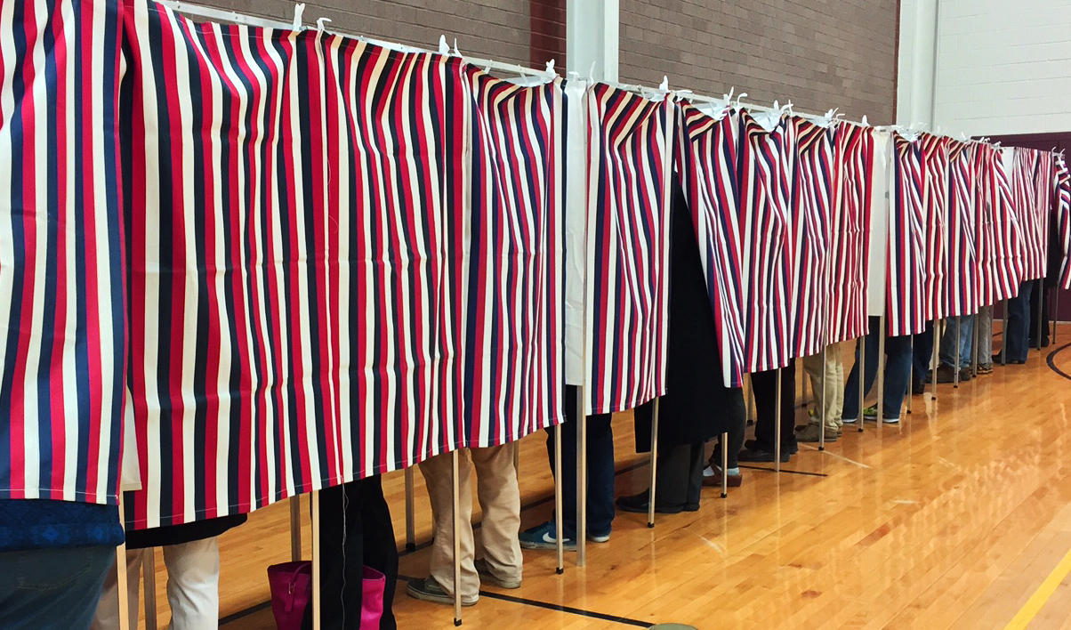
New Hampshire Voters go to the Polls, Nhpr images

The U.S. presidential primaries and caucuses are held in the various states, the District of Columbia, and territories of the United States as a key part of the process of nominating candidates for election to the office of President of the United States.

The U.S. presidential primary elections typically start in February and do not end until June. How many times do we have to vote for a new President of the United States, anyway? Why can't we just go to the polls once in November and be done with it? What's so important about the primaries?

Presidential Primary History

The U.S. Constitution doesn’t even mention political parties. Nor does it provide a method for choosing presidential candidates. It was not that the Founding Fathers did not anticipate political parties as they had known them in England would come along; they simply were not keen to seemingly sanction party politics and its many inherent ills by recognizing it in the nation’s Constitution.

In fact, for the first confirmed official presidential primary was not held until 1920 in New Hampshire. Until then, presidential candidates were nominated solely by elite and influential party officials without any input from the American people. By the late 1800s, however, social activists of the Progressive Era began to object to the lack of transparency and public involvement in the political process. Thus, today’s system of state primary elections evolved as a way to give the people more power in the presidential nomination process.

Today, some states hold only primaries, some hold only caucuses and others hold a combination of both. In some states, the primaries and caucuses are held separately be each party, while other states hold “open” primaries or caucuses in which members of all parties are allowed to participate. The primaries and caucuses start in late-January or early-February and are staggered state-by-state to end by mid-June before the general election in November.
The state primaries or caucuses are not direct elections. Rather than choosing a specific person to run for president, they determine the number of delegates each party's national convention will receive from their respective state. These delegates then actually select their party’s the presidential nominee at the party’s national nominating convention.

Especially after the 2016 presidential election, when Democratic Party candidate Hillary Clinton won the nomination over popular challenger Sen. Bernie Sanders, many rank-and-file Democrats argued that the party’s often-controversial “superdelegate” system circumvented, at least to an extent, the intent of the primary election process. Whether the Democratic Party leaders will decide to retain the superdelegate system or not remains to be seen.

Now, on to why the presidential primaries are important.

Get to Know the Candidates

First, primary election campaigns are the main way voters get to know about all the candidates. After the national conventions, voters hear mainly about the platforms of exactly two candidates -- one Republican and one Democrat.

During the primaries, however, voters get to hear from several Republican and Democratic candidates, plus the candidates of third parties. As media coverage focuses on the voters of each state during primary season, all the candidates are more likely to get some coverage. The primaries provide a nationwide stage for the free and open exchange of all ideas and opinions -- the foundation of the American form of participatory democracy.

Platform Building

Secondly, the primaries play a key role in shaping the final platforms of the major candidates in the November election. Let's say a weaker candidate drops out of the race during the final weeks of the primaries. If that candidate succeeded in winning a substantial number of votes during the primaries, there is a very good chance that some aspects of his or her platform will be adopted by the party's chosen presidential candidate.

Public Participation

Finally, and perhaps most importantly, the primary elections provide yet another avenue through which Americans can to take part in the process of choosing our own leaders. The interest generated by the presidential primaries moves many first-time voters to register and go to the polls.

Indeed, in the 2016 presidential election cycle, more than 57.6 million people, or 28.5% of all estimated eligible voters, voted in the Republican and Democratic presidential primaries – just slightly less than the all-time record of 19.5% set in 2008 – according to a report by the Pew Research Center.

While some states have dropped their presidential primary elections due to cost or other factors, the primaries continue to be a vital and important part of America's democratic process.

Why the First Primary is Held in New Hampshire

The first primary is held in New Hampshire during early February of election years. Taking pride in the notoriety and economic benefit of being the home of “First-In-The-Nation” presidential primary, New Hampshire has gone to great lengths to ensure it maintains its claim to the title.

A state law enacted in 1920 requires that New Hampshire hold its primary “on the Tuesday at least seven days immediately preceding the date on which any other state shall hold a similar election.” While the Iowa caucuses are held before the New Hampshire primary, they are not considered a “similar election” and rarely draw the same level of media attention.

Name: _________________________________________ Date: ___________

SWOT Analysis of the Presidential Primary System

Directions: Find examples of strengths and weaknesses of the presidential primary system based on what you’ve read about its history and process. Provide evidence by filling in the spaces below with quotations, facts and expert insights from your resources. Cite your sources.

STRENGTHS  What advantages does a contested primary season have for candidates and voters? | WEAKNESSES  What are some weak points in the system?
OPPORTUNITIES  What are some opportunities that the candidates and/or voters might be able to take advantage of? | THREATS (CHALLENGES)  What threats or challenges do the candidates face in a primary season?

Name: ______________________________________ Date: ___________

How Do the Candidates Address the Issues?

Directions: use the chart below to track issues that are important to you and how at least 3 of the candidates for president address those issues. This can be a supplement to your tracking of the outcome of the primary elections to see if these issues were important to other voters and may have affected the outcome of the elections.

Issue that is Important to me | Why it’s important | Candidate #1 Position  Name of Candidate: | Candidate #2 Position  Name of Candidate: | Candidate #3 Position  Name of Candidate:

2020 Presidential Primary Calendar

Date | State | Democratic | Republican
Feb. 3 | Iowa | Caucus | Caucus
Feb. 11 | New Hampshire | Primary | Primary
Feb. 22 | Nevada | Caucus
Feb. 29 | South Carolina | Primary
March 3  Super Tuesday | Alabama | Primary | Primary
 | American Samoa | Caucus
 | Arkansas | Primary | Primary
 | California | Primary | Primary
 | Colorado | Primary | Primary
 | Democrats Abroad | Primary
 | Maine | Primary | Primary
 | Massachusetts | Primary | Primary
 | Minnesota | Primary | Primary
 | North Carolina | Primary | Primary
 | Oklahoma | Primary | Primary
 | Tennessee | Primary | Primary
 | Texas | Primary | Primary
 | Utah | Primary | Primary
 | Vermont | Primary | Primary
 | Virginia | Primary
March 8 | Puerto Rico |  | Primary
March 10 | Hawaii |  | Caucus
 | Idaho | Primary | Primary
 | Michigan | Primary | Primary
 | Mississippi | Primary | Primary
 | Missouri | Primary | Primary
 | North Dakota | Primary
 | Washington | Primary | Primary
March 17 | Arizona | Primary
 | Florida | Primary | Primary
 | Illinois | Primary | Primary
 | Ohio | Primary | Primary
March 24 | Georgia | Primary | Primary
March 29 | Puerto Rico | Primary
April 4 | Alaska | Primary
 | Hawaii | Primary
 | Louisiana | Primary | Primary
 | Wyoming | Caucus
April 7 | Wisconsin | Primary | Primary
April 28 | Connecticut | Primary | Primary
 | Delaware | Primary | Primary
 | Maryland | Primary | Primary
 | New York | Primary | Primary
 | Pennsylvania | Primary | Primary
 | Rhode Island | Primary | Primary
May 2 | Guam | Caucus
 | Kansas | Primary
May 5 | Indiana | Primary | Primary
May 12 | Nebraska | Primary | Primary
 | West Virgnia | Primary | Primary
May 19 | Kentucky | Primary | Primary
 | Oregon | Primary | Primary
June 2 | District of Columbia | Primary
 | Montana | Primary | Primary
 | New Jersey | Primary | Primary
 | New Mexico | Primary | Primary
 | South Dakota
June 6 | Virgin Islands | Caucus
July 13 - 16 | Democratic Convention (Milwaukee, WI)
August 24-27 | Republican Convention (Charlotte, NC)
November 3 | 2020 Presidential Election

