CLP CURRENT EVENTS Tuesday December 5, 2017

TOPIC: #metoo Brings Sexual harassment Out from behind closed Doors

ha·rass·ment həˈrasmənt,ˈherəsmənt/
noun aggressive pressure or intimidation.
"the state also grants us the right to pursue this belief without any form of persecution or harassment"

synonyms:
persecution, intimidation, pressure, force, coercion; informal hassle

Harassment covers a wide range of behaviors of an offensive nature. ... Sexual harassment refers to persistent and unwanted sexual advances, typically in the workplace, where the consequences of refusing are potentially very disadvantageous to the victim.

https://en.wikipedia.org/wiki/Harassment

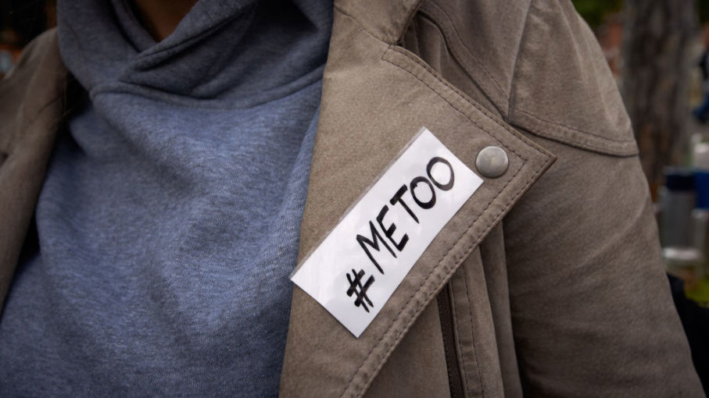
https://people.howstuffworks.com/sexual-harassment-is-legally-defined.htm
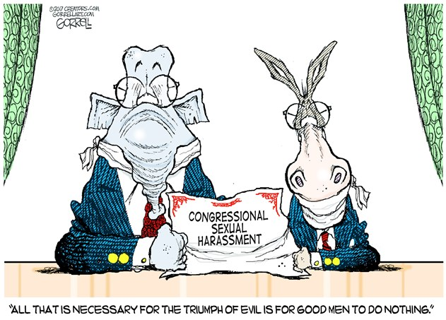
https://townhall.com/political-cartoons/2017/11/28/154307

NEWS SOURCES (7 total)

Pelosi, Ryan Call on Conyers to Step Down; Franken Under Senate Ethics Inquiry, by Brian Naylor, NPR, Nov. 30, 2017
“Rep. John Conyers, D-Mich., is coming under increasing pressure to step down … On the other side of Capitol Hill, the Senate Ethics Committee confirmed Thursday that it has opened an inquiry into Sen. Al Franken's behavior…”
https://www.npr.org/2017/11/30/567436833/conyers-hospitalized-for-stress-as-5th-franken-accuser-comes-forward
CLP: current state of affairs – vis a vis sexual harassment, 11/30/17 – in Congress

Readers Write: A False Equivalency in Judging Sexual Harassment (OPINION), by Dr. Hal Sobel in letter to The Island Now, Nov. 30, 2017.
“… raises the question as to whether what Roy Moore, Donald Trump and Al Franken have done are morally equivalent. I will argue punishments meted out for sexual harassment should be nuanced…”
https://theislandnow.com/opinions-100/readers-write-false-equivalency-judging-sexual-harrassment/
CLP: raises important questions on how to process and assign punishment for misbehavior.

Charlie Rose, Sexual Harassment and the Female Newsroom Managers Who Looked Away (OPINION), Alicia Shepard, USAToday, Nov. 28, 2017
“…what I have to wonder about is Rose’s longtime executive producer, Yvette Vega, who knew about his predatory behavior…She would just shrug and just say, ‘That’s just Charlie being Charlie.’ ”
https://www.usatoday.com/story/opinion/2017/11/28/charlie-rose-sexual-harassment-and-regrets-female-news-managers-alicia-shepard-column/895998001/
CLP: raises important questions about the role of and responsibility of managers and others who know about the misbehavior.

Sexual Harassment Allegations Continue; Franken, Conyers Claimed, by Gabe Fleisher, Wake Up to Politics Newsletter (by a 15-yr old “reporting live from WUTP World HQ in my bedroom” before leaving for school in the morning), Nov. 21, 2107
“The national reckoning with sexual harassment and assault has reached Washington, D.C. in earnest, and the spate of recent allegations are unlikely to stop. On Monday, new accusations were reported against...”
https://us3.campaign-archive.com/?u=4946817b18454973fb1cd7ecc&id=a6e15c0f9f
CLP: stunningly frank and comprehensive newsletter from high schooler’s newsletter with a circulation of 33,000+

From Charlie Rose to Donald Trump: 6 Thorny Questions for Washington on Sexual Harassment, by Amber Phillips, The Washington Post, Nov. 20, 2017
“… Since Washington is supposed to set the tone for the rest of society, having their own accused raises some very difficult ethical questions for politicians and the news organizations that cover them…”
https://www.washingtonpost.com/news/the-fix/wp/2017/11/20/from-charlie-rose-to-donald-trump-7-thorny-questions-for-washington-on-sexual-harassment/?
CLP: these questions get to the heart of the matter.

Bringing Awareness to Harrassment, by Andy Mehalshick, PA Homepage, Nov. 21, 2017 (includes video)
“…many women who were afraid to come forward are doing so now with the help of social media. …(sexual harassment) ‘It's not an illness like major depression or schizophrenia . It tends to be a personality flaw.’ added Psychiatrist Dr. Matthew Berger… He says sexual harassment is all about control…”

http://www.pahomepage.com/news/bringing-awareness-to-harrassment/861846363

#MeToo Act: New Bill Aimed at Combating Sexual Harrassment on Capitol Hill, by Julia Conley, Common Dreams, Nov. 15, 2017
"…The Me Too Act … demands an overhaul of the complaint process women in Congress must navigate in order to report sexual misconduct…”
https://www.commondreams.org/news/2017/11/15/metoo-act-new-bill-aimed-combating-sexual-harrassment-capitol-hill
CLP: positive steps by Congress to address sexual harassment among its own

QUESTIONS TO CONSIDER (17 total)
- What is harassment?
- What is sexual harassment? Why is sexual harassment a form of discrimination in the workplace?
- What aspects of a respectful democracy does sexual harassment threaten?
- Which democratic institutions protect victims of harassment?
- What is the role of media? Does its reporting hurt or help (victims, wrongdoers, culture)? Is disclosure helping to change inappropriate behavior?
- How might social media help victims of sexual harassment? How might social media lead to harassment?
- Does the increase in women in the work place impede sexual harassment? What is the role of women in standing up for victim of sexual harassment?
- What is the definition of consent? Are consent and power related?
- Why is consent complicated?
- What is the responsibility of managers to assist employees who report harassment? What is the role of women managers in acknowledging and taking action on harassment reports?
- What is the role of a citizen in speaking out for a society where respect is the goal?

6 thorny questions for Washington on sexual harassment
https://www.washingtonpost.com/news/the-fix/wp/2017/11/20/from-charlie-rose-to-donald-trump-7-thorny-questions-for-washington-on-sexual-harassment/?
- Is this a systemic problem?
- What's created this culture?
- What makes an accuser's story more credible than the next?
- Do we need to question accusers' timing or motives?
- Where should Congress draw the line on accusations?
- Should politics ever trump sex abuse allegations?

BACKGROUND AND More (1 total)

How to Talk to Children About Sexual Harassment, Harold S. Koplewicz, M.D., Child Mind Institute, Nov. 17, 2017
“…today we find ourselves in the painful position of having to talk to kids about sexual harassment, and the kind of inappropriate behavior that has become a staple of the news lately. Some of what’s being reported is, frankly, awful. So it’s tempting to avoid talking about it. But that’s a mistake…”
https://childmind.org/blog/talk-children-sexual-harassment/
CLP: Start here!

Lesson Plans (2 total)

Crossing the Line Online: Sexual Harassment and Violence in the Age of Social Media, by Katherine Schulten and Jennifer Cutraro, The Learning Network – New York Times, Jan. 9, 2013
“Note to Teacher: This lesson raises sensitive issues around teenagers’ sexual experiences and attitudes. We have provided a number of resources here that can be used for reading and discussion; as always, please choose the pieces and adapt the lesson as appropriate for your students. …”

https://learning.blogs.nytimes.com/2013/01/09/crossing-the-line-online-sexual-harassment-and-violence-in-the-age-of-social-media/

Sexual Harassment, from Discovery Education
http://www.discoveryeducation.com/teachers/free-lesson-plans/sexual-harassment.cfm
CLP: objectives include defining sexual harassment, identifying examples and considering responses; includes discussion questions.

Constitutional & Legal Connections (5 total)

How Does Your State Define Consent?, from RAINN (Rape, Abuse & Incest National Network), Mar. 27, 2016
“… What exactly is consent? From a legal standpoint, it’s a deceptively difficult question, since consent means something a little different in each state…”
https://www.rainn.org/news/how-does-your-state-define-consent
CLP: national website includes link to Oregon law on rape, sexual assault, consent, mandatory reporting.

6 Famous Cases of Sexual Harassment, by Lisa C. Johnson, Esq., Legalzoom,
There are two major varieties of unlawful sexual harassment…. ‘quid pro quo’ meaning “this for that” … The second is the ‘hostile environment,’ ...”
https://www.legalzoom.com/articles/6-famous-cases-of-sexual-harassment
CLP: brief overview of Clarence Thomas, Navy Tailhook scandal, Jenson v. Eveleth Taconite, Six-year-old v. Brocton School District, Oregon Sen. Bob Packwood, and David Letterman cases.

Know Your Rights: Workplace Sexual Harassment, American Association of University Women
“Sexual harassment is a form of sex discrimination that violates Title VII of the Civil Rights Act of 1964. Very generally, “sexual harassment” describes unwelcome sexual advances, requests for sexual favors, or other verbal or physical conduct of a sexual nature. Title VII is a federal law that prohibits discrimination in employment on the basis of sex, race, color, national origin, and religion, and it applies to employers with 15 or more employees, including federal, state, and local governments…”
https://www.aauw.org/what-we-do/legal-resources/know-your-rights-at-work/workplace-sexual-harassment/

CLP: CLP: similar in content to the How Stuff Works link, but this one has an FAQ approach.

This Is How Sexual Harassment Is Legally Defined in the U.S., by Alia Hoyt, How Stuff Works, Nov. 20, 2017
“The U.S. Equal Employment Opportunity Commission (EEOC), the government agency that enforces discrimination laws, says, ‘It is unlawful to harass a person (an applicant or employee) because of that person's sex. Harassment can include 'sexual harassment' or unwelcome sexual advances, requests for sexual favors, and other verbal or physical harassment of a sexual nature.’…"
https://people.howstuffworks.com/sexual-harassment-is-legally-defined.htm

CLP: similar in content to the AAUW link, but this one is more of a narrative.

Gender Discrimination: U.S. Supreme Court Cases, from Findlaw
“… a list of (9) U.S. Supreme Court cases involving gender discrimination and women's rights, including links to the full text of the U.S. Supreme Court decisions…”
http://civilrights.findlaw.com/discrimination/gender-discrimination-u-s-supreme-court-cases.html

OREGON (2 total)

Second Oregon State Senator Publicly Accuses Sen. Jeff Kruse of Sex Harassment, by Gordon R. Friedman, the Oregonian/OregonLive, Nov. 21, 2017
“Sen. Elizabeth Steiner-Hayward filed a formal sexual harassment complaint against Sen. Jeff Kruse on Tuesday, becoming the second sitting state senator to do so…”
http://www.oregonlive.com/politics/index.ssf/2017/11/second_oregon_state_senator_pu.html

Sexual Harassment: Questions & Answers, from Oregon Bureau of Labor and Industries
http://www.oregon.gov/boli/TA/pages/t_faq_tasexhar.aspx
CLP: BOLI is the Oregon agency charged with protecting employment rights; this link provides a helpful Q&A including hypotheticals.

For Oregon SOCIAL SCIENCE Standards
8.8 Evaluate information from a variety of sources and perspectives.
8.14 Explain rights and responsibilities of citizens.
8.20 Analyze the changing definition of citizenship and the expansion of rights.
8.21 Analyze important political and ethical values such as freedom, democracy, equality, and justice embodied in documents such as the Declaration of Independence, the United States Constitution, and the Bill of Rights.
8.25 Critique data for point of view, historical context, distortion, or propaganda and relevance.
8.26 Examine a controversial event, issue, or problem from more than one perspective.
8.27 Examine the various characteristics, causes, and effects of an event, issue, or problem.
8.28 Investigate a response or solution to an issue or problem and support or oppose, using research.

HS.1 Evaluate continuity and change over the course of world and United States history.
HS.6 Analyze ideas critical to the understanding of history, including, but not limited to: populism, progressivisim, isolationism, imperialism communism, environmentalism, liberalism, fundamentalism, racism, ageism, classism, conservatism, cultural diversity, feminism, and sustainability.
HS.27 Examine functions an process of United Sates government.
HS.30 Analyze the roles and activities of political parties, interest groups and mass media and how they affect the beliefs and behaviors of local, state, and national constituencies.
HS.33 Explain the role of government in various current events.
HS.34 Explain the responsibilities of citizens (e.g., vote, pay taxes).
HS.57 Define, research, and explain an event, issue, problem or phenomenon and its significance to society.
HS.58 Gather, analyze, use and document information from various sources, distinguishing facts, opinions, inferences, biases, stereotypes, and persuasive appeals.
HS.59 Demonstrate the skills and dispositions needed to be a critical consumer of information.
HS.60. Analyze an event, issue, problem, or phenomenon from varied or opposing perspectives or points of view.
HS.61 Analyze an event, issue, problem, or phenomenon, identifying characteristics, influences, causes, and both short- and long-term effects.
HS.63. Engage in informed and respectful deliberation and discussion of issues, events, and ideas.

For Connections to lessons in We the People: The Citizen & the Constitution texts

Middle School, Level 2
Unit 6, Lesson 29: What are the rights and responsibilities of citizenship?
Unit 6, Lesson 30: How might citizens participate in civic affairs?
High School, Level 3
Unit 6, Lesson 34: What is the importance of civic engagement to American constitutional democracy?
Unit 6, Lesson 37: What key challenges does the United States face in the future?

