CLP CURRENT EVENTS – October 3, 2017

TOPIC: Refugees In Crises: The Rohingya
(see archives for Aung San Suu Kyi, http://www.classroomlaw.org/current-events-2012-2017/)

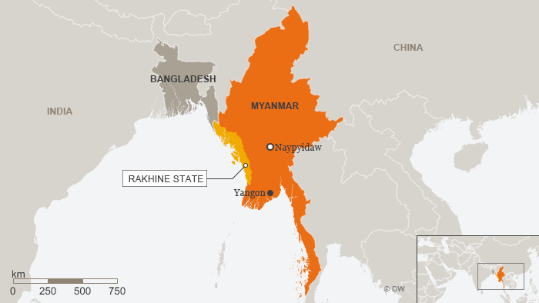
http://www.dw.com/en/rohingya-people-in-myanmar-what-you-need-to-know/a-40340067
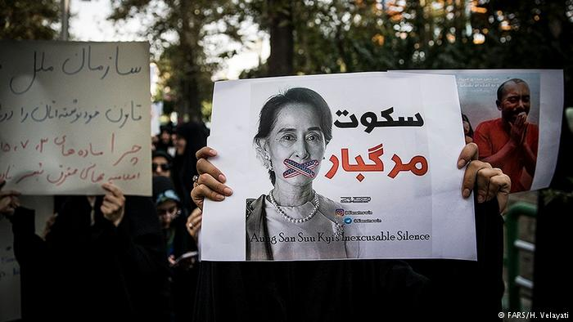
http://www.dw.com/en/rohingya-crisis-un-chief-warns-aung-san-suu-kyi-of-last-chance-to-act-for-refugees/a-40546452

How do you pronounce Rohingya?
https://www.youtube.com/watch?v=ep7nhep8eek
How do you pronounce Aung San Suu Kyi?
https://www.youtube.com/watch?v=ihqmcwfvj4o

NEWS SOURCES (6 total)

In Grim Camps, Rohingya Suffer on ‘Scale That We Couldn’t Imagine’, by Ben C. Solomon, New York Times, Sept. 29, 2017
https://www.nytimes.com/2017/09/29/world/asia/rohingya-refugees-myanmar-bangladesh.html
CLP: learn what’s happening in refugee camps in Bangladesh now.

Aung San Suu Kyi Says Myanmar Does Not Fear Scrutiny Over Rohingya Crisis, by Poppy McPherson, The Guardian, Sept. 19, 2017
https://www.theguardian.com/world/2017/sep/19/aung-san-suu-kyi-myanmar-rohingya-crisis-concerned
CLP finds: Nobel prize winning leader facing world scrutiny

India Seeks Deportation of Rohingya for Security Reasons, by Anjana Pasricha, VOA, Sept. 19, 2017
“... India is walking a tightrope on the issue of the Rohingya refugees …”
https://www.voanews.com/a/india-seeks-deportation-of-rohingya-for-security-reasons/4033312.html

India Has Asked Myanmar to End Rohingya Persecution, Claims Bangladesh, The Wire Staff, Sept. 15, 2017

https://thewire.in/178015/india-myanmar-rohingya-swaraj-bangladesh/

CLP: India weighs in; a regional issue goes global.

Myanmar's Suu Kyi Skips UN Assembly Amid Criticism Over Rohingya Crisis, by Ben Westcott, CNN, Sept. 13, 2017
www.cnn.com/2017/09/13/asia/rohingya-aung-san-suu-kyi-un/index.html
CLP: why Myanmar’s Noble Prize winning leader does not attend important UN meeting.

Myanmar Stands Accused of Ethnic Cleansing. Here's Why, by Feliz Solomon, Time, Sept. 11, 2017
"The Myanmar Government should stop claiming that the Rohingyas are setting fire to their own homes…"
http://time.com/4936882/myanmar-ethnic-cleansing-rohingya/
CLP: go-to article for history and current status of the Rohingya

QUESTIONS TO CONSIDER (15+ total)

- Where is Rakhine? Myanmar (formerly Burma)? Bangladesh? India?
- Who are the Rohingya?
- Who is Aung San Suu Kyi? What might explain her reluctance to comment about the threat to the Rohingya people in Myanmar? What pressure has forced her to explain the Rohingya refugee crisis? Why is she under special obligation to care about ethnic minorities in Burma?
- Why are the Rohingya fleeing Myanmar?
- What is the effect of the out migration of the Rohingya on the neighboring countries?
- What are the prospects for solving this refugee crisis?
- What is ethnic cleansing?
- Why should the world care?
- What is the connection between majority and minority rights in a constitutional government?
- How do international organizations guarantee minority rights?
- Why is it important to protect minority rights from the rule of the majority?
- Do decisions about protection for the Rohingya affect the treatment of other minorities?
- What might be some solutions to this crisis?
- What is the status of refugees in the United States?
- How should the United States and the rest of the world respond to the treatment of the Rohingya in Myanmar? https://learning.blogs.nytimes.com/2014/11/07/6-qs-about-the-news-as-myanmar-advances-resettlement-plan-rohingya-flee/?

Additional Questions to Consider from Other Sources

From Al Jazeera: The Rohingya
- Who are they?
- Where are they from?
- How are they persecuted?
- How many have fled?
- What does Myanmar say?
- What does Bangladesh say?
- What does the international community say?
- What is the ARSA?
http://www.aljazeera.com/indepth/features/2017/08/rohingya-muslims-170831065142812.html

From the Learning Network
- WHERE is Myanmar?
- WHO are the Rohingya people?
- WHAT policy has the Myanmar government adopted toward the Rohingya?
- WHY is the crisis an embarrassment to the White House?
- WHAT kind of discrimination have the Rohingya faced in Myanmar?
HOW many Rohingya have fled since an outbreak of sectarian rioting in 2012?
- WHEN did many Rohingya go to Myanmar?
- WHAT are some of the official policies laid out in the Rakhine Action Plan?
- WHAT is life like in Rohingya camps and villages?
- WHAT are the risks that many Rohingya face when they flee Myanmar by boat?
- For Higher-Order Thinking
- HOW should the United States and the rest of the world respond to the treatment of the Rohingya in Myanmar?
https://learning.blogs.nytimes.com/2014/11/07/6-qs-about-the-news-as-myanmar-advances-resettlement-plan-rohingya-flee/

From Breaking News English Lesson on The Rohingya
- What did the United Nations call the humanitarian situation?
- Which border did the Rohingya cross?
- How many Rohingya have fled?
- What did the BBC say had burned down?
- How long have the Rohingya lived in Myanmar?
- What did the article say Aung San Suu Kyi was under?
- When did Aung San Suu Kyi win the Nobel Peace Prize?
- What has Aung San Suu Kyi not condemned?
- Who asked Myanmar to take the refugees back?
- Who did the Myanmar army say were the indigenous people of Myanmar?
https://breakingnewsenglish.com/1709/170915-rohingya-1.html

BACKGROUND AND More (5 total)

Myanmar/Burma – Muslims and Rohingya, by Minority Rights Group International
“Rohingya would have been considered citizens of Burma under the 1948 Constitution until the military coup in 1962 …”
http://minorityrights.org/minorities/muslims-and-rohingya/
CLP found helpful profile, history, and current issues

Rohingya People in Myanmar: What You Need to Know, by DW (Deutsche Welle’s English-language news and information channel)
http://www.dw.com/en/rohingya-people-in-myanmar-what-you-need-to-know/a-40340067
CLP: everything in a nutshell; this is very good!

Aung San Suu Kyi, the Ignoble Laureate, by Gavin Jacobson, The New Yorker, Sept. 15, 2017
“… Suu Kyi’s champions are now contemplating her fall from grace, appalled that the Nobel Peace Prize winner remains silent about and unmoved by a crisis described this week by the U.N.’s human-rights chief as ‘a textbook example of ethnic cleansing’…”
https://www.newyorker.com/news/news-desk/aung-san-suu-kyi-the-ignoble-laureate?

Myanmar: Who are the Rohingya? by Al Jazeera Staff, Sept. 28, 2017

“Why are the more than one million Rohingya in Myanmar considered the 'world's most persecuted minority'? …”
http://www.aljazeera.com/indepth/features/2017/08/rohingya-muslims-170831065142812.html
CLP: comprehensive and up to date; a must read.

Myanmar...Terrorism Hotbed in The Making, by Basma Elbaz, Huffington Post, Sept. 17, 2017
“The way the international community is responding to Rohingya ethnic cleansing in Myanmar is not only inadequate but also extremely dangerous as the crisis is attracting attention of extremist groups around the globe. …”
http://www.huffingtonpost.com/entry/myanmarterrorism-hotbed-in-the-making_us_59bd6fd4e4b02c642e4a1717
CLP: why this is an international concern.

Lesson Plans (4 total)

6 Q’s About the News | As Myanmar Advances Resettlement Plan, Rohingya Flee, by Michael Gonchar, the Learning network, Nov. 7, 2014
https://learning.blogs.nytimes.com/2014/11/07/6-qs-about-the-news-as-myanmar-advances-resettlement-plan-rohingya-flee/
CLp: Important, basic “Questions to Consider” (listed in Section above and) found here.

Breaking News English Lesson on The Rohingya, ESL Lesson Plan
http://www.breakingnewsenglish.com/1709/170915-rohingya.html
CLp: Teaching English skills using Rohingya content.

How to Teach ... About Refugees, The Guardian, Teacher Network
“The number of people forced to flee their homes has reached record levels. Teach your students about the crisis ahead of Refugee Week with our lesson ideas … “

https://www.theguardian.com/teacher-network/2015/may/25/how-to-teach-refugees

Understanding the Global Refugee Crisis, by Facing history and Ourselves (3 class periods: includes videos, readings, interactive strategies)

https://www.facinghistory.org/resource-library/understanding-global-refugee-crisis

CLP: putting refugees in context of an historical event. Potentially powerful lesson.

Constitutional Connections (5 articles)

Do Rohingya Refugees in India have Constitutional Rights?, by Afreen Hashmi, Oxford Human Rights Hub, Sept. 29, 2017
“The Indian Government recently issued a direction to identify and deport around 40,000 Rohingya refugees in India, labelling them as a burden on the resources of the country and a security threat. However, the Supreme Court of India has decided to hear a case …”
http://ohrh.law.ox.ac.uk/do-rohingya-refugees-in-india-have-constitutional-rights/
CLP: mirrors constitutional questions in the United States

Declaration on the Rights of Persons Belonging to National or Ethnic, Religious and Linguistic Minorities, The United Nations General Assembly
“Reaffirming that one of the main purposes of the United Nations … is to achieve international cooperation in promoting and encouraging respect for human rights and for fundamental freedoms for all without distinction as to race, sex, language or religion, …”
http://www.un.org/documents/ga/res/47/a47r135.htm
CLP suggests: use this primary source document in your own lessons!

Majority Rule and Minority Rights, by John Patrick, Understanding Democracy, A Hip Pocket Guide, Annenberg Classroom – Resources for Excellent Civics Education
“… Tyranny by minority over the majority is barred, but so is tyranny of the majority against minorities. …”
http://www.annenbergclassroom.org/term/majority-rule-and-minority-rights
CLP notes: short, concise, useful resource.

Minority Rights: International Standards and Guidance for Implementation, Office of the High Commissioner, United Nations Human Rights, 2010
http://www.ohchr.org/documents/publications/minorityrights_en.pdf
CLP: fascinating primary source document that frames issues in useful questions for the classroom.

Rights, Constitution USA with Peter Sagal, PBS
“What is a right, and where does it come from? … The American system is one of majority rule with minority rights: everyday laws pass with a simple majority vote, but certain fundamental rights protected by the Bill of Rights are not subject to the wishes of the majority. …”
http://www.pbs.org/tpt/constitution-usa-peter-sagal/rights/#.wcevqtogngm
CLP notes: helpful background content.

OREGON (2 total)

CAIR-Oregon Commends Senator Merkley for Statement on Rohingya Crisis, Council on American-Islamic Relations, Sept. 15, 2017
Last Updated: September 17, 2017 |
“The Oregon chapter of the Council on American-Islamic Relations (CAIR-Oregon) today commended Senator Jeff Merkley (D-OR) for his statement asking Burma to cease its persecution of the Rohingya Muslim people.”
https://www.cair.com/press-center/press-releases/14619-cair-oregon-commends-senator-merkley-for-statement-on-rohingya-crisis.html

Merkley Statement on Anti-Rohingya Persecution in Burma, Sept. 15, 2017
WASHINGTON, D.C. – Oregon’s Senator Jeff Merkley, a member of the Senate Foreign Relations Committee, released the following statement …”
https://www.merkley.senate.gov/news/press-releases/merkley-statement-on-anti-rohingya-persecution-in-burma-

For Oregon SOCIAL SCIENCE Standards

8.8 Evaluate information from a variety of sources and perspectives.
8.26 Examine a controversial event, issue, or problem from more than one perspective.
8.27 Examine the various characteristics, causes, and effects of and event, issue, or problem.
8.28 Investigate a response or solution to an issue or problem and support or oppose, using research.

HS.3 Explain the historical development and impact of major world religions and philosophies.
HS.16 Analyze the interconnectedness of physical and human regional systems (e.g., a river valley and culture, water rights/use in regions, choice/impact of settlement locations) and their interconnectedness to global communities.
HS.17 Explain how migration, immigration and communication (cultural exchange, convergence and divergence) lead to cultural changes and make predictions and draw conclusions about the global impact of cultural diffusion.
HS.19 Evaluate how differing points of view, self-interest, and global distribution of natural resources play a role in conflict over territory.
HS.28 Evaluate how governments interact at the local, state, tribal, national and global levels.
HS.31 Describe United States foreign policy and evaluate its impact on the United States and other countries.
HS.33 Explain the role of government in various current events.
HS.57 Define, research, and explain an event, issue, problem or phenomenon and its significance to society.
HS.58 Gather, analyze, use and document information from various sources, distinguishing facts, opinions, inferences, biases, stereotypes, and persuasive appeals.
HS.60 Analyze an event, issue, problem, or phenomenon from varied or opposing perspectives or points of view.
HS.63 Engage in informed and respectful deliberation and discussion of issues, events, and ideas.

For Connections to lessons in We the People: The Citizen & the Constitution texts

Middle School, Level 2
- Unit 6, Lesson 28: What is the relationship of the United States to other nations in the world?
- Unit 6, Lesson 29: What are the rights and responsibilities of citizenship?
- Unit 6, Lesson 30: How might citizens participate in civic affairs?
High School, Level 3
- Unit 6, Lesson 34: What is the importance of civic engagement to American Constitutional democracy?
- Unit 6, Lesson 36: How have American political ideas and the American Constitutional System influenced other nations?
- Unit 6, Lesson 37: What key challenges does the United States face in the future?

