CLP CURRENT EVENTS Tuesday, Sept. 12, 2017

TOPIC: WHEN Disaster sTRIKES - Federal Emergency Management Agency (FEMA)

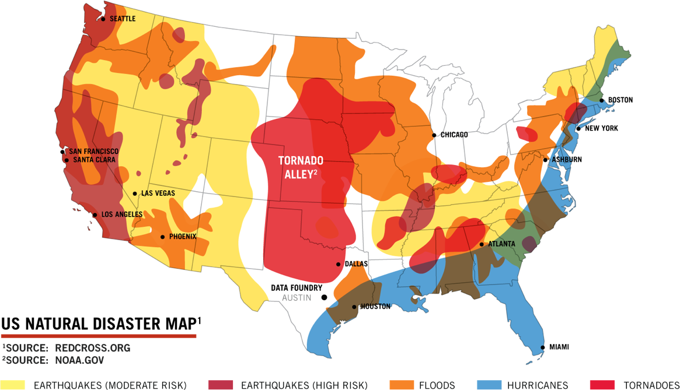

https://www.datafoundry.com/services/disaster-recovery/

http://www.npr.org/2017/09/08/549279078/with-harvey-and-now-irma-federal-funds-and-fema-are-put-to-the-test

Disaster
www.dictionary.com/browse/disaster
a calamitous event, especially one occurring suddenly and causing great loss of life, damage, or hardship, as a flood, airplane crash, or business failure. ... Disaster, calamity, catastrophe, cataclysm refer to adverse happenings often occurring suddenly and unexpectedly.

“When I was a boy and I would see scary things in the news, my mother would say to me, ‘Look for the helpers. You will always find people who are helping’.”
― Fred Rogers
https://www.goodreads.com/quotes/198594-when-i-was-a-boy-and-i-would-see-scary

The Role of Government in a Disaster, The Role of Government in a Disaster – A Report by the U of Florida

http://disaster.ifas.ufl.edu/pdfs/chap03/d03-07.pdf
CLP says: understandable outline with helpful definitions and explanations

fema.gov, Wikipedia
The Federal Emergency Management Agency is an agency of the United States Department of Homeland Security …
CLP says: yes, Wikipedia for a good overview!

NEWS SOURCES (7 total)

Frustrated first responders have to ignore Irma 911 calls, by Elizabeth Cohen and Debra Goldschmidt, CNN, Sept. 11, 2017

“ winds were so high that emergency services in many areas were suspended to protect the rescuers…”

http://www.cnn.com/2017/09/11/health/first-responders-frustrated-during-irma/index.html

Wave of Disasters Put Strain on FEMA and Relief Groups by Jaie Avila, News4San Antonio, Sept. 8, 2017

“… ’Your federal government is working as diligently as we can to make certain we can respond to whatever needs arise,’ said HHS Secretary Tom Price.”

http://news4sanantonio.com/news/trouble-shooters/wave-of-disasters-put-strain-on-fema-and-relief-groups

CLP: good, current, short introduction to the issues

With Harvey And Now Irma, Federal Funds And FEMA Are Put To The Test, by Brian Naylor, NPR, Sept. 8, 2017
“… There is at least one more hurricane on the immediate horizon, and it isn’t even the peak of the season yet. The agency is also providing funds to help fight wildfires in the West…”

http://www.npr.org/2017/09/08/549279078/with-harvey-and-now-irma-federal-funds-and-fema-are-put-to-the-test
CLP says: in addition to FEMA, also learn about ‘Cajun Navy’ volunteers

Congress Eyes More FEMA Disaster Aid, Short-Term Flood Insurance Renewal, by David Shepardson, Insurance Journal, Sept. 7, 2017
“ … (FEMA) will run out of disaster assistance funding on Friday unless Congress approves more money, two Florida senators warned on Thursday….”
http://www.insurancejournal.com/news/national/2017/09/07/463708.htm

As Floodwaters Recede, Israeli Disaster Aid Is In Houston for the Long Haul, Renee Ghert-Zand, The Times of Isreal, September 1, 2017

With experience after hurricanes Sandy and Katrina, humanitarian organizations bring supplies and help pick up the pieces from one of the country's worst natural disasters
https://www.timesofisrael.com/as-floodwaters-recede-israeli-disaster-aid-is-in-houston-for-the-long-haul/
CLP says: one example of other countries coming to the aid of the U.S.

Va. nurses, students detail long days of Texas volunteer efforts, by Alix Bryan, wtvr.com, Sept. 4, 2017
http://wtvr.com/2017/09/04/richmond-healthcare-workers-travel-to-texas-to-volunteer-after-hurricane-harvey/
CLP finds volunteerism at its best

Local Red Cross Volunteers Prepare for Irma, by Logan Wilson, abc27.com, Sept. 8, 2017
http://abc27.com/2017/09/08/local-red-cross-volunteers-prepare-for-irma/
CLP: role of NGOs and volunteerism
CLP says: NGOs, out-of-staters to the rescue after Irma

QUESTIONS TO CONSIDER (15 total)

- What is a disaster?
- What is the role of the federal government? What is the role of local government? What is the role of mayors and governors? How do the executive and legislative branches of the government function in an emergency? What is the role of non-governmental (NGO) agencies? What is the role of individual citizens? What is the role of volunteers?
- What is a declaration of emergency?
- What is an evacuation order? What is a mandatory evacuation order?
- Who funds disaster relief? How is the funding tied to the debt ceiling?
- What funding needs to be allocated to prevention efforts to avoid floods and fires? What does it mean to be “prepared”?
- How do collaboration and cooperation help when responding to a disaster? What do we learn about effective processes from disaster experiences? How crucial is setting aside partisan politics?
- What do our national documents say about the role of government when a disaster occurs?
- What is the common good? What is civic virtue? What is civic responsibility?
- What is the role of science in planning the future?
- What responsibility do we assign to individuals whose careless or reckless behavior causes disasters? What responsibility do we assign to individuals who do not obey evacuation orders?
- What is the role of the news media when a disaster strikes?
- What is the role of the United States when disasters happen in other countries?
- How do other countries respond to emergencies in the United States?
- Has our nation’s response to major disasters improved since Hurricane Katrina, the last time a storm left such a catastrophic mark on the United States?
https://www.brookings.edu/blog/up-front/2012/11/02/feds-states-cities-the-all-of-the-above-disaster-response/

BACKGROUND AND More (6 total)

The Disaster Declaration Process, Official website of the Department of Homeland Security
https://www.fema.gov/disaster-declaration-process
CLP says: find procedural information here

The Office of U.S. Foreign Disaster Assistance (OFDA), a U.S. government agency
“OFDA responds to an average of 65 disasters in more than 50 countries every year …”
https://www.usaid.gov/who-we-are/organization/bureaus/bureau-democracy-conflict-and-humanitarian-assistance/office-us
CLP: role of the U.S. when disaster strikes in other parts for the world

Are catastrophic disasters striking more often? by the Associated Press and Jay L. Zagorsky, Sept. 8, 2017
“No sooner had Hurricane Harvey’s record rains receded from Houston and neighboring cities than the residents of Florida began bracing for a wallop …
Is the number of major natural disasters striking the United States actually increasing, or does the media’s natural tendency to overhype conflict only make it seem so?... As an economist, I take a different approach from how a climate or environmental scientist might answer the question.”
http://wtop.com/business-finance/2017/09/are-catastrophic-disasters-striking-more-often/
CLP: an economist’s view

Who Should Do What: The Role of Citizens, Government, and Nongovernmental Organizations in a Disaster, National Issues Forums Community Conversation hosted by the Ashland University Center for Civic Life, June 16, 2014.
https://www.nifi.org/en/groups/who-should-do-what-role-citizens-government-and-nongovernmental-organizations-disaster
CLP notes: we all have a role

Democracy in America 1835 by Alexis de Tocqueville, Wikipedia
“… Tocqueville saw democracy as an equation that balanced liberty and equality, concern for the individual as well as for the community. … (On civil and political society and the individual) … Tocqueville's main purpose was to analyze the functioning of political society and various forms of political associations, although he brought some reflections on civil society too … civil society was a sphere of private entrepreneurship and civilian affairs regulated by civil code. As a critic of individualism, Tocqueville thought that through associating, the coming together of people for mutual purpose, both in public and private, Americans are able to overcome selfish desires, thus making both a self-conscious and active political society and a vibrant civil society functioning according to political and civil laws of the state. “
https://en.wikipedia.org/wiki/Alexis_de_Tocqueville#On_civil_and_political_society_and_the_individual
CLP: make connections with an early view of Americans and social activity

Lesson Plans (4 total)

Student Tools for Emergency Planning (STEP) Program – A Curriculum for 4th and 5th Grade Students by FEMA

https://www.fema.gov/media-library-data/1446646244445-e4c7811152d75912ab1bda6fb01d121b/FEMA_STEP_Curriculum_October2015_508_v2.pdf

Teaching Activities for: ‘Hurricane Irma Devastates Caribbean and Heads Toward Florida’ by Caroline Crossin Gilpin and Katherine Schulten, The Learning Network – New York Times, Sept. 8, 2017
https://www.nytimes.com/2017/09/08/learning/teaching-activities-for-hurricane-irma-churning-over-dominican-republic-heads-toward-turks-and-caicos.html?

Teaching Hurricane Harvey: Ideas and Resources by Katherine Schulten , Michael Gonchar, and Caroline Crossin Gilpin, The Learning Network – New York Times, Aug. 31, 2017, updated Sept. 4 with additional ideas from a Houston English teacher
https://www.nytimes.com/2017/08/31/learning/lesson-plans/teaching-hurricane-harvey-ideas-and-resources.html?

What Is the Role of Government? - Definition, Role & Functions by Study.com
study.com/academy/lesson/what-is-government-definition-role-functions.html
CLP notes: constitutional connections found here; requires an account to get the lesson

Natural Disasters by PBS-OPB New Perspectivs on The West
Focuses on the causes and consequences of natural disasters; nature's role versus the impact of human activity in contibuting to natural disasters is examined.
http://www.pbs.org/weta/thewest/lesson_plans/lesson10.htm

Constitutional Connections

The Role of Government in a Disaster, The Role of Government in a Disaster – A Report by the U of Florida

http://disaster.ifas.ufl.edu/pdfs/chap03/d03-07.pdf
CLP says: understandable outline with helpful definitions and explanations

Federalism: A system of dual sovereignty by the Bill of Rights Institute

“The people delegate certain powers to the national government, while the states and the people retain those powers not delegated.”
https://www.billofrightsinstitute.org/founding-documents/founding-principles/
CLP says: find applicable Founders’ quotes

Why The Federal Government Should Handle Disaster Relief by Zack Beauchamp,
https://thinkprogress.org/why-the-federal-government-should-handle-disaster-relief-b3c991bbd4a0/
CLP says: written post-Sandy and applicable today

OREGON

Oregon lawmakers to Congress: Treat wildfires like natural disasters by Connor Radnovich, Statesman Journal, Sept. 7, 2017
“As devastation from Oregon's near-record fire season mounts, local and state lawmakers are renewing calls for a long-term solution to inadequate funding …
Currently, wildfires are not considered disasters in the same way as, for example, hurricanes are.”

http://www.statesmanjournal.com/story/news/politics/2017/09/07/oregon-lawmakers-congress-treat-wildfires-like-natur-seek-solution-fire-borrowing-season-nears-recor/644066001/

Public demands consequences for 15-year-old Eagle Creek fire suspect by Aimee Green, Oregonian/OregonLive, updated Sept. 8, 2017

http://www.oregonlive.com/wildfires/index.ssf/2017/09/public_demands_consequences_fo.html
CLP urges caution! Consider balancing defendant(s)’ constitutional guarantees (due process, innocent until proven guilty, etc.) while discussing public outrage

For Oregon SOCIAL SCIENCE Standards

8.1 Evaluate continuity and change over the course of United States history by analyzing examples of conflict, cooperation, and interdependence among groups, societies, or nations.
8.8 Evaluate information from a variety of sources and perspectives.
8.12 Investigate how differing geographic perspectives apply to issues in U.S. History.
8.13 Explain how current and historical technological developments, societal decisions, and personal practices influence sustainability in the United States.
8.26. Examine a controversial event, issue, or problem from more than one perspective.
8.27 Examine the various characteristics, causes, and effects of an event, issue, or problem.
HS.14 Create and use maps, technology, imagery and other geographical representations to extrapolate and interpret geographic data.
HS.15 Analyze and illustrate geographic issues by synthesizing data derived from geographic representations.
HS.16 Analyze the interconnectedness of physical and human regional systems 9e.g., a river valley and culture, water rights/use in regions, choice/impact of settlement locations) and their interconnectedness to global communities.
HS.18 Analyze the impact of human migration on physical and human systems (e.g., urbanization, immigration, urban to rural).
HS.20 Analyze the impact on physical and human systems of resource development, use, and management and evaluate the issues of sustainability.
HS.22 Analyze how humans have used technology to modify the physical environment (e.g., dams, tractor, housing types).
HS.27 Examine functions an process of United Sates government.
HS.28 Evaluate how governments interact at the local, state, tribal, national and global levels.
HS.29 Examine the structures and functions of Oregon’s state, county, local and regional governments.
HS.31 Describe United States foreign policy and evaluate its impact on the United States and other countries.
HS.33 Explain the role of government in various current events.
HS.34 Explain the responsibilities of citizens (e.g., vote, pay taxes).
HS.57 Define, research, and explain an event, issue, problem or phenomenon and its significance to society.
HS.58 Gather, analyze, use and document information from various sources, distinguishing facts, opinions, inferences, biases, stereotypes, and persuasive appeals.
HS.60. Analyze an event, issue, problem, or phenomenon from varied or opposing perspectives or points of view.
HS.61 Analyze an event, issue, problem, or phenomenon, identifying characteristics, influences, causes, and both short- and long-term effects.
HS.63. Engage in informed and respectful deliberation and discussion of issues, events, and ideas.

For Connections to lessons in We the People: The Citizen & the Constitution texts

Middle School, Level 2
- Unit 6, Lesson 28: What is the relationship of the United States to other nations in the world?
- Unit 6, Lesson 29: What are the rights and responsibilities of citizenship?
- Unit 6, Lesson 30: How might citizens participate in civic affairs?
High School, Level 3
- Unit 6, Lesson 34: What is the importance of civic engagement to American constitutional democracy?
- Unit 6, Lesson 37: What key challenges does the United States face in the future?
- Unit 6, Lesson 38: What are the challenges of the participation of the United States in world affairs?
- Unit 6, Lesson 39: What does returning to fundamental principles mean?

